Lesson 22
Objective: Compare the size of the product to the size of the factors.

Suggested Lesson Structure
 Fluency Practice (11 minutes)
 Application Problem (7 minutes)
 Concept Development (32 minutes)
 Student Debrief (10 minutes)
Total Time (60 minutes)
Fluency Practice (11 minutes)
- Find the Unit Conversion 5.MD.2 (5 minutes)
- Multiply Fractions by Whole Numbers 5.NF.4 (4 minutes)
- Group Count by Multiples of 100 5.NBT.2 (2 minutes)
Find the Unit Conversion (5 minutes)
Materials: (S) Personal white board
Note: This fluency activity reviews Lesson 20.
T: (Write $\text{3}\frac{1}{4}$ gal = ____ qt and $\text{3}\frac{1}{4}$ gal = $\text{3}\frac{1}{4}$ $\text{×}$ 1 gal.) How many quarts are in 1 gallon?
S: 4 quarts.
T: Write an equivalent multiplication sentence using an improper fraction and quarts.
S: (Write = $\frac{13}{4}$ $\text{×}$ 4 qt.)
T: Solve and show.
S: (Work and hold up personal white boards.)
Continue with one or more of the following possible problems: $2\frac{2}{3}$ yd = ____ ft, $2\frac{5}{6}$ ft = ____ yd,$5\frac{1}{2}$ pt = ____ c, and $\frac{1}{2}$ c = ____ pt.

Multiply Fractions by Whole Numbers (4 minutes)
Materials: (S) Personal white board
Note: This fluency activity reviews Lesson 21.
T: (Write $\frac{1}{2}$ $\text{×}$ 10 = ____.) Say the multiplication sentence with the answer.
S: $\frac{1}{2}$ $\text{×}$ 10 = 5.
T: (Write 10 $\text{×}$ $\frac{1}{2}$ = ____.) Try this problem.
S: 10 $\text{×}$ $\frac{1}{2}$ = 5.
Continue the process with the following possible problems: $\frac{1}{3}$ $\text{×}$ 12, 12 $\text{×}$ $\frac{1}{3}$, 15 $\text{×}$ $\frac{1}{5}$, and $\frac{1}{5}$ $\text{×}$ 15.
T: (Write $\frac{1}{2}$ $\text{×}$ 6 = ____.) On your personal white boards, write the number sentence and the answer.
S: (Write $\frac{1}{2}$ $\text{×}$ 6 = 3.)
T: (Write $\frac{2}{2}$ $\text{×}$ 6 = ____.) Write the multiplication sentence. Below it, rewrite the multiplication sentence as a whole number times 6.
S: (Write $\frac{2}{2}$ $\text{×}$ 6 = ____. Below it, write 1 $\text{×}$ 6 = 6.)
T: (Write $\frac{3}{2}$ $\text{×}$ 6 = ____.) Write the number sentence and the answer.
S: (Write $\frac{3}{2}$ × 6 = 9.)
Continue with the following possible sequence: 8 × $\frac{1}{4}$, 8 × $\frac{4}{4}$, and 8 × $\frac{5}{4}$.
Group Count by Multiples of 100 (2 minutes)
Note: This fluency activity prepares students for Lesson 22.
T: Count by tens to 100. (Extend a finger each time a multiple is counted.)
S: 10, 20, 30, 40, 50, 60, 70, 80, 90, 100.
T: (Show 10 extended fingers.) How many tens are in 100?
S: 10.
T: (Write 10 × 10 = 100.) Count by twenties to 100. (Extend a finger each time a multiple is counted.)
S: 20, 40, 60, 80, 100.
T: (Show 5 extended fingers.) How many twenties are in 100?
S: 5.
T: (Write 20 × 5 = 100. Below it, write 5 × ____ = 100.) How many fives are in 100?
S: 20.
Repeat the process by counting multiples of 4 and 25, as well as 2 and 50.
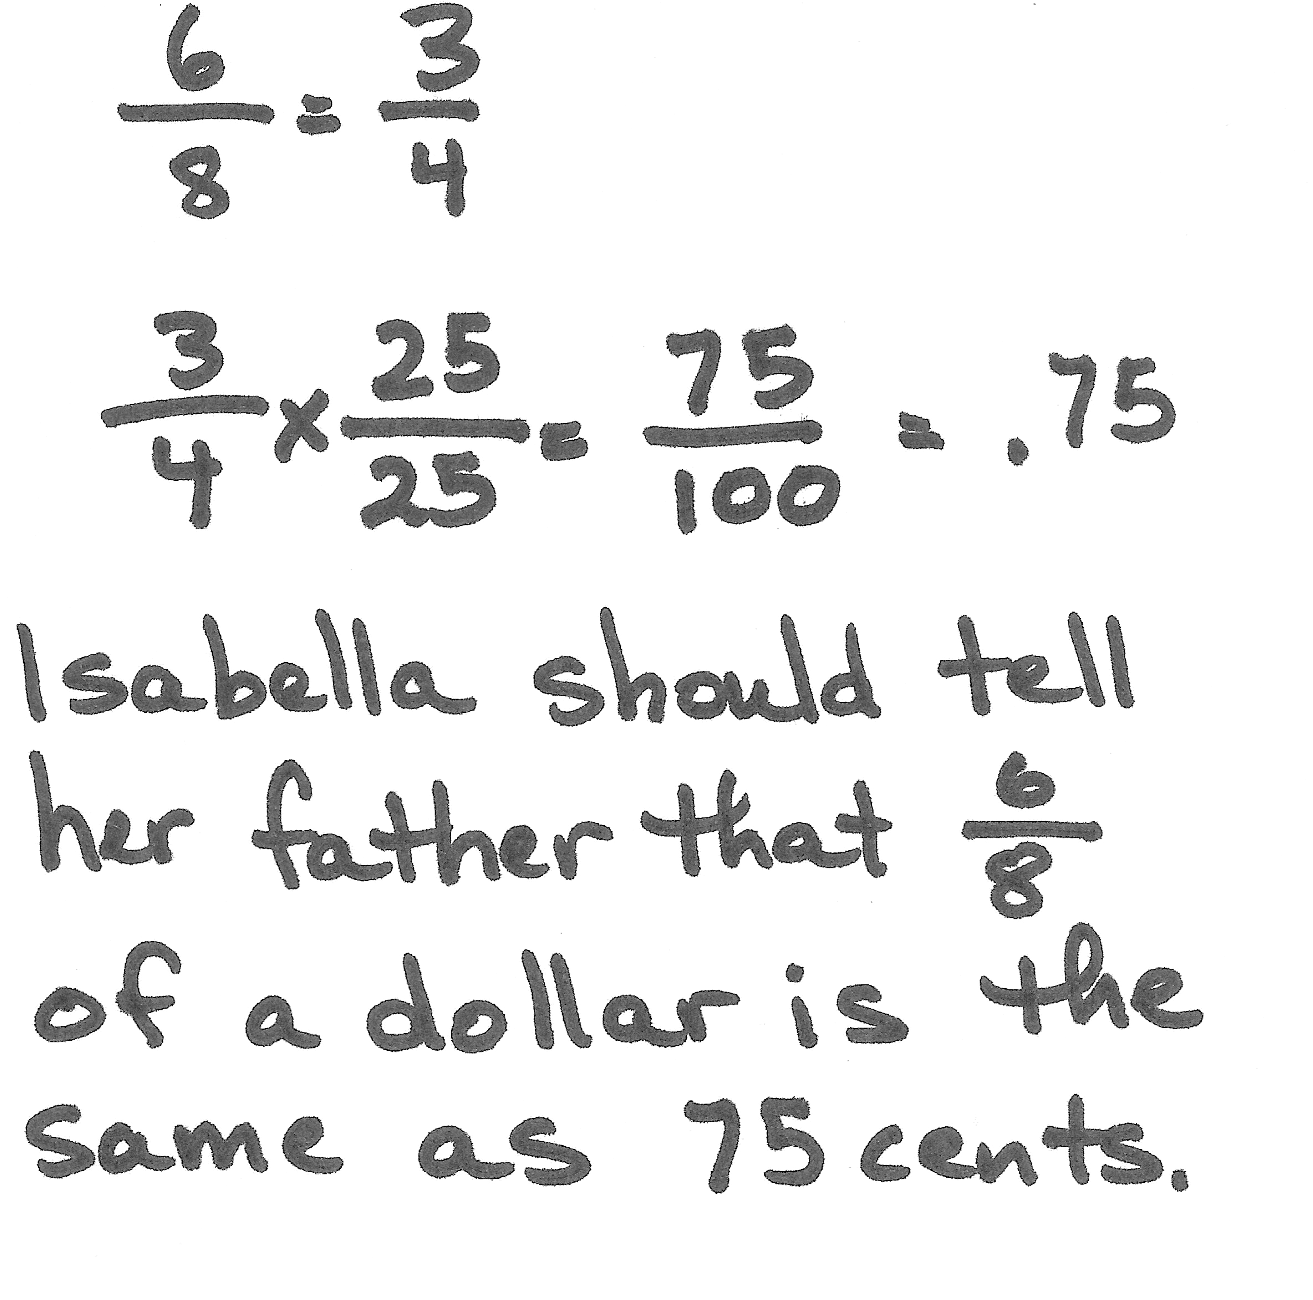
Application Problem (7 minutes)
To test her math skills, Isabella’s father told her he would give her $\frac{6}{8}$ of a dollar if she could tell him how much money it is, as well as the money amount in decimal form. What should Isabella tell her father? Show your calculations.
Note: This Application Problem reviews Lesson 21’s Concept Development. Among other strategies, students might convert the eighths to fourths, and then multiply by $\frac{25}{25}$, or they may remember the decimal equivalent of 1 eighth and multiply by 6.
Concept Development (32 minutes)

Materials: (T) 12-inch string (S) Personal white board
Problem 1: a. $\frac{4}{4}\text{× 12}$ inches b.$\frac{3}{4}$ $\text{× 12}$ inches c.$\frac{5}{4}$ $\text{× 12}$ inches
T: (Post Problem 1(a─c) on the board.) Find the products of these expressions.
S: (Work.)
T: Let’s compare the size of the products you found to the size of this factor. (Point to 12 inches.) Did multiplying 12 inches by 4 fourths change the length of this string? (Hold up the string.) Why or why not? Turn and talk.

NOTES ON
MULTIPLE MEANS
OF REPRESENTATION:
Whenever students calculate problems involving measurements, they will benefit from having established mental benchmarks of each increment. For example, students should be able to think about 12 inches not just as a foot, but also as a specific length (perhaps a length just a little longer than a sheet of paper). Although teachers can give benchmarks for specific increments, it is probably better if students discover benchmarks on their own. Establishing mental benchmarks may be essential for English language learners’ understanding.
S: The product is equal to 12 inches. We multiplied and got 48 fourths, but that’s just another name for 12 using a different unit. It’s 4 fourths of the string, all of it. Multiplying by 1 means just 1 copy of the number, so it stays the same. The other factor just named 1 as a fraction, but it is still just multiplying by 1, so the size of 12 won’t change.
T: (Write $\frac{4}{4}×$ 12 = 12 under Problem 1(a).) Did multiplying by 3 fourths change the size of our other factor—12 inches? If so, how? Turn and talk.
S: The string became shorter because we only took 3 of 4 parts of it. We got almost all of 12 inches, but not quite. We wanted 3 fourths of it rather than 4 fourths, so the factor became smaller after we multiplied. We got 9 inches this time instead of 12 inches.
T: (Write $\frac{3}{4}$ $\text{× 12 <} \text{12}$ under Problem 1(b).) I hear you saying that 12 inches was shortened—resized to 9 inches. How can it be that multiplying made 12 inches smaller when I thought multiplication always made numbers become larger? Turn and talk.

S: We took only part of 12 inches. When you take just a part of something, it is smaller than what you start with. We ended up with 3 of the 4 parts, not the whole thing. Adding $\frac{3}{4}$ twelve times is going to be smaller than adding one the same number of times.
T: So, 9 inches is 3 fourths as much as 12 inches. True or false?
S: True.
T: Let’s consider our last expression—Problem 1(c). How did multiplying by 5 fourths change or not change the size of the other factor, 12 inches? How would it change the length of the string? Turn and talk.
MP.2
S: The answer to this one was greater than 12 inches because it’s more than 4 fourths of it. The product was greater than 12 inches. $\frac{5}{4}\text{× 12} \text{=}\frac{60}{4}\text{=} \text{15}$. We copied a number greater than 1 twelve times. The answer had to be greater than copying 1 the same number of times. 5 fourths of the string would be 1 fourth longer than the string is now.
T: (Write $\frac{5}{4}$ $\text{× 12} \text{>} \text{12}$ under Problem 1(c).) So, 15 inches is 5 fourths as much as 12 inches. True or false?
S: True.
T: 15 inches is 1 and $\frac{1}{4}$times as much as 12 inches. True or false?
S: True.
T: We’ve compared our products to one factor, 12 inches, in each of these expressions. We explained the changes we noticed by thinking about the other factor. We can call that other factor a scaling factor. A scaling factor can change the size of the other factor. Let’s look at the relationships in these expressions one more time. (Point to Problem 1(a).) When we multiplied 12 inches by a scaling factor equal to 1, what happened to the 12 inches?
S: 12 inches didn’t change. The product was the same size as 12 inches, even after we multiplied it.
T: (Point to Problem 1(b).) In this expression, $\frac{3}{4}$ was the scaling factor. Was this scaling factor more than or less than 1? How do you know?
S: Less than 1 because 4 fourths is 1.
T: What happened to the length of the string?
S: It became shorter.
T: (Point to Problem 1(c).) Also, in our last expression, what was the scaling factor?
S: 5 fourths.
T: Was 5 fourths more or less than 1?
S: More than 1.
T: What happened to the length of the string?
S: It became longer. The product was larger than 12 inches.
Problem 2: a. $\frac{4}{4}\text{×} \frac{1}{3}$ b. $\frac{3}{4}$ $\text{×} \frac{1}{3}$ c. $\frac{5}{4}$ $\text{×} \frac{1}{3}$
T: (Post Problem 2 (a–c) on the board.) Considering the relationships that we’ve just noticed between our products and factors, evaluate these expressions.
S: (Work.)
T: Let’s compare the products that you found to this factor. (Point to $\frac{1}{3}$.) What is the product of $\frac{1}{3}$and $\frac{4}{4}$?
S: $\frac{4}{12}$.
T: Did the size of $\frac{1}{3}$ change when we multiplied it by a scaling factor equal to 1?
S: No.
T: (Write $\frac{4}{4}\text{×}\frac{1}{3}\text{=}\frac{1}{3}$ under Problem 2(a).) Since we are comparing our product to 1 third, what is the scaling factor in the second expression? (Point to Problem 2(b).)
S: $\frac{3}{4}$.
T: Is this scaling factor more than or less than 1?
S: Less than 1.
T: What happened to the size of $\frac{1}{3}$ when we multiplied it by a scaling factor less than 1? Why? Turn and share.
S: The product was 3 twelfths. That is less than 1 third, which is 4 twelfths. We only wanted part of 1 third this time, so the answer had to be smaller than 1 third. When you multiply by less than 1, the product is smaller than what you started with.
T: (Write $\frac{3}{4}\text{×} \frac{1}{3} \text{<} \frac{1}{3}$ under Problem 2(b).) In the last expression, $\frac{5}{4}$ was the scaling factor. Is the scaling factor more than or less than 1?
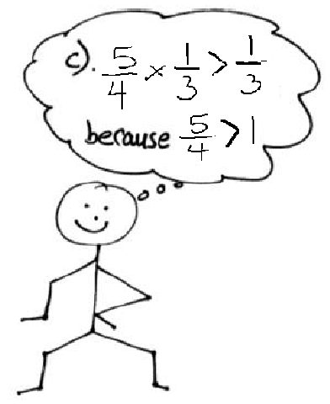
S: More than 1.
T: Say the product of $\frac{1}{3}\text{×}\frac{5}{4}$.
S: $\frac{5}{12}$.
T: Is 5 twelfths more than, less than, or equal to $\frac{1}{3}?$
S: More than $\frac{1}{3}.$
T: (Write $\frac{5}{4}\text{×} \frac{1}{3} \text{>} \frac{1}{3}$under Problem 2(c).) Explain why the product of $\frac{1}{3}$ and $\frac{5}{4}$ is more than $\frac{1}{3}$.
S: (Share.)
Problem 3: $\frac{1}{2}\text{×}\frac{5}{5}$ b. $\frac{1}{2}\text{×}\frac{3}{5}$ c. $\frac{1}{2}\text{×}\frac{9}{5}$
T: I’m going to show you some multiplication expressions where we start with $\frac{1}{2}$. The expressions will have different scaling factors. Think about what will happen to the size of 1 half when it is multiplied by the scaling factor. Tell whether the product will be equal to $\frac{1}{2}$, more than $\frac{1}{2},$or less than $\frac{1}{2}$. Ready? (Show $\frac{1}{2}\text{×}\frac{5}{5}$.)
S: Equal to $\frac{1}{2}$.
T: Tell a neighbor why.
S: The scaling factor is equal to 1.
T: (Show $\frac{1}{2}\text{×}\frac{3}{5}$.)
S: Less than $\frac{1}{2}$.
T: Tell a neighbor why.
S: The scaling factor is less than 1.
T: (Show $\frac{1}{2}\text{×}\frac{9}{5}$.)
S: More than $\frac{1}{2}$.
T: Tell a neighbor why.
S: The scaling factor is more than 1.
Repeat the questioning with the following possible problems: $\frac{1}{2}\text{×}\frac{2}{3}$, $\frac{1}{2}\text{×}\frac{1}{2}$, $\frac{1}{2}\text{×}\frac{4}{3}$, and $\frac{1}{2}\text{×}\frac{8}{8}$.
Problem 4:
At the book fair, Vald spends all of his money on new books. Pamela spends $\frac{2}{3}$ as much as Vald. Eli spends $\frac{4}{3}$ as much as Vald. Who spent the most? The least?
T: (Post Problem 4 on the board, and read it aloud with the students.) Read the first sentence again out loud.
S: (Read.)
T: Before we begin drawing, to whose money will we make the comparisons?
S: Vald’s money.
T: What can we draw from the first sentence?
S: We can make a tape diagram. We should label a tape diagram Vald’s money.
T: Vald spent all of his money at the book fair. I’ll draw a tape diagram and label it Vald’s money. (Write Vald’s $.) Read the next sentence aloud.
S: (Read.)
T: What can we draw from this sentence?
S: We can draw another tape that is shorter than Vald’s.
T: Let me record that. (Draw a shorter tape representing Pamela’s money.) How will we know how much shorter to draw it? Turn and talk.
S: We know she spent $\frac{2}{3}$ of the same amount. Since Pamela’s units are thirds, we can split Vald’s tape into 3 equal units, and then draw a tape below it that is 2 units long and label it Pamela’s money.
I know Pamela’s has 2 units, and those 2 units are 2 out of the 3 that Vald spent. I’ll draw 2 units for Pam, and then make Vald’s 1 unit longer than hers.
T: I’ll record that. Thinking of $\frac{2}{3}$ as a scaling factor, did Pamela spend more or less than Vald? How do you know? Does our tape diagram show it?
S: Pamela spent less than Vald. If you think of $\frac{2}{3}$ as a scaling factor, it’s less than 1, so she spent less than Vald. That’s how we drew it. She spent less than Vald. She only spent a part of the same amount as Vald. Vald spent all his money, or $\frac{3}{3}$ of his money. Pamela only spent $\frac{2}{3}$ as much as Vald. You can see that in the diagram.
T: Read the third sentence and discuss what you can draw from this information.
S: (Read and discuss.)
T: Eli spent $\frac{4}{3}$ as much as Vald. If we think of $\frac{4}{3}$ as a scaling factor, what does that tell us about how much money Eli spent?
S: Eli spent more than Vald because $\frac{4}{3}$ is more than 1. Again, Vald spent all of his money, or $\frac{3}{3}$ of it.
$\frac{4}{3}$ is more than $\frac{3}{3}$, so Eli spent more than Vald. We have to draw a tape diagram that is one-third more than Vald’s.
T: Since the scaling factor $\frac{4}{3}$ is more than 1, I’ll draw a third tape diagram for Eli that is longer than Vald’s money. What is the question we have to answer?
S: Who spent the most and least money at the book fair?
T: Does our tape diagram show enough information to answer this question?
S: Yes, it’s very easy to see whose tape diagram is the longest and shortest. Even though we don’t know exactly how much Vald spent, we can still answer the question. Since the scaling factors are more than 1 and less than 1, we know who spent the most and least amount of money.
T: Answer the question in a complete sentence.
S: Eli spent the most money. Pamela spent the least money.

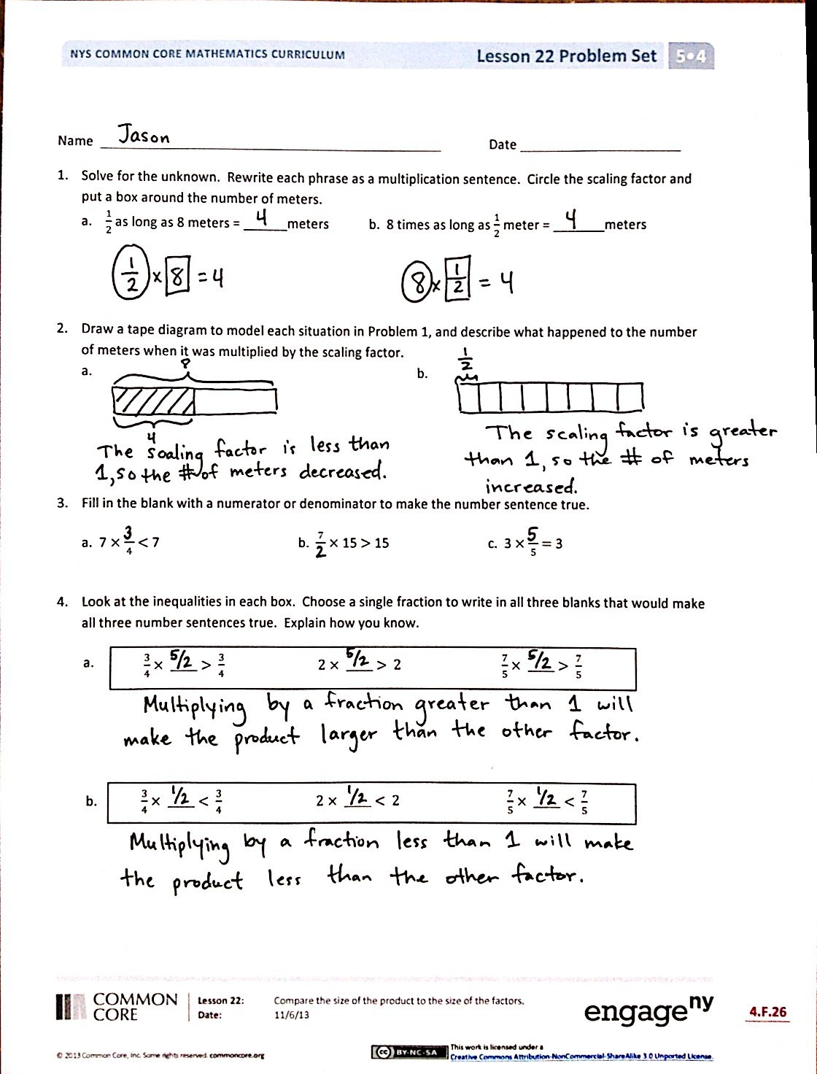
Problem Set (10 minutes)
Students should do their personal best to complete the Problem Set within the allotted 10 minutes. For some classes, it may be appropriate to modify the assignment by specifying which problems they work on first. Some problems do not specify a method for solving. Students should solve these problems using the RDW approach used for Application Problems.
Student Debrief (10 minutes)
Lesson Objective: Compare the size of the product to the size of the factors.
The Student Debrief is intended to invite reflection and active processing of the total lesson experience.
Invite students to review their solutions for the Problem Set. They should check work by comparing answers with a partner before going over answers as a class. Look for misconceptions or misunderstandings that can be addressed in the Debrief. Guide students in a conversation to debrief the Problem Set and process the lesson.
You may choose to use any combination of the questions below to lead the discussion.
- In Problem 1, what relationship did you notice between Parts (a) and (b)?

NOTES ON
MULTIPLE MEANS
OF REPRESENTATION:
Some students may find it helpful to have a physical representation of the tape diagrams as they work to draw these models. Students can use square tiles or unifix cubes. For some students, arranging the manipulatives first, and then drawing may be easier. Additionally, it may eliminate the need to redraw or erase.

- For Problem 2, compare your tape diagrams with a partner. Are your drawings similar to or different from your partner’s?
- Explain to a partner your thought process for solving Problem 3. How did you know what to put for the missing numerator or denominator?
- In Problem 4, did you notice a relationship between Parts (a) and (b)? How did you solve them?
- For Problem 5, did you and your partner use the same examples to support the solution? Can you also give some examples to support the idea that multiplication can make numbers larger?
- What’s the scaling factor in Problem 6? What is an expression to solve this problem?
- How did you solve Problem 7? Share your solution and explain your strategy to a partner.
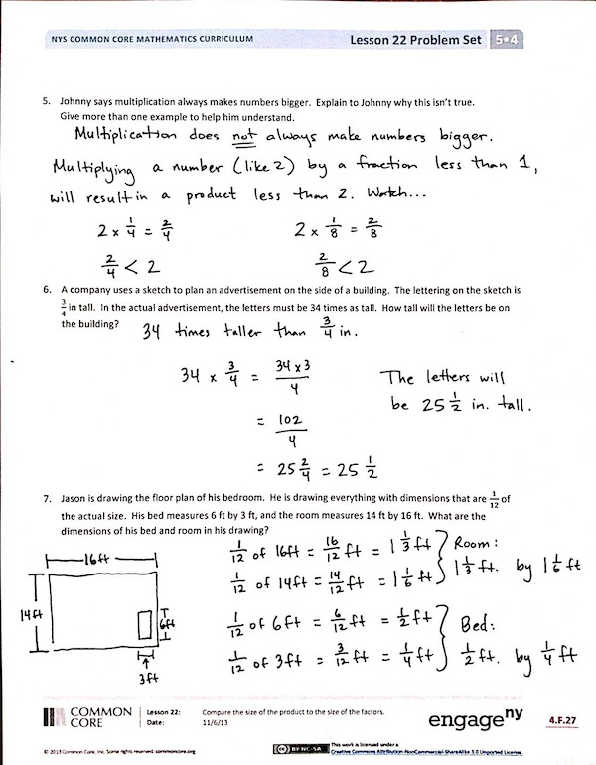
Exit Ticket (3 minutes)
After the Student Debrief, instruct students to complete the Exit Ticket. A review of their work will help you assess the students’ understanding of the concepts that were presented in the lesson today and plan more effectively for future lessons. You may read the questions aloud to the students.

Name Date
- Solve for the unknown. Rewrite each phrase as a multiplication sentence. Circle the scaling factor and put a box around the number of meters.
- $\frac{1}{2}$as long as 8 meters = ______ meters b. 8 times as long as $\frac{1}{2}$ meter = _______ meters

- Draw a tape diagram to model each situation in Problem 1, and describe what happened to the number of meters when it was multiplied by the scaling factor.
- b.

- Fill in the blank with a numerator or denominator to make the number sentence true.
a. 7 $×$ $\frac{}{4}$ $<$ 7 b. $\frac{7}{}$ $×$ 15 $>$ 15 c. 3 $×$ $\frac{}{5}$ $=$ 3

- Look at the inequalities in each box. Choose a single fraction to write in all three blanks that would make all three number sentences true. Explain how you know.
$\frac{3}{4}$ $×$ _____ $>$ $\frac{3}{4}$ $2$ $×$ _____ $>$ $2$ $\frac{7}{5}$ $×$ _____ $>$ $\frac{7}{5}$

b.
a.

$\frac{3}{4}$ $×$ _____ $<$ $\frac{3}{4}$ $2$ $×$ _____ $<$ $2$ $\frac{7}{5}$ $×$ _____ $<$ $\frac{7}{5}$

- Johnny says multiplication always makes numbers bigger. Explain to Johnny why this isn’t true.
Give more than one example to help him understand.

- A company uses a sketch to plan an advertisement on the side of a building. The lettering on the sketch is $\frac{3}{4}$ inch tall. In the actual advertisement, the letters must be 34 times as tall. How tall will the letters be on the building?

- Jason is drawing the floor plan of his bedroom. He is drawing everything with dimensions that are $\frac{1}{12}$ of the actual size. His bed measures 6 ft by 3 ft, and the room measures 14 ft by 16 ft. What are the dimensions of his bed and room in his drawing?

Name Date
Fill in the blank to make the number sentences true. Explain how you know.
a. $\frac{}{3}$ $×$ 11 ˃ 11

b. 5 $×$ $\frac{}{8}$ ˂ 5

c. 6 $×$ $\frac{2}{}$ = 6

Name Date
1. Solve for the unknown. Rewrite each phrase as a multiplication sentence. Circle the scaling factor and put a box around the number of meters.
- $\frac{1}{3}$ as long as 6 meters = ______ meters b. 6 times as long as $\frac{1}{3}$meter = ______ meters

2. Draw a tape diagram to model each situation in Problem 1, and describe what happened to the number of meters when it was multiplied by the scaling factor.
a. b.

- Fill in the blank with a numerator or denominator to make the number sentence true.
a. 5 $×$ $\frac{}{3}$ ˃ 9 b. $\frac{6}{}$ $×$ 12 $˂$ 13 c. 4 $×$ $\frac{}{5}$ $=$ 4

- Look at the inequalities in each box. Choose a single fraction to write in all three blanks that would make all three number sentences true. Explain how you know.

$\frac{2}{3}$ $×$ _____ $>$ $\frac{2}{3}$ $4$ $×$ _____ $>4$ $\frac{5}{3}$ $×$ _____ $>$ $\frac{5}{3}$

a.

b.
$\frac{2}{3}$ $×$ _____ $<$ $\frac{2}{3}$ $4$ $×$ _____ $<$ $4$ $\frac{5}{3}$ $×$ _____ $<$ $\frac{5}{3}$

- Write a number in the blank that will make the number sentence true.

- 3 × _____ ˂ 1

- Explain how multiplying by a whole number can result in a product less than 1.

- In a sketch, a fountain is drawn $\frac{1}{4}$ yard tall. The actual fountain will be 68 times as tall. How tall will the
fountain be?

- In blueprints, an architect’s firm drew everything $\frac{1}{24}$ of the actual size. The windows will actually measure 4 ft by 6 ft and doors measure 12 ft by 8 ft. What are the dimensions of the windows and the doors in the drawing?

