Lesson 15
Objective: Multiply non-unit fractions by non-unit fractions.

Suggested Lesson Structure
 Fluency Practice (12 minutes)
 Application Problem (7 minutes)
 Concept Development (31 minutes)
 Student Debrief (10 minutes)
Total Time (60 minutes)
Fluency Practice (12 minutes)
- Multiply Fractions 5.NF.4 (4 minutes)
- Write Fractions as Decimals 5.NF.3 (4 minutes)
- Convert to Hundredths 4.NF.5 (4 minutes)
Multiply Fractions (4 minutes)
Materials: (S) Personal white board
Note: This fluency activity reviews Lesson 13.
T: (Write $\frac{1}{2}$ of $\frac{1}{3}$.) Say the fraction of a set as a multiplication sentence.
S: $\frac{1}{2}\text{×}$ $\frac{1}{3}$.
T: Draw a rectangle and shade in 1 third.
S: (Draw a rectangle, partition it into 3 equal units, and shade 1 of the units.)
T: To show $\frac{1}{2}$ of $\frac{1}{3}$, how many parts do you need to break the 1 third into?
S: 2.
T: Shade 1 half of 1 third.
S: (Shade 1 of the 2 parts.)
T: How can we name this new unit?
S: Partition the other 2 thirds in half.
T: Show the new units.
S: (Partition the other thirds into 2 equal parts.)
T: How many new units do you have?
S: 6 units.
T: Write the multiplication sentence.
S: (Write $\frac{1}{2}$ × $\frac{1}{3}$ = $\frac{1}{6}$.)
Continue the process with the following possible sequence: $\frac{1}{3}$ of $\frac{3}{4}$ , $\frac{1}{2}$ of $\frac{6}{5}$ , and $\frac{3}{5}$ of $\frac{1}{2}$.
Write Fractions as Decimals (4 minutes)
Note: This fluency activity prepares students for Lessons 17 and 18.
T: (Write $\frac{1}{10}$.) Say the fraction.
S: 1 tenth.
T: Say it as a decimal.
S: Zero point one.
Continue with the following possible suggestions: $\frac{2}{10}$ , $\frac{3}{10}$ , $\frac{9}{10}$ , and $\frac{6}{10}$.
T: (Write $\frac{1}{100}$ = .) Say the fraction.
S: 1 hundredth.
T: Say it as a decimal.
S: Zero point zero one.
Continue with the following possible sequence: $\frac{2}{100}$ , $\frac{8}{100}$ , $\frac{9}{100}$ , $\frac{11}{100}$ , $\frac{17}{100}$ , and $\frac{53}{100}$.
T: (Write 0.01 = .) Say it as a fraction.
S: 1 hundredth.
T: (Write 0.01 = $\frac{1}{100}$.)
Continue with the following possible sequence: 0.02, 0.09, 0.13, and 0.37.
Convert to Hundredths (4 minutes)
Materials: (S) Personal white board
Note: This fluency exercise prepares students for Lessons 17 and 18.
T: (Write $\frac{1}{5}$ = $\frac{}{100}$.) Write the equivalent fraction.
S: (Write $\frac{1}{5}$ = $\frac{20}{100}$.)
T: (Write $\frac{1}{5}$ = $\frac{20}{100}$ = .) Write 1 fifth as a decimal.
S: (Write $\frac{1}{5}$ = $\frac{20}{100}$ = 0.2.)
Continue with the following possible sequence: $\frac{2}{5}$ , $\frac{4}{5}$, $\frac{1}{50}$, $\frac{9}{50}$, $\frac{11}{50}$, $\frac{1}{4}$, $\frac{3}{4}$, $\frac{1}{25}$, $\frac{2}{25}$, $\frac{7}{25}$, and $\frac{12}{25}$.

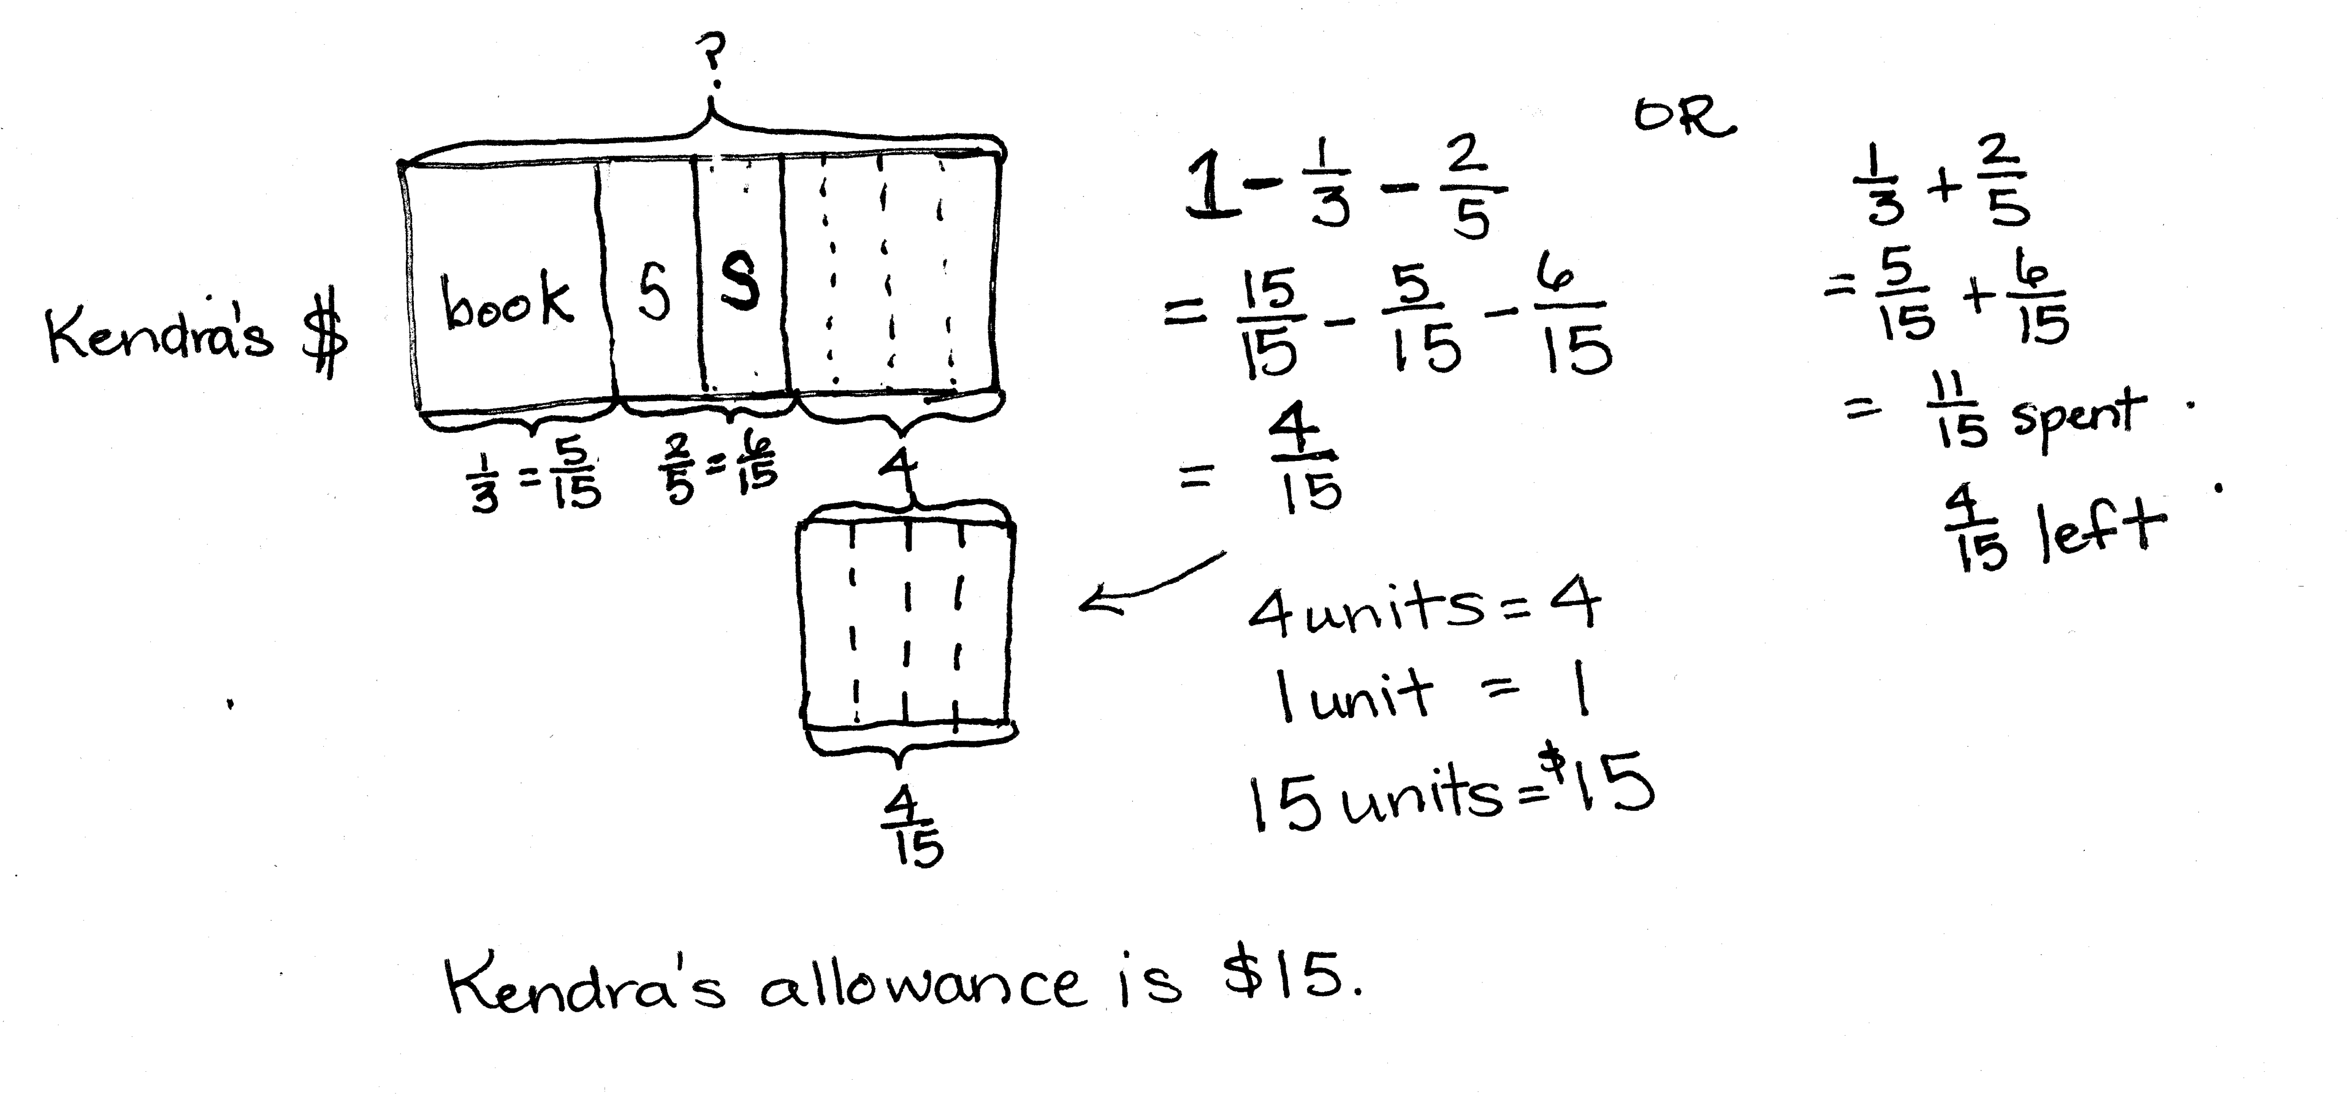
Application Problem (7 minutes)
Kendra spent $\frac{1}{3}$ of her allowance on a book and $\frac{2}{5}$ on a snack. If she had four dollars remaining after purchasing a book and snack, what was the total amount of her allowance?
Note: This problem reaches back to addition and subtraction of fractions, as well as fraction of a set. Keeping these skills fresh is an important goal of Application Problems.
Concept Development (31 minutes)
Materials: (S) Personal white board
NOTES ON
MULTIPLE MEANS
OF REPRESENTATION:
Notice the dotted lines in the area model shown below.
If this were an actual pan partially full of brownies, the empty part of the pan would obviously not be cut! However, to name the unit represented by the double-shaded parts, the whole pan must show the same size or type of unit. Therefore, the empty part of the pan must also be partitioned as illustrated by the dotted lines.
Problem 1: $\frac{2}{3}$ of $\frac{3}{4}$
T: (Post Problem 1 on the board.) How is this problem different from the problems we did yesterday? Turn and talk.
S: In every problem we did yesterday, one factor had a numerator of 1. There are no numerators that are ones today. Every problem multiplied a unit fraction by a non-unit fraction, or a non-unit fraction by a unit fraction. This is two non-unit fractions.
T: (Write $\frac{1}{3}$ of 3 fourths.) What is 1 third of 3 fourths?
S: 1 fourth.
T: If 1 third of 3 fourths is 1 fourth, what is 2 thirds of 3 fourths? Discuss with your partner.
S: 2 thirds would just be double 1 third, so it would be 2 fourths. 3 fourths is 3 equal parts, so $\frac{1}{3}$ of that would be 1 part or 1 fourth. We want $\frac{2}{3}$ this time, so that is 2 parts, or 2 fourths.
T: Name 2 fourths using halves.
S: 1 half.
T: So, 2 thirds of 3 fourths is 1 half. Let’s draw a rectangular fraction model to show the product and check our thinking.
T: I’ll draw it on the board, and you’ll draw it on your personal white board. Let’s draw 3 fourths and label it on the bottom. (Draw a rectangle and cut it vertically into 4 units, and shade in 3 units.)
T: (Point to the 3 shaded units.) We now have to take 2 thirds of these 3 shaded units. What do I have to do? Turn and talk.
S: Cut each unit into thirds. Cut it across into 3 equal parts, and shade in 2 parts.
T: Let’s do that now. (Partition horizontally into thirds, shade in 2 thirds, and label.)
T: (Point to the whole rectangle.) What unit have we used to rename our whole?
S: Twelfths.
T: (Point to the 6 double-shaded units.) How many twelfths are double-shaded when we took $\frac{2}{3}$ of $\frac{3}{4}$?
S: 6 twelfths.
T: Compare our model to the product we thought about. Do they represent the same product or have we made a mistake? Turn and talk.
S: The units are different, but the answer is the same. 2 fourths and 6 twelfths are both names for 1 half. When we thought about it, we knew it would be 2 fourths. In the rectangular fraction model, there are 12 parts, and we shaded 6 of them. That’s half.
T: Both of our approaches show that 2 thirds of 3 fourths is what simplified fraction?
S: $\frac{1}{2}$.
T: Let’s write this problem as a multiplication sentence. (Write $\frac{2}{3}\text{×}\frac{3}{4}\text{=}\frac{6}{12}$ on the board.) Turn and talk to your partner about the patterns you notice.
S: If you multiply the numerators, you get 6, and for the denominators, you get 12. That’s 6 twelfths, just like the rectangular fraction model. It’s easy to solve a fraction of a fraction problem. Just multiply the top numbers to get the numerator, and the bottom numbers to get the denominator. Sometimes you can simplify.
T: So, the product of the denominators tells us the total number of units—12 (point to the model). The product of the numerators tells us the total number of units selected—6 (point to the model).
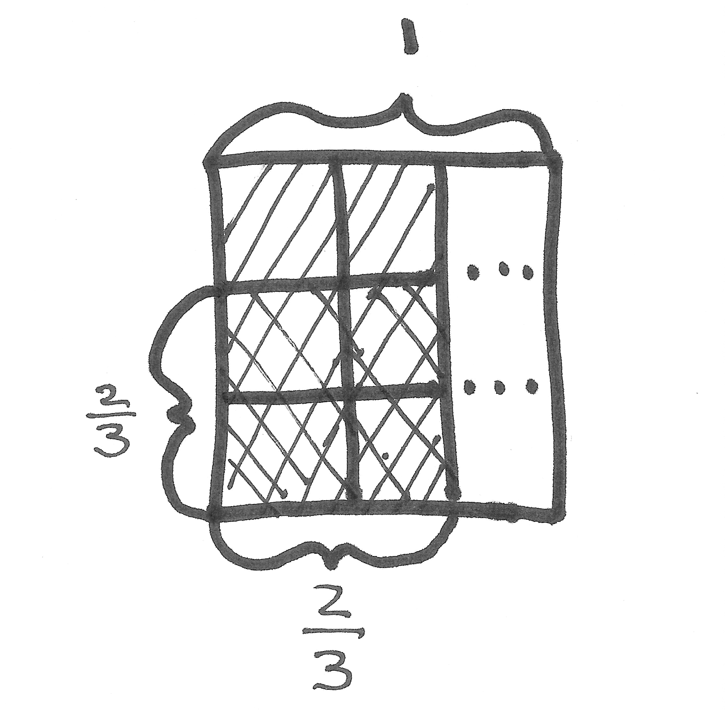
Problem 2: $\frac{2}{3}\text{×}\frac{2}{3}$
T: (Post Problem 2 on the board.) Let’s solve 2 thirds of 2 thirds by drawing a rectangular fraction model, and then write a multiplication sentence.
S: (Work.)
T: Talk to your partner about whether the patterns are the same as the previous problem.
S: (Share.)
T: What patterns do you see between this problem and the last problem?
S: This problem has the same pattern as the previous problem. When you multiply the numerators, you get the numerator of the double-shaded part. When you multiply the denominators, you get the denominator of the double-shaded part. It’s pretty cool! The denominator of the product gives the area of the whole rectangle (3 by 3), and the numerator of the product gives the area of the double-shaded part (2 by 2).
T: Yes, we see from the model that the product of the denominators tells us the total number of units—9. The product of the numerator tells us the total number of units selected—4.

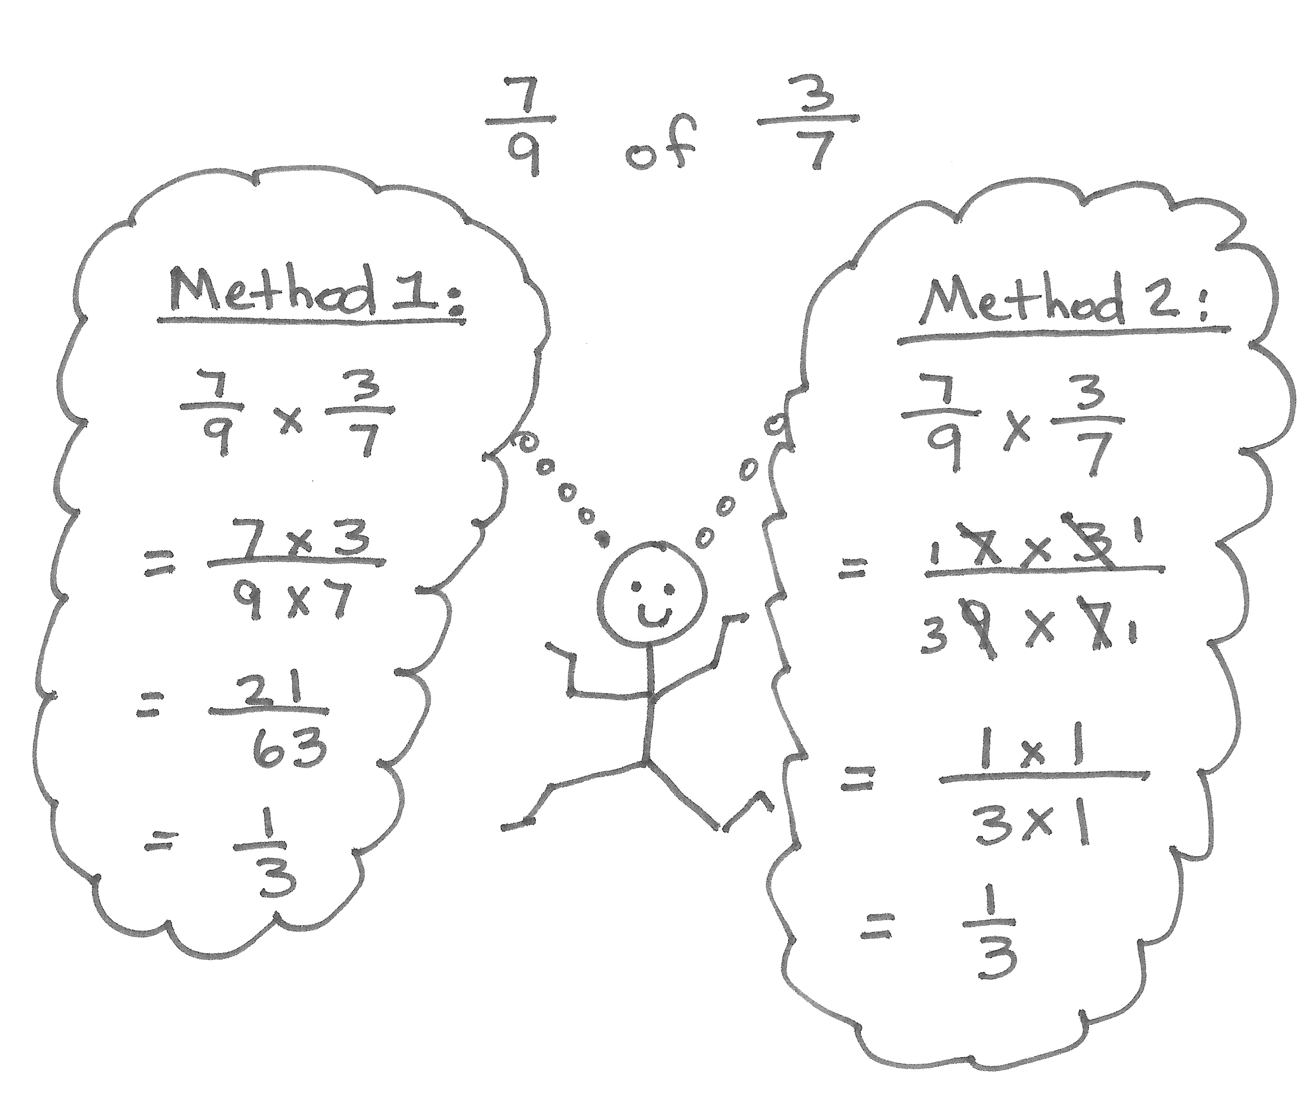
Problem 3: a. $\frac{7}{9}$ of $\frac{3}{7}$ b. $\frac{3}{10}$ $\text{×}$ $\frac{5}{9}$ c. $\frac{5}{8}$ $\text{×}$ $\frac{4}{15}$

T: (Post Problem 3(a) on the board.) How would this problem look if we drew a rectangular fraction model for it? Discuss with your partner.
S: We’d have to draw 3 sevenths first, and then split each seventh into ninths. We’d end up with a model showing sixty-thirds. It would be really hard to draw.
T: You are right. It’s not really practical to draw a rectangular fraction model for a problem like this because the units are so small. Could the pattern that we’ve noticed in the multiplication sentences help us? Turn and talk.
S: $\frac{7}{9}$of $\frac{3}{7}$ is the same as $\frac{7}{9}\text{×}$ $\frac{3}{7}$. Our pattern lets us just multiply the numerators and the denominators. We can multiply and get 21 as the numerator, and 63 as the denominator. Then, we can simplify and get 1 third.
T: Let me write what I hear you saying. (Write $\frac{7}{9}\text{×}$ $\frac{3}{7}$ = $\frac{7 × 3}{9 × 7}\text{=}\frac{21}{63}$ on the board.)
T: What’s the simplest form for $\frac{21}{63}$? Solve it on your personal white board.
S: $\frac{1}{3}$.
T: Let’s use another strategy we learned recently and rename this fraction using larger units before we multiply. (Point to $\frac{7 × 3}{9 × 7}$.) Look for factors that are shared by the numerator and denominator. Turn and talk.
S: There’s a 7 in both the numerator and denominator. The numerator and denominator have a common factor of 7. I know the 3 in the numerator can be divided by 3 to get 1, and the 9 in the denominator can be divided by 3 to get 3. 7 divided by 7 is 1, so both sevens change to ones. The factors of 3 and 9 can both be divided by 3 and changed to 1 and 3.
T: We can rename this fraction by dividing both the numerators and denominators by common factors. 7 divided by 7 is 1 in both the numerator and denominator. (Cross out both sevens and write ones next to them.) 3 divided by 3 is 1 in the numerator, and 9 divided by 3 is 3 in the denominator. (Cross out the 3 and 9 and write 1 and 3, respectively, next to them.)
T: What does the numerator show now?
S: 1 $\text{×}$ 1.
T: What’s the denominator?
S: 3 $\text{×}$ 1.
T: Now, multiply. What is $\frac{7}{9}$of $\frac{3}{7}$ equal to?
S: $\frac{1}{3}$.
T: Look at the two strategies. Which one do you think is easier and more efficient to use? Turn and talk.
S: The first strategy of simplifying $\frac{21}{63}$ after I multiply is a little bit harder because I have to find the common factors between 21 and 63. Simplifying first is a little easier. Before I multiply, the numbers are a little smaller, so it’s easier to see common factors. Also, when I simplify first, the numbers I have to multiply are smaller, and my product is already expressed using the largest unit.
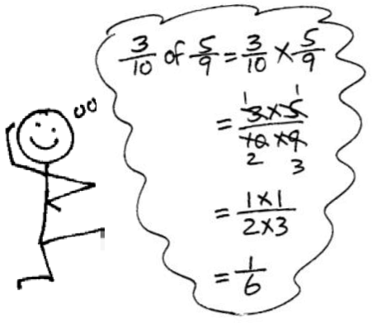
T: (Post Problem 3(b) on the board.) Let’s practice using the strategy of simplifying first before we multiply. Work with a partner and solve. Remember, we are looking for common factors before we multiply. (Allow students time to work and share their answers.)
T: What is $\frac{3}{10}$ of $\frac{5}{9}$?
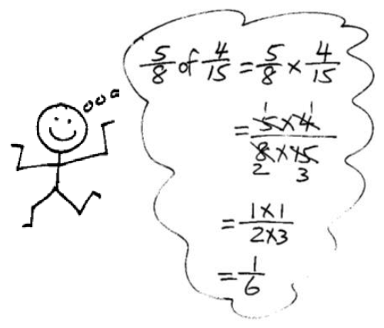
S: $\frac{1}{6}$.
T: Let’s confirm that by multiplying first, and then simplifying.
S: (Rework the problem to find $\frac{3}{10}\text{×}\frac{5}{9}\text{=}\frac{15}{90}\text{=}\frac{1}{6}$.)
T: (Post Problem 3(c) on the board.) Solve independently. (Allow students time to solve the problem.)
T: What is $\frac{5}{8}$ of $\frac{4}{15}$?
S: $\frac{1}{6}$.
Problem 4
Nigel completes $\frac{3}{7}$ of his homework immediately after school and $\frac{1}{4}$ of the remaining homework before supper. He finishes the rest after dessert. What fraction of his work did he finish after dessert?
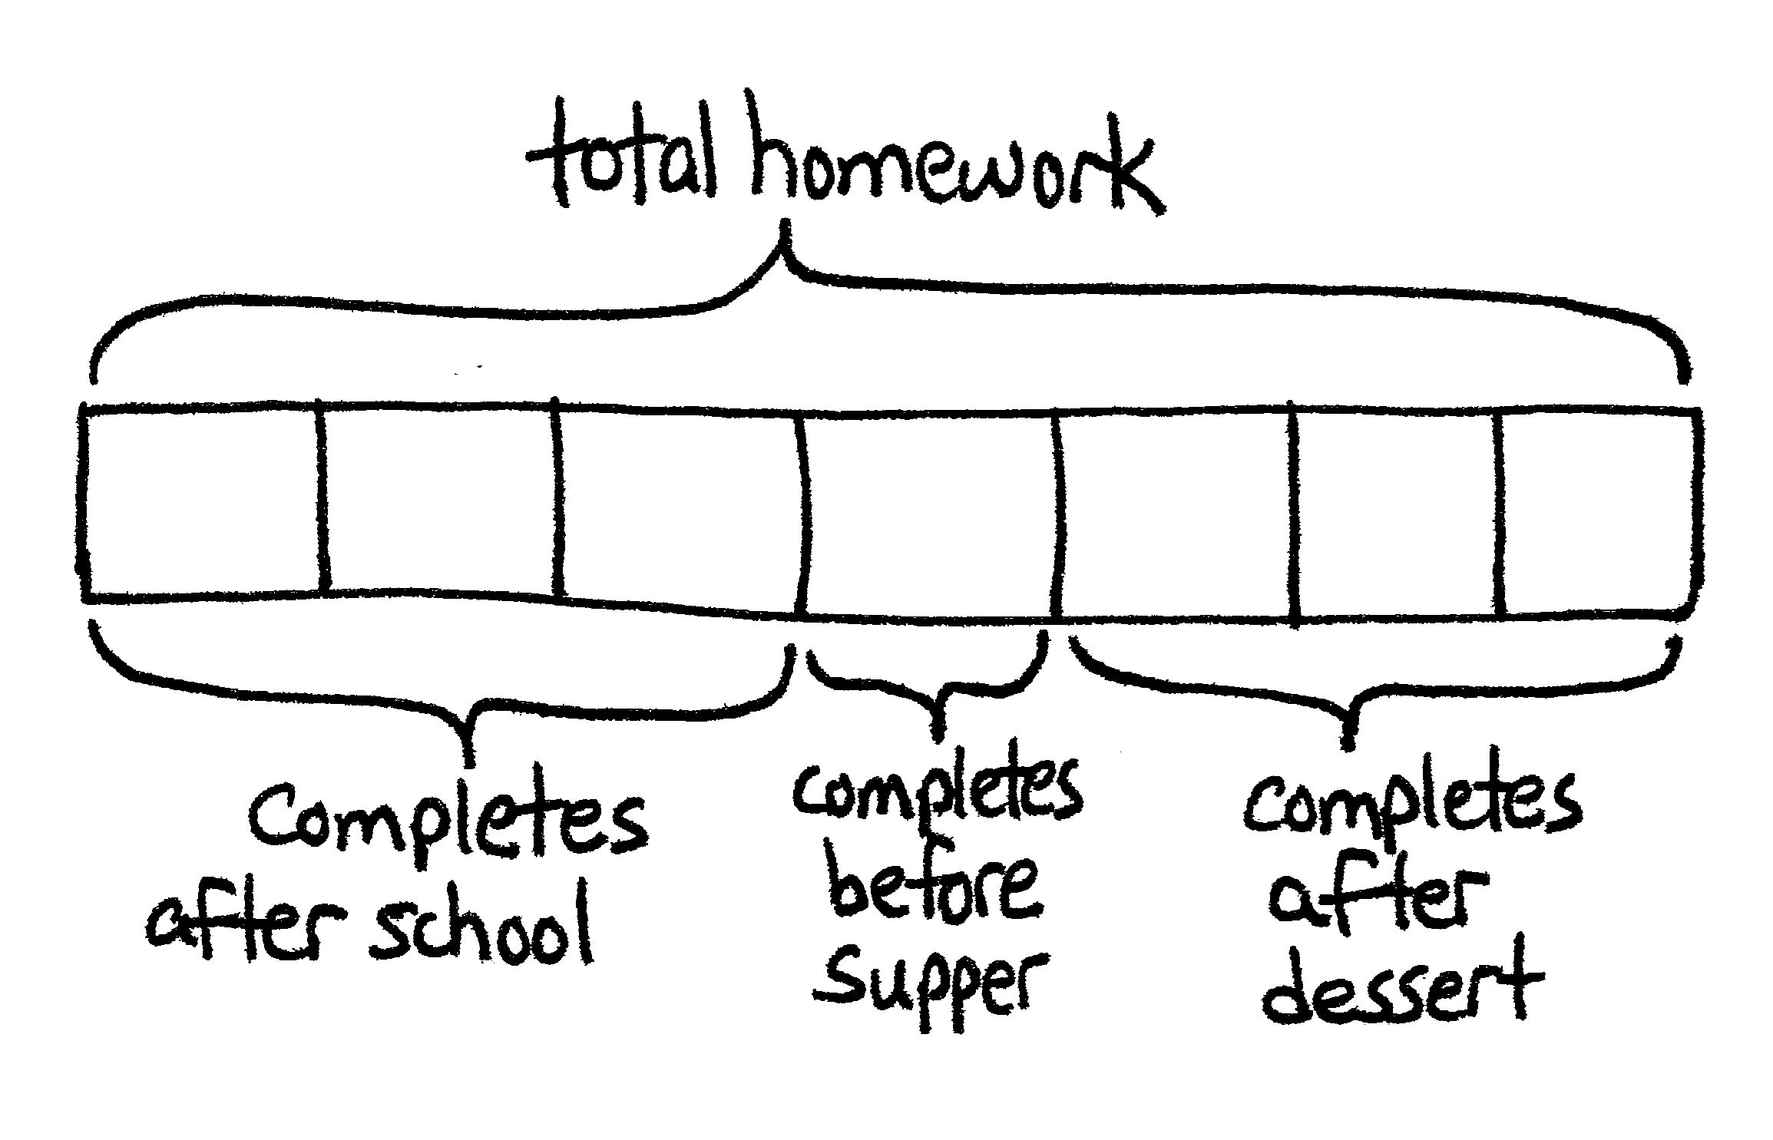
T: (Post the problem on the board, and read it aloud with students.) Let’s solve using a tape diagram.
S/T: (Draw a tape diagram and label it total homework.)
T: What fraction of his homework does Nigel finish immediately after school?
S: $\frac{3}{7}$.
T: (Partition diagram into sevenths and label 3 of them completes after school.) What fraction of the homework does Nigel have remaining?
S: $\frac{4}{7}$.
T: What fraction of the remaining homework does Nigel finish before supper?
S: One-fourth of the remaining homework.
T: Nigel completes $\frac{1}{4}$of $\text{4}$ sevenths before supper. (Point to the remaining 4 units on the tape diagram.) What’s $\frac{1}{4}$ of these 4 units?
S: 1 unit.
NOTES ON
MULTIPLE MEANS
OF REPRESENTATION:
In these examples, students are simplifying the fractional factors before they multiply. This step may eliminate the need to simplify the product, or make simplifying the product easier.
To help struggling students understand this procedure, it may help to use the commutative property to reverse the order of the factors. The following is an example:
$$\frac{3 × 4}{4 × 7}=\frac{4 × 3}{4 × 7}$$
In this example, students may now more readily see that $\frac{4}{4}$ is equivalent to $\frac{1}{1}$, and can be simplified before multiplying.
T: Then, what’s $\frac{1}{4}$ of 4 sevenths? (Write $\frac{1}{4}$ of 4 sevenths
= _____ sevenths on the board.)
S: 1 seventh. (Label 1 seventh of the diagram completes before supper.)
T: When does Nigel finish the rest? (Point to the remaining units.)
S: After dessert. (Label the remaining $\frac{3}{7}$ completes after dessert.)
T: Answer the question with a complete sentence.
S: Nigel completes $\frac{3}{7}$ of his homework after dessert.
T: Let’s imagine that Nigel spent 70 minutes to complete all of his homework. Where would I place that information in the model?
S: Put 70 minutes above the diagram. We just found out the whole, so we can label it above the tape diagram.
T: How could I find the number of minutes he worked on homework after dessert? Discuss with your partner, and then solve.
S: He finished $\frac{4}{7}$ already, so we can find $\frac{4}{7}$of 70 minutes, and then just subtract that from 70 to find how long he spent after dessert. It’s a fraction of a set. He does $\frac{3}{7}$ of his homework after dessert. We can multiply to find $\frac{3}{7}$ of 70. That’ll be how long he worked after dessert. We can first find the total minutes he spent after school by solving $\frac{3}{7}$ of 70. Then, we know each unit is 10 minutes. We find what one unit is equal to, which is 10 minutes. Then, we know the time he spent after dessert is 3 units. 10 times 3 = 30 minutes.
T: Use your work to answer the question.
S: Nigel spends 30 minutes working after dessert.

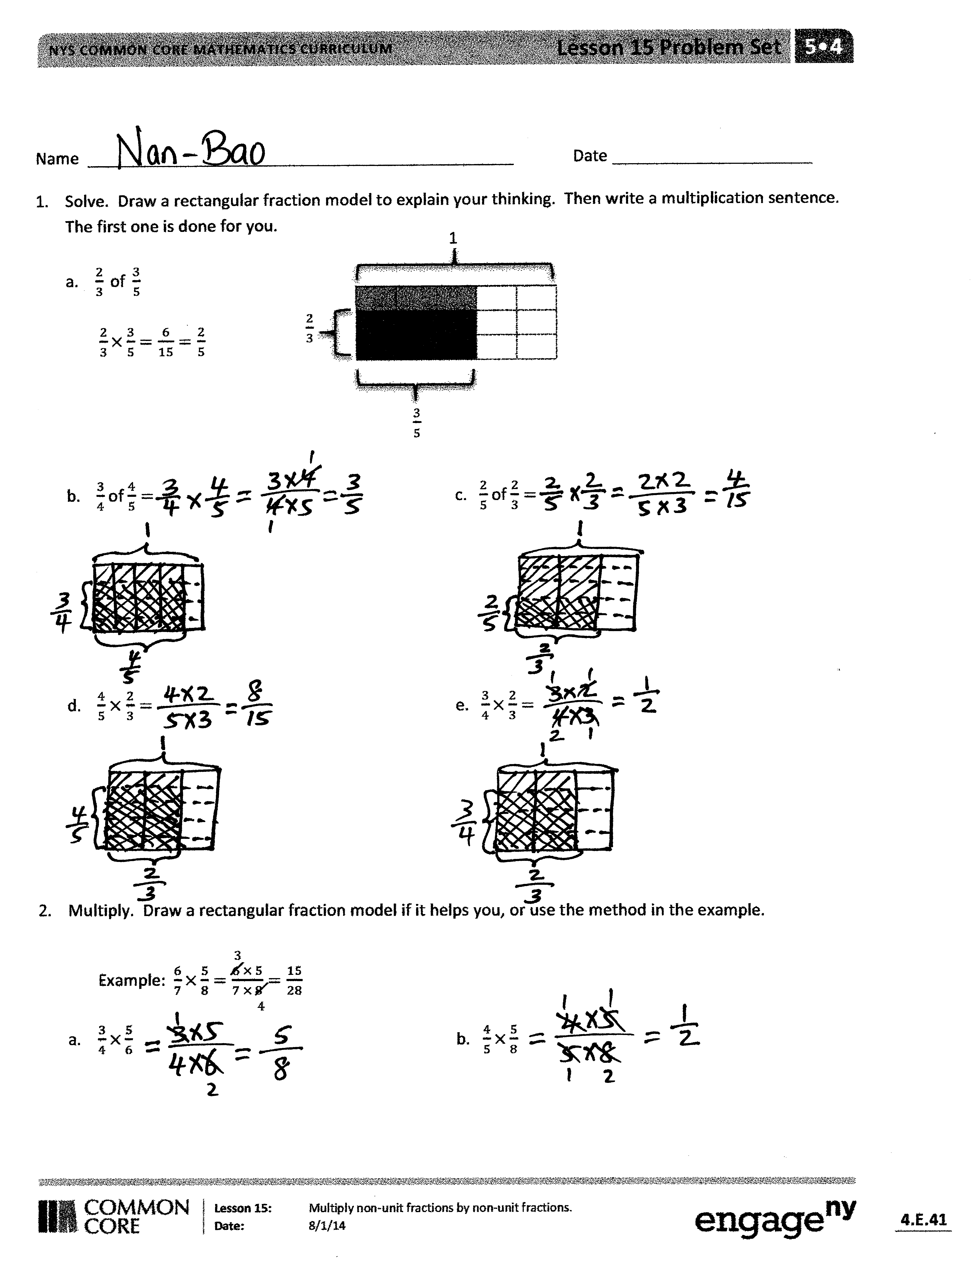
Problem Set (10 minutes)
Students should do their personal best to complete the Problem Set within the allotted 10 minutes. For some classes, it may be appropriate to modify the assignment by specifying which problems they work on first. Some problems do not specify a method for solving. Students should solve these problems using the RDW approach used for Application Problems.
Student Debrief (10 minutes)
Lesson Objective: Multiply non-unit fractions by non-unit fractions.
The Student Debrief is intended to invite reflection and active processing of the total lesson experience.
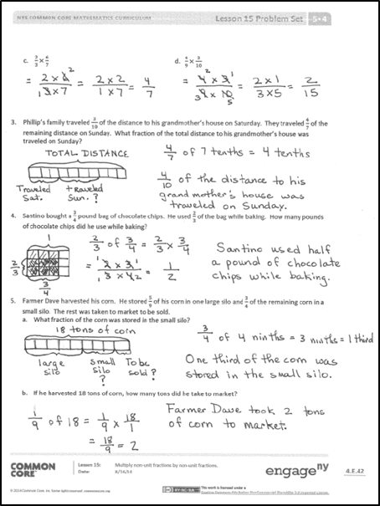
Invite students to review their solutions for the Problem Set. They should check work by comparing answers with a partner before going over answers as a class. Look for misconceptions or misunderstandings that can be addressed in the Debrief. Guide students in a conversation to debrief the Problem Set and process the lesson.
You may choose to use any combination of the questions below to lead the discussion.
- What is the relationship between Parts (c) and (d) of Problem 1? (Part (d) is double Part (c).)
- In Problem 2, how are Parts (b) and (d) different from Parts (a) and (c)? (Parts (b) and (d) each have two common factors.)
- Compare the picture you drew for Problem 3 with a partner. Explain your solution.
- In Problem 5, how is the information in the answer to Part (a) different from the information in the answer to Part (b)? What are the different approaches to solving, and is there one strategy that is more efficient than the others? (Using fraction of a set might be more efficient than subtraction.) Explain your strategy to a partner.

Exit Ticket (3 minutes)
After the Student Debrief, instruct students to complete the Exit Ticket. A review of their work will help you assess the students’ understanding of the concepts that were presented in the lesson today and plan more effectively for future lessons. You may read the questions aloud to the students.

Name Date
- Solve. Draw a rectangular fraction model to explain your thinking. Then, write a multiplication sentence. The first one is done for you.

1
$\frac{2}{3}$
$\frac{3}{5}$

- $\frac{2}{3} \text{of} \frac{3}{5}$

$\frac{2}{3}×\frac{3}{5}=\frac{6}{15}=\frac{2}{5}$

- $\frac{3}{4}$ of $\frac{4}{5}=$ c. $\frac{2}{5}$ of $\frac{2}{3}=$

- $\frac{4}{5}$ $×$ $\frac{2}{3}=$ e. $\frac{3}{4}×\frac{2}{3}=$

- Multiply. Draw a rectangular fraction model if it helps you, or use the method in the example.
4
3
Example: $\frac{6}{7}×\frac{5}{8}=\frac{6 × 5}{7 × 8}=\frac{15}{28}$

- $\frac{3}{4}×\frac{5}{6}$ b. $\frac{4}{5}×\frac{5}{8}$

- $\frac{2}{3}×\frac{6}{7}$ d. $\frac{4}{9}×\frac{3}{10}$

- Phillip’s family traveled $\frac{3}{10}$ of the distance to his grandmother’s house on Saturday. They traveled $\frac{4}{7}$ of the remaining distance on Sunday. What fraction of the total distance to his grandmother’s house was traveled on Sunday?

- Santino bought a $\frac{3}{4}$ pound bag of chocolate chips. He used $\frac{2}{3}$ of the bag while baking. How many pounds of chocolate chips did he use while baking?

- Farmer Dave harvested his corn. He stored $\frac{5}{9}$ of his corn in one large silo and $\frac{3}{4}$ of the remaining corn in a small silo. The rest was taken to market to be sold.
  - What fraction of the corn was stored in the small silo?

  - If he harvested 18 tons of corn, how many tons did he take to market?

Name Date
- Solve. Draw a rectangular fraction model to explain your thinking. Then, write a multiplication sentence.

- $\frac{2}{3}$ of $\frac{3}{5}=$

- $\frac{4}{9}$ × $\frac{3}{8}=$

- A newspaper’s cover page is $\frac{3}{8}$ text and photographs fill the rest. If $\frac{2}{5}$ of the text is an article about endangered species, what fraction of the cover page is the article about endangered species?

Name Date
  - Solve. Draw a rectangular fraction model to explain your thinking. Then, write a multiplication sentence.
- $\frac{2}{3}$ of $\frac{3}{4}=$ b. $\frac{2}{5}$ of $\frac{3}{4}=$

- $\frac{2}{5}$ of $\frac{4}{5}=$ d. $\frac{4}{5}$ of $\frac{3}{4}=$

- Multiply. Draw a rectangular fraction model if it helps you.

- $\frac{5}{6}$ ×$\frac{3}{10}$ b. $\frac{3}{4}$ × $\frac{4}{5}$

- $\frac{5}{6}$ × $\frac{5}{8}$ d. $\frac{3}{4}$ × $\frac{5}{12}$

- $\frac{8}{9}$ × $\frac{2}{3}$ f. $\frac{3}{7}$ × $\frac{2}{9}$

- Every morning, Halle goes to school with a 1 liter bottle of water. She drinks $\frac{1}{4}$ of the bottle before school starts and $\frac{2}{3}$ of the rest before lunch.
- What fraction of the bottle does Halle drink after school starts, but before lunch?

- How many milliliters are left in the bottle at lunch?

- Moussa delivered $\frac{3}{8}$ of the newspapers on his route in the first hour and $\frac{4}{5}$ of the rest in the second hour. What fraction of the newspapers did Moussa deliver in the second hour?

- Rose bought some spinach. She used $\frac{3}{5}$ of the spinach on a pan of spinach pie for a party, and $\frac{3}{4}$ of the remaining spinach for a pan for her family. She used the rest of the spinach to make a salad.
- What fraction of the spinach did she use to make the salad?

- If Rose used 3 pounds of spinach to make the pan of spinach pie for the party, how many pounds of spinach did Rose use to make the salad?

