Lesson 24: Applications of Systems of Equations and Inequalities

Classwork
Opening Exercise
In Lewis Carroll’s Through the Looking Glass, Tweedledum says, “The sum of your weight and twice mine is $361$pounds.” Tweedledee replies, “The sum of your weight and twice mine is $362$ pounds.” Find both of their weights.

Example 1
Lulu tells her little brother, Jack, that she is holding $20$ coins all of which are dimes and quarters. They have a value of $\$4.10$. She says she will give him the coins if he can tell her how many of each she is holding. Solve this problem for Jack.

Exploratory Challenge
  - At a state fair, there is a game where you throw a ball at a pyramid of cans. If you knock over all of the cans, you win a prize. The cost is $3$ throws for $\$1$, but if have you an armband, you get $6$ throws for $\$1$. The armband costs $\$10$.
    - Write two cost equations for the game in terms of the number of throws purchased, one without an armband and one with.

    - Graph the two cost equations on the same graph. Be sure to label the axes and show an appropriate scale.

    - Does it make sense to buy the armband?
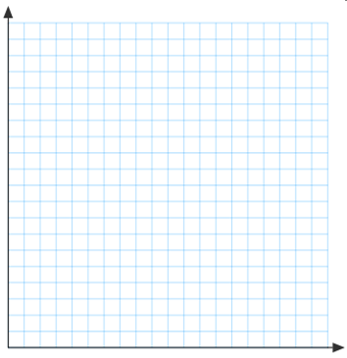

  - A clothing manufacturer has $1,000$ yd. of cotton to make shirts and pajamas. A shirt requires $1$ yd. of fabric, and a pair of pajamas requires $2$ yd. of fabric. It takes 2 hr. to make a shirt and $3$ hr. to make the pajamas, and there are $1,600$ hr. available to make the clothing.
    - What are the variables?

    - What are the constraints?

    - Write inequalities for the constraints.

    - Graph the inequalities and shade the solution set.

    - What does the shaded region represent?

    - Suppose the manufacturer makes a profit of $\$10$ on shirts and$\$18$ on pajamas. How would it decide how many of each to make?

    - How many of each should the manufacturer make, assuming he will sell all the shirts and pajamas he makes?
Problem Set

- Find two numbers such that the sum of the first and three times the second is $5$and the sum of second and two times the first is $8$.

- A chemist has two solutions: a $50\%$ methane solution and an $80\%$ methane solution. He wants $100$ ml of a $70\%$methane solution. How many ml of each solution does he need to mix?

- Pam has two part time jobs. At one job, she works as a cashier and makes $\$8$ per hour. At the second job, she works as a tutor and makes $\$12$ per hour. One week she worked $30$ hours and made $\$268$. How many hours did she spend at each job?

- A store sells Brazilian coffee for $\$10$ per lb. and Columbian coffee for $\$14$ per lb. If the store decides to make a $150$-lb. blend of the two and sell it for $\$11$ per lb., how much of each type of coffee should be used?

- A potter is making cups and plates. It takes her $6$min. to make a cup and $3$ min. to make a plate. Each cup uses $\frac{3}{4}$ lb. of clay, and each plate uses $1$ lb. of clay. She has $20$ hr. available to make the cups and plates and has $250$ lb. of clay.
  - What are the variables?
  - Write inequalities for the constraints.
  - Graph and shade the solution set.
  - If she makes a profit of $\$2$ on each cup and $\$1.50$ on each plate, how many of each should she make in order to maximize her profit?
  - What is her maximum profit?

