Lesson 21: Solution Sets to Inequalities with Two Variables

Classwork
Exercise 1
  - Circle each ordered pair $(x,y)$that is a solution to the equation $4x-y≤10$.

    - $\left(3,2\right)$ $\left(2, 3\right)$ $\left(-1,-14\right)$ $\left(0,0\right)$ $\left(1,-6\right)$

    - $\left(5,10\right)$ $\left(0, -10\right)$ $\left(3,4\right)$ $\left(6,0\right)$ $\left(4,-1\right)$

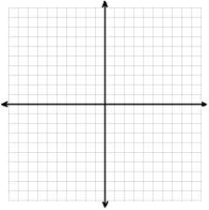

  - Plot each solution as a point $(x,y)$ in the coordinate plane.

  - How would you describe the location of the solutions in the coordinate plane?

Exercise 2
  - Discover as many additional solutions to the inequality $4x-y≤10$ as possible. Organize your solutions by plotting each solution as a point $(x,y)$ in the coordinate plane. Be prepared to share the strategies used to find your solutions.

  - Graph the line $y=4x-10$. What do you notice about the solutions to the inequality $4x-y≤10$ and the graph of the line $y=4x-10$?

  - Solve the inequality for $y$.

  - Complete the following sentence:
If an ordered pair is a solution to $4x-y≤10,$then it will be located

the line $y=4x-10$.

Explain how you arrived at your conclusion.

Example 1
The solution to $x+y=20$ is shown on the graph below.
- Graph the solution to $x+y≤20$.  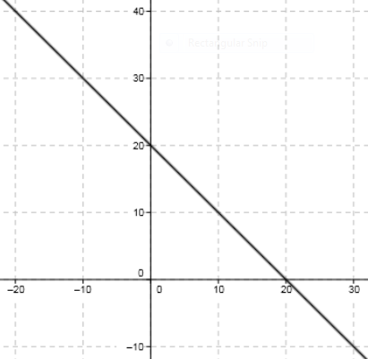  - Graph the solution to $x+y≥20$. | - Graph the solution to $x+y<20$.  - Graph the solution to $x+y>20$.

Exercises 3–5
- Using a separate sheet of graph paper, plot the solution sets to the following equations and inequalities:
- $x-y=10$  - $x-y<10$  - $y>x-10$  - $y≥x$  - $x≥y$ | - $y=5$  - $y<5$  - $x≥5$  - $y≠1$  - $x=0$ | - $x>0$  - $y<0$  - $x^{2}-y=0$  - $x^{2}+y^{2}>0$  - $xy≤0$

Which of the inequalities in this exercise are linear inequalities?

A half-plane is the graph of a solution set in the Cartesian coordinate plane of an inequality in two real number variables that is linear and strict.

- Describe in words the half-plane that is the solution to each inequality.
  - $y≥0$

  - $x<-5$

  - $y≥2x-5$

  - $y<2x-5$

- Graph the solution set to $x<-5$, reading it as an inequality in one variable, and describe the solution set in words. Then graph the solution set to $x<-5$ again, this time reading it as an inequality in two variables, and describe the solution set in words.

Lesson Summary
An ordered pair is a solution to a two-variable inequality if, when each number is substituted into its corresponding variable, it makes the inequality a true number sentence.
Each ordered pair of numbers in the solution set of the inequality corresponds to a point on the coordinate plane. The set of all such points in the coordinate plane is called the graph of the inequality.
The graph of a linear inequality in the coordinate plane is called a half-plane.

Problem Set

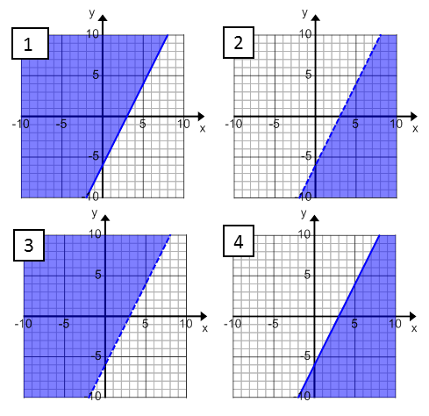
- Match each inequality with its graph. Explain your reasoning.

  - $2x-y>6$

  - $y≤2x-6$

  - $2x<y+6$

  - $2x-6≤y$

- Graph the solution set in the coordinate plane. Support your answer by selecting two ordered pairs in the solution set and verifying that they make the inequality true.
- $-10x+y>25$ | - $-6≤y$ | - $y≤-7.5x+15$
- $2x-8y≤24$ | - $3x<y$ | - $2x>0$

- Marti sells tacos and burritos from a food truck at the farmers market. She sells burritos for$\$3.50$ each and tacos for $\$2.00$ each. She hopes to earn at least $\$120$ at the farmers market this Saturday.
  - Identify three combinations of tacos and burritos that will earn Marti more than $\$120$.
  - Identify three combinations of tacos and burritos that will earn Marti exactly $\$120$.
  - Identify three combinations of tacos and burritos that will not earn Marti at least $\$120$.
  - Graph your answers to parts (a–c) in the coordinate plane and then shade a half-plane that contains all possible solutions to this problem.
  - Create a linear inequality that represents the solution to this problem. Let $x$ equal the number of burritos that Marti sells, and let $y$ equal the number of tacos that Marti sells.
  - Are the points $(10, 49.5)$ a solution to inequality you created in part (e)? Explain your reasoning.

