Table of Contents
GRADE 4 • MODULE 7
Exploring Measurement with Multiplication

Module Overview i

Topic A: Measurement Conversion Tables 7.A.1

Topic B: Problem Solving with Measurement 7.B.1

Topic C: Investigation of Measurements Expressed as Mixed Numbers 7.C.1

Topic D: Year in Review 7.D.1

Module Assessment 7.S.1

NOTE: Student sheets should be printed at 100% scale to preserve the intended size of figures for accurate measurements. Adjust your copier or printer settings to actual size and set page scaling to none.

Grade 4 • Module 7
Exploring Measurement with Multiplication

OVERVIEW
In this module, students build their competencies in measurement as they relate multiplication to the conversion of measurement units. Throughout the module, students will explore multiple strategies for solving measurement problems involving unit conversion.
In Topic A, students build on the work they did in Module 2 with measurement conversions. Working heavily in customary units, students use two-column conversion tables (4.MD.1) to practice conversion rates. For example, following a discovery activity where students learn that 16 ounces make 1 pound, students generate a two-column conversion table listing the number of ounces in 1 to 10 pounds. Tables for other measurement units are then generated in a similar fashion. Students then reason about why they do not need to complete the tables beyond 10 of the larger units. They use their multiplication skills from Module 3 to complete the tables and are able to see and explain connections such as (13 × 16) = (10 × 16) + (3 × 16). One student could reason, for example, that “Since the table shows that there are 160 ounces in 10 pounds and 48 ounces in 3 pounds, I can add them together to tell that there are 208 ounces in 13 pounds.” Another student might reason, “Since there are 16 ounces in each pound, I can use the rule of the table and multiply 13 pounds by 16 to find that there are 208 ounces in 13 pounds.”
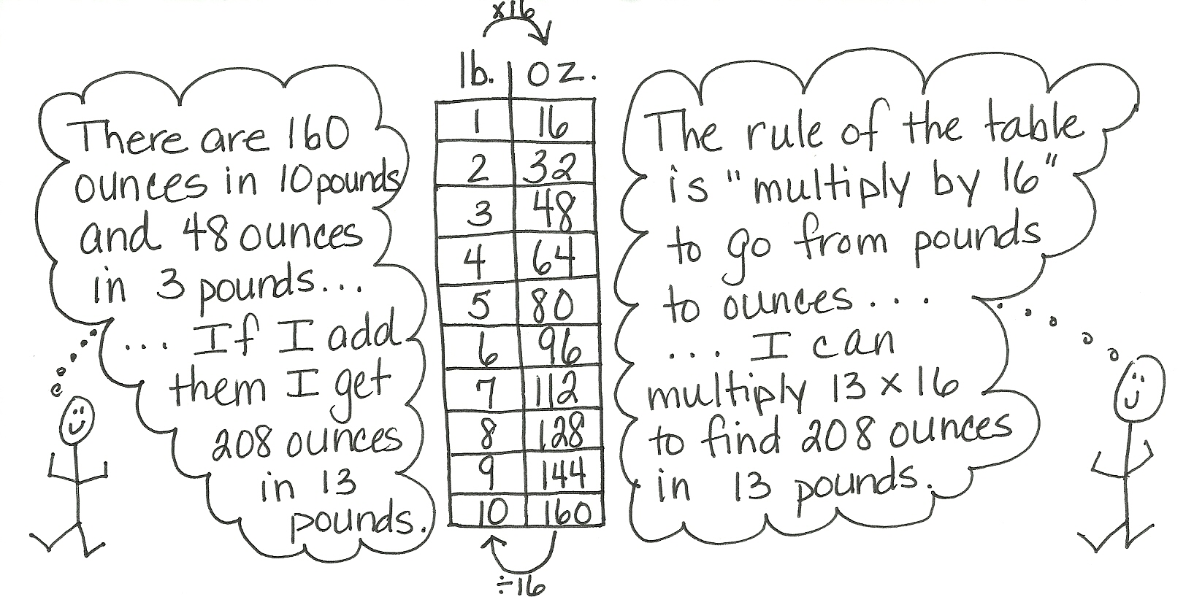

As the topic progresses, students solve multiplicative comparison word problems. They are then challenged to create and solve their own word problems and to critique the reasoning of their peers (4.OA.1, 4.OA.2). They share their solution strategies and original problems within small groups, as well as share and critique the problem solving strategies used by their peers. Through the use of guided questions, students discuss not only how the problems were solved, but also the advantages and disadvantages of using each strategy. They further discuss what makes one strategy more efficient than another. By the end of Topic A, students have started to internalize the conversion rates through fluency exercises and continued practice.
Topic B builds upon the conversion work from Topic A to add and subtract mixed units of capacity, length, weight, and time. Working with metric and customary units, students add like units, making comparisons to adding like fractional units, further establishing the importance of deeply understanding the unit. Just as 2 fourths + 3 fourths = 5 fourths, so does 2 quarts + 3 quarts = 5 quarts. 5 fourths can be decomposed into 1 one 1 fourth, and therefore, 5 quarts can be decomposed into 1 gallon 1 quart. Students realize the same situation occurs in subtraction. Just as 1 – $\frac{3}{4}$ must be renamed to $\frac{4}{4}-\frac{1}{4}$ so that the units are alike, students must also rename units of measurements to make like units (1 quart – 3 cups = 4 cups – 3 cups). Students go on to add and subtract mixed units of measurements, finding multiple solution strategies, similar to the mixed number work in fractions. With focus on measurement units of capacity, length, weight, and time, students apply this work to solve multi-step word problems.
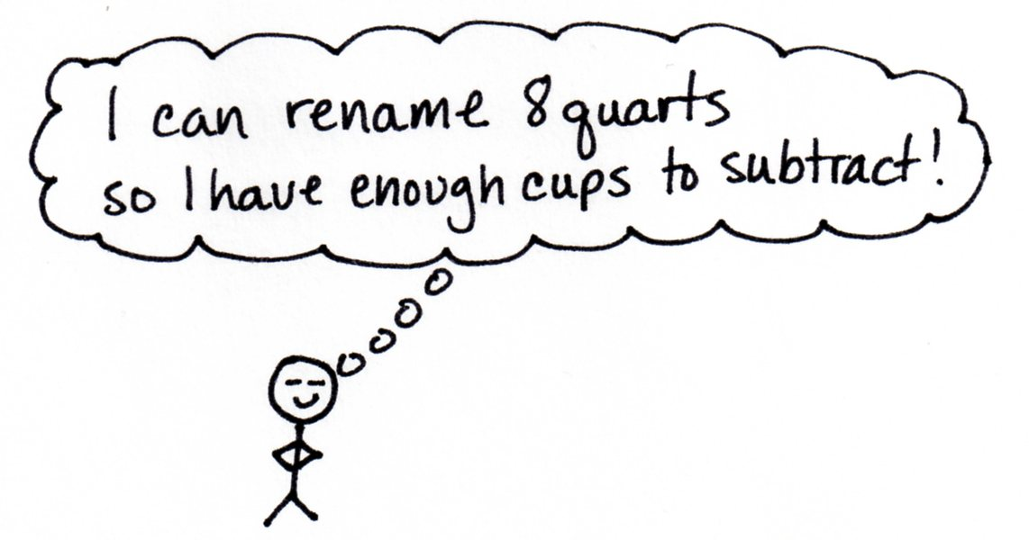
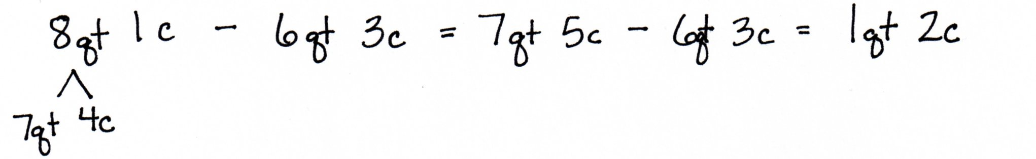

In Topic C, students reason how to convert larger units of measurements with fractional parts into smaller units by using hands-on measurements. For example, students convert $\text{3}\frac{1}{4}$ feet to inches by first finding the number of inches in $\frac{1}{4}$ foot. They partition a length of one foot into 4 equal parts and find $\frac{1}{4}$ foot equals 3 inches. They then convert 3 feet to 36 inches and add 3 inches to find that $\text{3}\frac{1}{4}$ feet = 39 inches. This work is directly analogous to earlier work with fraction equivalence using the tape diagram, area model, and number line in Topics A, B, and D of Module 5. Students partitioned a whole into 4 equal parts, decomposed 1 part into 3 smaller units and found 1 fourth to be equal to 3 twelfths. The foot ruler is partitioned with precisely the same reasoning. Students close the topic by using measurements to solve multi-step word problems that require converting larger units into smaller units.
The End-of-Module Assessment follows Topic C.
Students review their year in Topic D through the practice of skills they have learned throughout the modules and through the creation of a take-home Summer Folder. The cover of the folder is transformed into the student’s own miniature personal board and a collection of activities from the lessons within this Topic are placed inside the folder to be practiced throughout the summer. Students practice major skills and concepts learned throughout the year in these final four lessons, including measuring angles and drawing lines, multiplication and division, and addition and subtraction through guided group work, fluency activities, and vocabulary games.
Focus Grade Level Standards
Use the four operations with whole numbers to solve problems.
4.OA.1 Interpret a multiplication equation as a comparison, e.g., interpret 35 = 5 × 7 as a statement that 35 is 5 times as many as 7 and 7 times as many as 5. Represent verbal statements of multiplicative comparisons as multiplication equations.
4.OA.2 Multiply or divide to solve word problems involving multiplicative comparison, e.g., by using drawings and equations with a symbol for the unknown number to represent the problem, distinguishing multiplicative comparison from additive comparison. (See CCSS Glossary, Table 2.)
4.OA.3 Solve multi-step word problems posed with whole numbers and having whole-number answers using the four operations, including problems in which remainders must be interpreted. Represent these problems using equations with a letter standing for the unknown quantity. Assess the reasonableness of answers using mental computation and estimation strategies including rounding.

Solve problems involving measurement and conversion of measurements from a larger unit to a smaller unit.
4.MD.1 Know relative sizes of measurement units within one system of units including km, m, cm; kg, g; lb, oz; l, ml; hr, min, sec. Within a single system of measurement, express measurements in a larger unit in terms of a smaller unit. Record measurement equivalents in a two-column table. For example, know that 1 ft is 12 times as long as 1 in. Express length of a 4 ft snake as 48 in. Generate a conversion table for feet and inches listing the number pairs (1, 12), (2, 24), (3, 36), ….
4.MD.2 Use the four operations to solve word problems involving distances, intervals of time, liquid volumes, masses of objects, and money, including problems involving simple fractions or decimals, and problems that require expressing measurements given in a larger unit in terms of a smaller unit. Represent measurement quantities using diagrams such as number line diagrams that feature a measurement scale.
Foundational Standards
3.OA.1 Interpret products of whole numbers, e.g., interpret 5 × 7 as the total number of objects in 5 groups of 7 objects each. For example, describe a context in which a total number of objects can be expressed as 5 × 7.
3.OA.3 Use multiplication and division within 100 to solve word problems in situations involving equal groups, arrays, and measurement quantities, e.g., by using drawings and equations with a symbol for the unknown number to represent the problem.
3.OA.5 Apply properties of operations as strategies to multiply and divide. Examples: If 6 × 4 = 24 is known, then 4 × 6 = 24 is also known. (Commutative property of multiplication.) 3 × 5 × 2 can be found by 3 × 5 = 15, then 15 × 2 = 30, or by 5 × 2 = 10, then 3 × 10 = 30. (Associative property of multiplication.) Knowing that 8 × 5 = 40 and 8 × 2 = 16, one can find 8 × 7 as 8 × (5 + 2) = (8 × 5) + (8 × 2) = 40 + 16 = 56. (Distributive property.)
3.OA.7 Fluently multiply and divide within 100, using strategies such as the relationship between multiplication and division (e.g., knowing that 8 × 5 = 40, one knows 40 ÷ 5 = 8) or properties of operations. By the end of Grade 3, know from memory all products of two one-digit numbers.
3.NBT.3 Multiply one-digit whole numbers by multiples of 10 in the range 10–90 (e.g., 9 × 80, 5 × 60) using strategies based on place value and properties of operations.
3.NF.3 Explain equivalence of fractions in special cases, and compare fractions by reasoning about their size.
a. Understand two fractions as equivalent (equal) if they are the same size, or the same point on a number line.

b. Recognize and generate simple equivalent fractions, (e.g., 1/2 = 2/4, 4/6 = 2/3). Explain why the fractions are equivalent, e.g., by using a visual fraction model.
c. Express whole numbers as fractions, and recognize fractions that are equivalent to whole numbers. Examples: Express 3 in the form 3 = 3/1; recognize that 6/1 = 6; locate 4/4 and at the same point of a number line diagram.
3.MD.2 Measure and estimate liquid volumes and masses of objects using standard units of grams (g), kilograms (kg), and liters (l). Add, subtract, multiply, or divide to solve one-step word problems involving masses or volumes that are given in the same units, e.g., by using drawings (such as a beaker with a measurement scale) to represent the problem.
Focus Standards for Mathematical Practice
MP.2 Reason abstractly and quantitatively. Students create conversion charts for related measurement units and use the information in the charts to solve complex real-world measurement problems. They also draw number lines and tape diagrams to represent word problems.

MP.3 Construct viable arguments and critique the reasoning of others. Students work in groups to select appropriate strategies to solve problems. They present these strategies to the class and discuss the advantages and disadvantages of each strategy in different situations before deciding which ones are most efficient. Students also solve problems created by classmates and explain to the problem’s creator how they solved it to see if it is the method the student had in mind when writing the problem.

MP.7 Look for and make use of structure. Students look for and make use of connections between measurement units and word problems to help them understand and solve related word problems. They choose the appropriate unit of measure when given the choice and see that the structure of the situations in the word problems dictates which units to measure with.
MP.8 Look for an express regularity in repeated reasoning. The creation and use of the measurement conversion tables is a focal point of this module. Students identify and use the patterns found in each table they create. Using the tables to solve various word problems gives students ample opportunities to apply the same strategy to different situations.

Overview of Module Topics and Lesson Objectives
Standards | Topics and Objectives |  | Days
4.OA.1  4.OA.2  4.MD.1  4.NBT.5  4.MD.2 | A | Measurement Conversion Tables  Lessons 1–2: Create conversion tables for length, weight, and capacity units using measurement tools, and use the tables to solve problems.  Lesson 3: Create conversion tables for units of time, and use the tables to solve problems.  Lesson 4: Solve multiplicative comparison word problems using measurement conversion tables.  Lesson 5: Share and critique peer strategies. | 5
4.OA.2  4.OA.3  4.MD.1  4.MD.2  4.NBT.5  4.NBT.6 | B | Problem Solving with Measurement  Lesson 6: Solve Problems involving mixed units of capacity.  Lesson 7: Solve problems involving mixed units of length.  Lesson 8: Solve problems involving mixed units of weight.  Lesson 9: Solve problem involving mixed units of time.  Lessons 10–11: Solve multi-step measurement word problems. | 6
4.OA.3  4.MD.1  4.MD.2  4.NBT.5  4.NBT.6 | C | Investigation of Measurements Expressed as Mixed Numbers  Lessons 12–13: Use measurement tools to convert mixed number measurements to smaller units.  Lesson 14: Solve multi-step word problems involving converting mixed number measurements to a single unit. | 3
 |  | End-of-Module Assessment: Topics A–C (assessment 1 day, ½ day return, remediation or further application ½ day) | 2
 | D | Year in Review  Lessons 15–16: Create and determine the area of composite figures.  Lesson 17: Practice and solidify Grade 4 fluency.  Lesson 18: Practice and solidify Grade 4 vocabulary. | 4
Total Number of Instructional Days |  |  | 20
Terminology
New or Recently Introduced Terms
- Customary system of measurement (measurement system commonly used in the United States that includes such units as yards, pounds, and gallons)
- Customary unit (e.g., foot, ounce, quart)
- Cup (c) (customary unit of measure for liquid volume)
- Gallon (gal) (customary unit of measure for liquid volume)
- Metric system of measurement (base ten system of measurement used internationally that includes such units as meters, kilograms, and liters)
- Metric unit (e.g., kilometer, gram, milliliter)
- Ounce (oz) (customary unit of measure for weight)
- Pint (pt) (customary unit of measure for liquid volume)
- Pound (lb) (customary unit of measure for weight)
- Quart (qt) (customary unit of measure for liquid volume)
Familiar Terms and Symbols
- Capacity (the maximum amount that a container can hold)
- Convert (to express a measurement in a different unit)
- Distance (the length of the line segment joining two points)
- Equivalent (the same)
- Foot (ft) (customary unit of measure for length)
- Hour (hr) (unit of measure for time)
- Inch (customary unit of measure for length, 12 inches = 1 foot)
- Interval (time passed or a segment on the number line)
- Gram (g), kilogram (kg) (metric units of measure for mass, not distinguished from weight at this time)
- Length (the measurement of something from end to end)
- Liter (L), milliliter (mL) (metric units of measure for liquid volume)
- Measurement (dimensions, quantity, or capacity as determined by comparison with a standard)
- Meter (m), centimeter (cm), kilometer (km), (metric units of measure for length)
- Minute (min) (unit of measure for time)
- Mixed units (e.g., 3 m 43 cm)
- Second (sec) (unit of measure for time)
- Table (used to represent data)
- Weight (the measurement of how heavy something is)
- Yard (yd) (customary unit of measure for length)

Suggested Tools and Representations
- Analog clock (with second hand)
- Balance scale with mass weights
- Beaker (marked for mL and L)
- Composite figure
- Digital scale (metric and customary units)
- Gallon, quart, pint, and cup containers
- Meter stick, yard stick, 12-inch ruler, centimeter ruler
- Number bond
- Number line
- Protractor
- Stopwatch
- Tape diagram
- Two-column table
Scaffolds
The scaffolds integrated into A Story of Units give alternatives for how students access information as well as express and demonstrate their learning. Strategically placed margin notes are provided within each lesson elaborating on the use of specific scaffolds at applicable times. They address many needs presented by English language learners, students with disabilities, students performing above grade level, and students performing below grade level. Many of the suggestions are organized by Universal Design for Learning (UDL) principles and are applicable to more than one population. To read more about the approach to differentiated instruction in A Story of Units, please refer to “How to Implement A Story of Units.”
Assessment Summary
Type | Administered | Format | Standards Addressed
End-of-Module Assessment Task | After Topic C | Constructed response with rubric | 4.OA.1  4.OA.2  4.OA.3  4.MD.1  4.MD.2

The focus now is on customary units in word problems for application of fraction concepts. 4.MD.3 is addressed in Module 3.
These are terms and symbols students have seen previously.
Students with disabilities may require Braille, large print, audio, or special digital files. Please visit the website, www.p12.nysed.gov/specialed/aim, for specific information on how to obtain student materials that satisfy the National Instructional Materials Accessibility Standard (NIMAS) format.

