Table of Contents
GRADE 4 • MODULE 4
Angle Measure and Plane Figures

Module Overview i

Topic A: Lines and Angles 4.A.1

Topic B: Angle Measurement 4.B.1

Topic C: Problem Solving with the Addition of Angle Measures 4.C.1

Topic D: Two-Dimensional Figures and Symmetry 4.D.1

Module Assessments 4.S.1

Grade 4 • Module 4
Angle Measure and Plane Figures
OVERVIEW
This 20-day module introduces points, lines, line segments, rays, and angles, as well as the relationships between them. Students construct, recognize, and define these geometric objects before using their new knowledge and understanding to classify figures and solve problems. With angle measure playing a key role in the work throughout the module, students learn how to create and measure angles, as well as how to create and solve equations to find unknown angle measures. In these problems, where the unknown angle is represented by a letter, students explore both measuring the unknown angle with a protractor and reasoning through the solving of an equation. This connection between the measurement tool and the numerical work lays an important foundation for success with middle school geometry and algebra. Through decomposition and composition activities, as well as an exploration of symmetry, students recognize specific attributes present in two-dimensional figures. They further develop their understanding of these attributes as they classify two-dimensional figures.
Topic A begins with students drawing points, lines, line segments, and rays, as well as identifying these in various contexts and within familiar figures. Students recognize that two rays sharing a common endpoint form an angle (4.MD.5). They create right angles through a paper-folding activity, identify right angles in their environment, and see that one angle can be greater (obtuse) or less (acute) than a right angle. Next, students use their understanding of angles to explore relationships between pairs of lines as they define, draw, and recognize intersecting, perpendicular, and parallel lines (4.G.1).
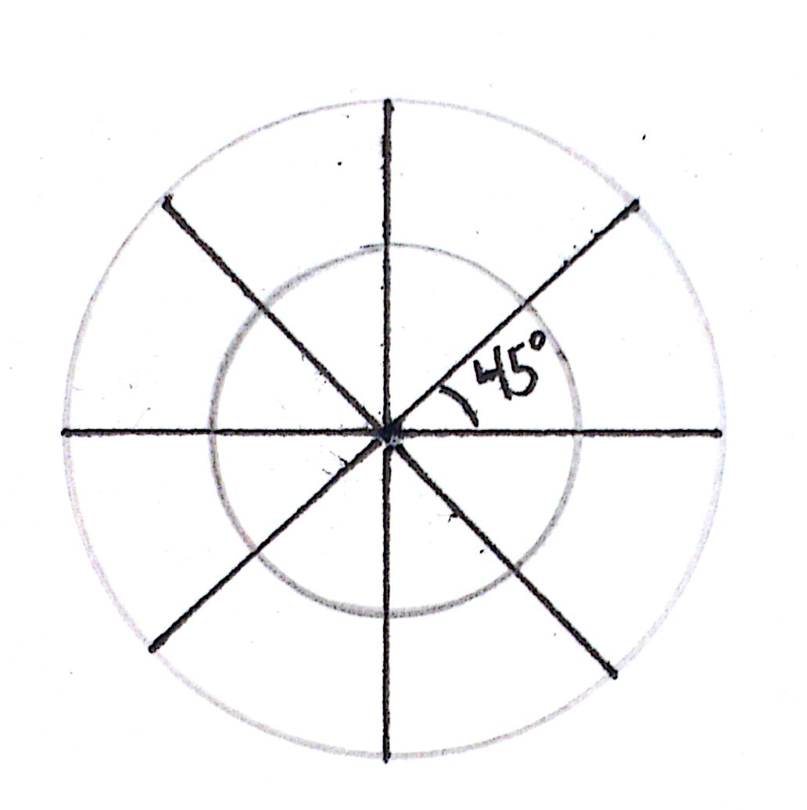
In Topic B, students explore the definition of degree measure, beginning with a circular protractor. By dividing the circumference of a circle into 360 equal parts, they recognize one part as representing 1 degree (4.MD.5). Through exploration, students realize that, although the size of a circle may change, an angle spans an arc, representing a constant fraction of the circumference. By carefully distinguishing the attribute of degree measure from that of length measure, the common misconception that degrees are a measure of length is avoided. Armed with their understanding of the degree as a unit of measure, students use various types of protractors to measure angles to the nearest degree and sketch angles of a given measure (4.MD.6). The idea that an angle measures the amount of turning in a particular direction is explored as students recognize familiar angles in varied contexts (4.G.1, 4.MD.5).
Topic C begins by decomposing 360° using pattern blocks, allowing students to see that a group of angles meeting at a point with no spaces or overlaps add up to 360°. With this new understanding, students now discover that the combined measure of two adjacent angles on a line is 180$°$ (supplementary angles), that the combined measure of two adjacent angles meeting to form a right angle is 90° (complementary angles), and that vertically opposite angles have the same measure. These properties are then used to solve unknown angle problems (4.MD.7).

An introduction to symmetry opens Topic D as students recognize lines of symmetry for two-dimensional figures, identify line-symmetric figures, and draw lines of symmetry (4.G.3). Given one-half of a line-symmetric figure and the line of symmetry, students draw the other half of the figure. This leads to their work with triangles. Students are introduced to the precise definition of a triangle, and then classify triangles based on angle measure and side length (4.G.2). For isosceles triangles, a line of symmetry is identified, and a folding activity demonstrates that base angles are equal. Folding an equilateral triangle highlights multiple lines of symmetry and establishes that all interior angles are equal. Students construct triangles given a set of classifying criteria (e.g., create a triangle that is both right and isosceles). Finally, students explore the definitions of familiar quadrilaterals and classify them based on their attributes, including angle measure and parallel and perpendicular lines (4.G.2). This work builds on Grade 3 reasoning about the attributes of shapes and lays a foundation for hierarchical classification of two-dimensional figures in Grade 5. The topic concludes as students compare and analyze two-dimensional figures according to their properties and use grid paper to construct two-dimensional figures given a set of criteria.
The Mid-Module Assessment follows Topic B. The End-of-Module Assessment follows Topic D.
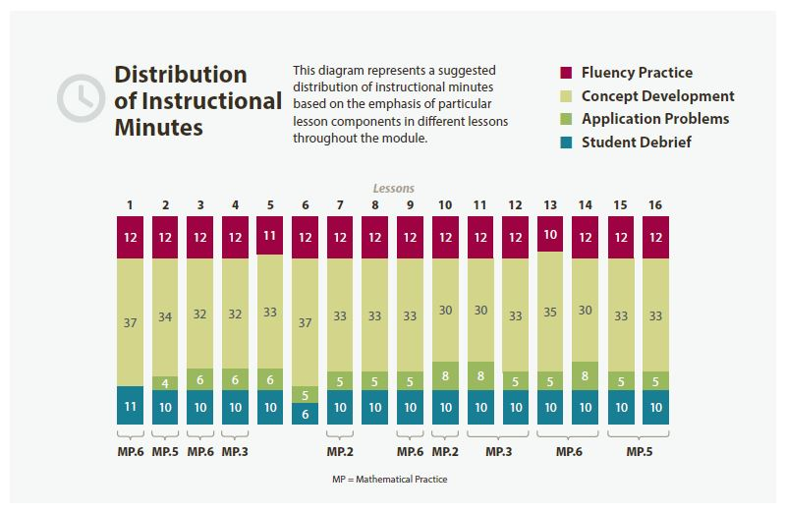

Focus Grade Level Standards
Geometric measurement: understand concepts of angle and measure angles.
4.MD.5 Recognize angles as geometric shapes that are formed whenever two rays share a common endpoint, and understand concepts of angle measurement:
- An angle is measured with reference to a circle with its center at the common endpoint of the rays, by considering the fraction of the circular arc between the points where the two rays intersect the circle. An angle that turns through 1/360 of a circle is called a “one-degree angle,” and can be used to measure angles.
- An angle that turns through n one-degree angles is said to have an angle measure of n degrees.
4.MD.6 Measure angles in whole-number degrees using a protractor. Sketch angles of specified measure.
4.MD.7 Recognize angle measure as additive. When an angle is decomposed into non-overlapping parts, the angle measure of the whole is the sum of the angle measures of the parts. Solve addition and subtraction problems to find unknown angles on a diagram in real world and mathematical problems, e.g., by using an equation with a symbol for the unknown angle measure.
Draw and identify lines and angles, and classify shapes by properties of their lines and angles.
4.G.1 Draw points, lines, line segments, rays, angles (right, acute, obtuse), and perpendicular and parallel lines. Identify these in two-dimensional figures.
4.G.2 Classify two-dimensional figures based on the presence or absence of parallel or perpendicular lines, or the presence or absence of angles of a specified size. Recognize right triangles as a category, and identify right triangles.
4.G.3 Recognize a line of symmetry for a two-dimensional figure as a line across the figure such that the figure can be folded along the line into matching parts. Identify line-symmetric figures and draw lines of symmetry.

Foundational Standards
3.OA.8 Solve two-step word problems using the four operations. Represent these problems using equations with a letter standing for the unknown quantity. Assess the reasonableness of answers using mental computation and estimation strategies including rounding. (This standard is limited to problems posed with whole numbers and having whole-number answers; students should know how to perform operations in the conventional order when there are no parentheses to specify a particular order, i.e., Order of Operations.)
3.G.1 Understand that shapes in different categories (e.g., rhombuses, rectangles, and others) may share attributes (e.g., having four sides), and that the shared attributes can define a larger category (e.g., quadrilaterals). Recognize rhombuses, rectangles, and squares as examples of quadrilaterals, and draw examples of quadrilaterals that do not belong to any of these subcategories.
Focus Standards for Mathematical Practice
MP.2 Reason abstractly and quantitatively. Students represent angle measures within equations, and when determining the measure of an unknown angle, they represent the unknown angle with a letter or symbol both in the diagram and in the equation. They reason about the properties of groups of figures during classification activities.
MP.3 Construct viable arguments and critique the reasoning of others. Knowing and using the relationships between adjacent and vertical angles, students construct an argument for identifying the angle measures of all four angles generated by two intersecting lines when given the measure of one angle. Students explore the concepts of parallelism and perpendicularity on different types of grids with activities that require justifying whether completing specific tasks is possible on different grids.
MP.5 Use appropriate tools strategically. Students choose to use protractors when measuring and sketching angles, drawing perpendicular lines, and precisely constructing two-dimensional figures with specific angle measurements. They use right angle templates (set squares) and straightedges to construct parallel lines. They also choose to use straightedges for sketching lines, line segments, and rays.
MP.6 Attend to precision. Students use clear and precise vocabulary. They learn, for example, to cross-classify triangles by both angle size and side length (e.g., naming a shape as a right, isosceles triangle). They use right angle templates (set squares) and straightedges to construct parallel lines and become sufficiently familiar with a protractor to decide which set of numbers to use when measuring an angle whose orientation is such that it opens from either direction, or when the angle measures more than 180$°$.

Overview of Module Topics and Lesson Objectives
Standards | Topics and Objectives |  | Days
4.G.1 | A | Lines and Angles  Lesson 1: Identify and draw points, lines, line segments, rays, and angles. Recognize them in various contexts and familiar figures.  Lesson 2: Use right angles to determine whether angles are equal to, greater than, or less than right angles. Draw right, obtuse, and acute angles.  Lesson 3: Identify, define, and draw perpendicular lines.  Lesson 4: Identify, define, and draw parallel lines. | 4
4.MD.5  4.MD.6 | B | Angle Measurement  Lesson 5: Use a circular protractor to understand a 1-degree angle as $\frac{1}{360}$ of a turn. Explore benchmark angles using the protractor.  Lesson 6: Use varied protractors to distinguish angle measure from length measurement.  Lesson 7: Measure and draw angles. Sketch given angle measures and verify with a protractor.  Lesson 8: Identify and measure angles as turns and recognize them in various contexts. | 4
 |  | Mid-Module Assessment: Topics A–B (assessment ½ day, return ½ day, remediation or further application 1 day) | 2
4.MD.7 | C | Problem Solving with the Addition of Angle Measures  Lesson 9: Decompose angles using pattern blocks.  Lessons 10–11: Use the addition of adjacent angle measures to solve problems using a symbol for the unknown angle measure. | 3
4.G.1  4.G.2  4.G.3 | D | Two-Dimensional Figures and Symmetry  Lesson 12: Recognize lines of symmetry for given two-dimensional figures. Identify line-symmetric figures and draw lines of symmetry.  Lesson 13: Analyze and classify triangles based on side length, angle measure, or both.  Lesson 14: Define and construct triangles from given criteria. Explore symmetry in triangles.  Lesson 15: Classify quadrilaterals based on parallel and perpendicular lines and the presence or absence of angles of a specified size.  Lesson 16: Reason about attributes to construct quadrilaterals on square or triangular grid paper. | 5
 |  | End-of-Module Assessment: Topics A–D (assessment ½ day, return ½ day, remediation or further application 1 day) | 2
Total Number of Instructional Days |  |  | 20

Terminology
New or Recently Introduced Terms
- Acute angle (angle with a measure of less than 90$°$)
- Acute triangle (triangle with all interior angles measuring less than 90$°$)
- Adjacent angle (Two angles $∠AOC$ and $∠COB$, with a common side $\overset{⃑}{OC}$, are adjacent angles if $C$is in the interior of $∠AOB$.)
- Angle (union of two different rays sharing a common vertex, e.g., $∠ABC$)
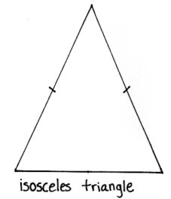
- Arc (connected portion of a circle)
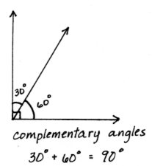
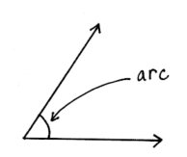
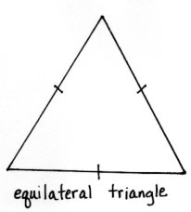

- Collinear (Three or more points are collinear if there is a line containing all of the points; otherwise, the points are non-collinear.)
- Complementary angles (two angles with a sum of 90$°$)
- Degree, degree measure of an angle (Subdivide the length around a circle into 360 arcs of equal length. A central angle for any of these arcs is called a one-degree angle and is said to have an angle measure of 1$°$. )
- Diagonal (straight lines joining two opposite corners of a straight-sided shape)
- Equilateral triangle (triangle with three equal sides)
- Figure (set of points in the plane)
- Interior of an angle (the convex region defined by the angle)
- Intersecting lines (lines that contain at least one point in common)
- Isosceles triangle (triangle with at least two equal sides)
- Length of an arc (circular distance around the arc)
- Line (straight path with no thickness that extends in both directions without end)
- Line of symmetry (line through a figure such that when the figure is folded along the line, two halves are created that match up exactly)
- Line segment (two points, A and B, together with the set of points on the line $\overset{⃡}{AB}$ between $A$ and $B$, e.g., $\overline{AB}$)
- Obtuse angle (angle with a measure greater than 90$°$, but less than 180$°$)
- Obtuse triangle (triangle with an interior obtuse angle)
- Parallel (two lines in a plane that do not intersect, e.g., $\overline{AB} ∥ \overline{CD}$)
- Perpendicular (Two lines are perpendicular if they intersect, and any of the angles formed between the lines is a 90° angle, e.g., $\overline{EF} ⊥ \overline{GH}$.)
- Point (precise location in the plane)
- Protractor (instrument used in measuring or sketching angles)
- Ray (The ray $\overset{⃑}{OA}$ is the point $O$ and the set of all points on the line $\overset{⃡}{OA}$ that are on the same side of $O$ as the point $A$.)
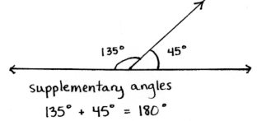
- Right angle (angle formed by perpendicular lines, measuring 90$°$)
- Right triangle (triangle that contains one 90° angle)
- Scalene triangle (triangle with no sides or angles equal)
- Straight angle (angle that measures 180$°$)
- Supplementary angles (two angles with a sum of 180$°$)
- Triangle (A triangle consists of three non-collinear points and the three line segments between them. The three segments are called the sides of the triangle, and the three points are called the vertices.)
- Vertex (a point, often used to refer to the point where two lines meet, such as in an angle or the corner of a triangle)
- Vertical angles (When two lines intersect, any two non-adjacent angles formed by those lines are called vertical angles or vertically opposite angles.)

Familiar Terms and Symbols
- Decompose (process of separating something into smaller components)
- Parallelogram (quadrilateral with two pairs of parallel sides)
- Polygon (closed two-dimensional figure with straight sides)
- Quadrilateral (polygon with four sides)
- Rectangle (quadrilateral with four right angles)
- Rhombus (quadrilateral with all sides of equal length)
- Square (rectangle with all sides of equal length)
- Sum (result of adding two or more numbers)
- Trapezoid (quadrilateral with at least one pair of parallel sides)
Suggested Tools and Representations
- Protractors of various diameters, including a 360° and 180° protractor
- Ruler (used to measure length), straightedge (used to draw straight lines)
- Right angle template (created in Lesson 2), set square
- Folded paper models
- Pattern blocks
- Rectangular and triangular grid paper
Scaffolds
The scaffolds integrated into A Story of Units give alternatives for how students access information as well as express and demonstrate their learning. Strategically placed margin notes are provided within each lesson elaborating on the use of specific scaffolds at applicable times. They address many needs presented by English language learners, students with disabilities, students performing above grade level, and students performing below grade level. Many of the suggestions are organized by Universal Design for Learning (UDL) principles and are applicable to more than one population. To read more about the approach to differentiated instruction in A Story of Units, please refer to “How to Implement A Story of Units.”

Assessment Summary
Assessment Type | Administered | Format | Standards Addressed
Mid-Module Assessment Task | After Topic B | Constructed response with rubric | 4.MD.5  4.MD.6  4.G.1
End-of-Module Assessment Task | After Topic D | Constructed response with rubric | 4.MD.5  4.MD.6  4.MD.7  4.G.1  4.G.2  4.G.3

In Grade 4, a picture will suffice. A precise definition of convexity will be given in Grade 10 geometry.
Students with disabilities may require Braille, large print, audio, or special digital files. Please visit the website, www.p12.nysed.gov/specialed/aim, for specific information on how to obtain student materials that satisfy the National Instructional Materials Accessibility Standard (NIMAS) format.

