Table of Contents
GRADE 4 • MODULE 1
Place Value, Rounding, and Algorithms for Addition and Subtraction

Module Overview i

Topic A: Place Value of Multi-Digit Whole Numbers 1.A.1

Topic B: Comparing Multi-Digit Whole Numbers 1.B.1

Topic C: Rounding Multi-Digit Whole Numbers 1.C.1

Topic D: Multi-Digit Whole Number Addition 1.D.1

Topic E: Multi-Digit Whole Number Subtraction 1.E.1

Topic F: Addition and Subtraction Word Problems 1.F.1

Module Assessments 1.S.1

Grade 4 • Module 1
Place Value, Rounding, and Algorithms for Addition and Subtraction
OVERVIEW
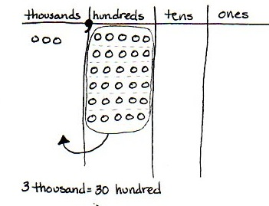
In this 25-day Grade 4 module, students extend their work with whole numbers. They begin with large numbers using familiar units (hundreds and thousands) and develop their understanding of millions by building knowledge of the pattern of times ten in the base ten system on the place value chart (4.NBT.1). They recognize that each sequence of three digits is read as hundreds, tens, and ones followed by the naming of the corresponding base thousand unit (thousand, million, billion).
The place value chart is fundamental to Topic A. Building upon their previous knowledge of bundling, students learn that 10 hundreds can be composed into 1 thousand and, therefore, 30 hundreds can be composed into 3 thousands because a digit’s value is 10 times what it would be one place to its right (4.NBT.1). Students learn to recognize that in a number such as 7,777 each 7 has a value that is 10 times the value of its neighbor to the immediate right. One thousand can be decomposed into 10 hundreds, therefore 7 thousands can be decomposed into 70 hundreds.
Similarly, multiplying by 10 shifts digits one place to the left, and dividing by 10 shifts digits one place to the right.
3,000 = 10 × 300 3,000 ÷ 10 = 300

In Topic B, students use place value as a basis for comparing whole numbers. Although this is not a new concept, it becomes more complex as the numbers become larger. For example, it becomes clear that 34,156 is 3 thousands greater than 31,156.
$$\text{34,156} \text{>} \text{31,156}$$
Comparison leads directly into rounding, where their skill with isolating units is applied and extended. Rounding to the nearest ten and hundred was mastered with three-digit numbers in Grade 3. Now, Grade 4 students moving into Topic C learn to round to any place value (4.NBT.3), initially using the vertical number line, though ultimately moving away from the visual model altogether. Topic C also includes word problems where students apply rounding to real life situations.
In Grade 4, students become fluent with the standard algorithms for addition and subtraction. In Topics D and E, students focus on single like-unit calculations (ones with ones, thousands with thousands, etc.), at times requiring the composition of greater units when adding (10 hundreds are composed into 1 thousand) and decomposition into smaller units when subtracting (1 thousand is decomposed into 10 hundreds) (4.NBT.4). Throughout these topics, students apply their algorithmic knowledge to solve word problems. Students also use a variable to represent the unknown quantity.
The module culminates with multi-step word problems in Topic F (4.OA.3). Tape diagrams are used throughout the topic to model additive compare problems like the one exemplified below. These diagrams facilitate deeper comprehension and serve as a way to support the reasonableness of an answer.

A goat produces 5,212 gallons of milk a year. A cow produces 17,279 gallons of milk a year. How much more milk does a goat need to produce to make the same amount of milk as a cow?
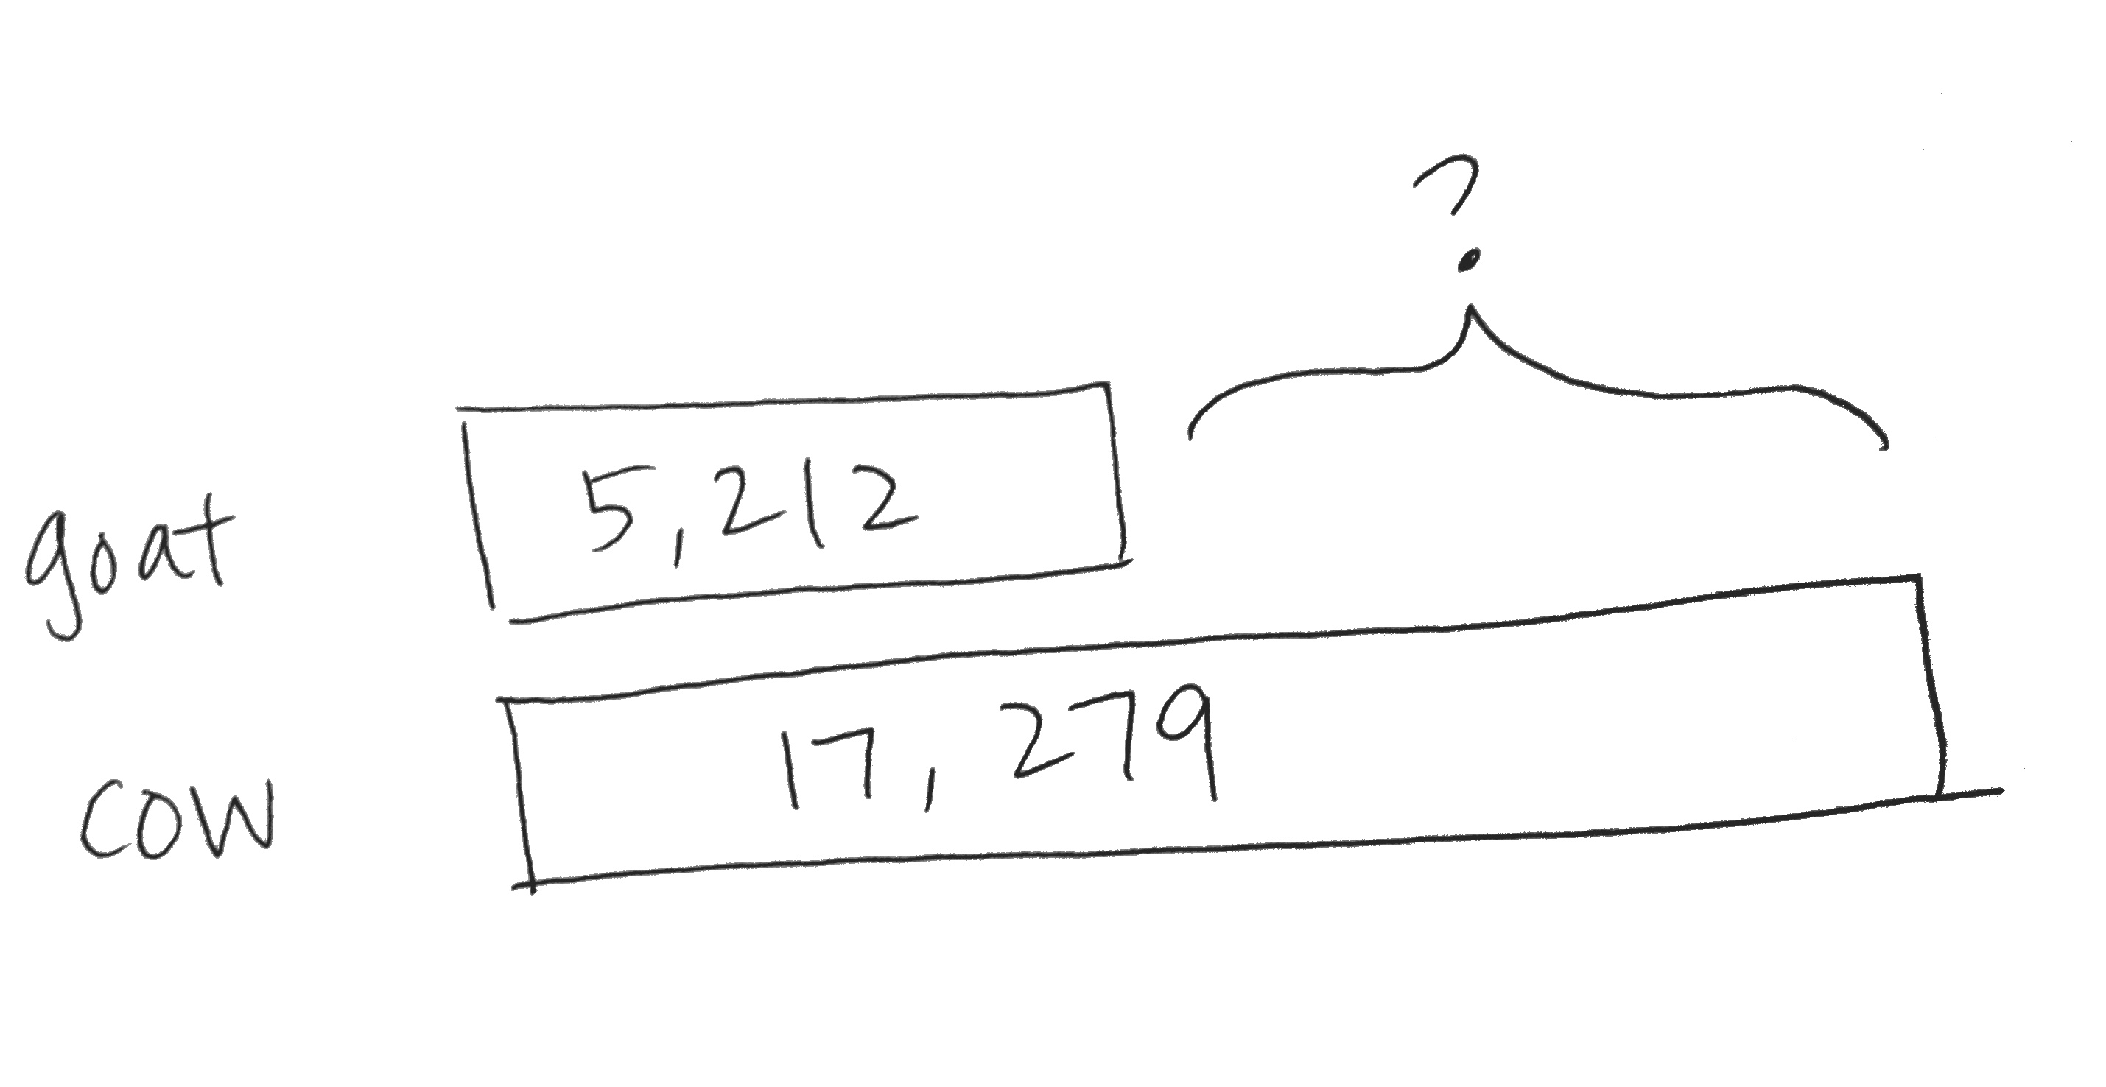

17,279 – 5,212 = ________

A goat needs to produce _______ more gallons of milk a year.

The Mid-Module Assessment follows Topic C. The End-of-Module Assessment follows Topic F.

Focus Grade Level Standards
Use the four operations with whole numbers to solve problems.
4.OA.3 Solve multistep word problems posed with whole numbers and having whole-number answers using the four operations, including problems in which remainders must be interpreted. Represent these problems using equations with a letter standing for the unknown quantity. Assess the reasonableness of answers using mental computation and estimation strategies including rounding.
Generalize place value understanding for multi-digit whole numbers. (Grade 4 expectations are limited to whole numbers less than or equal to 1,000,000.)
4.NBT.1 Recognize that in a multi-digit whole number, a digit in one place represents ten times what it represents in the place to its right. For example, recognize that 700 ÷ 70 = 10 by applying concepts of place value and division.
4.NBT.2 Read and write multi-digit whole numbers using base-ten numerals, number names, and expanded form. Compare two multi-digit numbers based on meanings of the digits in each place, using >, =, and < symbols to record the results of comparisons.
4.NBT.3 Use place value understanding to round multi-digit whole numbers to any place.
Use place value understanding and properties of operations to perform multi-digit arithmetic.
4.NBT.4 Fluently add and subtract multi-digit whole numbers using the standard algorithm.
Foundational Standards
3.OA.8 Solve two-step word problems using the four operations. Represent these problems using equations with a letter standing for the unknown quantity. Assess the reasonableness of answers using mental computation and estimation strategies including rounding.
3.NBT.1 Use place value understanding to round whole numbers to the nearest 10 or 100.
3.NBT.2 Fluently add and subtract within 1000 using strategies and algorithms based on place value, properties of operations, and/or the relationship between addition and subtraction.
Focus Standards for Mathematical Practice
MP.1 Make sense of problems and persevere in solving them. Students use the place value chart to draw diagrams of the relationship between a digit’s value and what it would be one place to its right, for instance, by representing 3 thousands as 30 hundreds. Students also use the place value chart to compare large numbers.
MP.2 Reason abstractly and quantitatively. Students make sense of quantities and their relationships as they use both special strategies and the standard addition algorithm to add and subtract multi-digit numbers. Students decontextualize when they represent problems symbolically and contextualize when they consider the value of the units used and understand the meaning of the quantities as they compute.
MP.3 Construct viable arguments and critique the reasoning of others. Students construct arguments as they use the place value chart and model single- and multi-step problems. Students also use the standard algorithm as a general strategy to add and subtract multi-digit numbers when a special strategy is not suitable.
MP.5 Use appropriate tools strategically. Students decide on the appropriateness of using special strategies or the standard algorithm when adding and subtracting multi-digit numbers.
MP.6 Attend to precision. Students use the place value chart to represent digits and their values as they compose and decompose base ten units.
Overview of Module Topics and Lesson Objectives
Standards | Topics and Objectives |  | Days
4.NBT.1  4.NBT.2  4.OA.1 | A | Place Value of Multi-Digit Whole Numbers  Lesson 1: Interpret a multiplication equation as a comparison.  Lesson 2: Recognize a digit represents 10 times the value of what it represents in the place to its right.  Lesson 3: Name numbers within 1 million by building understanding of the place value chart and placement of commas for naming base thousand units.  Lesson 4: Read and write multi-digit numbers using base ten numerals, number names, and expanded form. | 4
4.NBT.2 | B | Comparing Multi-Digit Whole Numbers  Lesson 5: Compare numbers based on meanings of the digits using >, <, or = to record the comparison.  Lesson 6: Find 1, 10, and 100 thousand more and less than a given number. | 2
4.NBT.3 | C | Rounding Multi-Digit Whole Numbers  Lesson 7: Round multi-digit numbers to the thousands place using the vertical number line.  Lesson 8: Round multi-digit numbers to any place using the vertical number line.  Lesson 9: Use place value understanding to round multi-digit numbers to any place value.  Lesson 10: Use place value understanding to round multi-digit numbers to any place value using real world applications. | 4
 |  | Mid-Module Assessment: Topics A–C (review content 1 day, assessment ½ day, return ½ day, remediation or further applications 1 day) | 3
4.OA.3  4.NBT.4  4.NBT.1  4.NBT.2 | D | Multi-Digit Whole Number Addition  Lesson 11: Use place value understanding to fluently add multi-digit whole numbers using the standard addition algorithm, and apply the algorithm to solve word problems using tape diagrams.  Lesson 12: Solve multi-step word problems using the standard addition algorithm modeled with tape diagrams, and assess the reasonableness of answers using rounding. | 2
4.OA.3  4.NBT.4  4.NBT.1  4.NBT.2 | E | Multi-Digit Whole Number Subtraction  Lesson 13: Use place value understanding to decompose to smaller units once using the standard subtraction algorithm, and apply the algorithm to solve word problems using tape diagrams.  Lesson 14: Use place value understanding to decompose to smaller units up to three times using the standard subtraction algorithm, and apply the algorithm to solve word problems using tape diagrams.  Lesson 15: Use place value understanding to fluently decompose to smaller units multiple times in any place using the standard subtraction algorithm, and apply the algorithm to solve word problems using tape diagrams.  Lesson 16: Solve two-step word problems using the standard subtraction algorithm fluently modeled with tape diagrams, and assess the reasonableness of answers using rounding. | 4
4.OA.3  4.NBT.1  4.NBT.2  4.NBT.4 | F | Addition and Subtraction Word Problems  Lesson 17: Solve additive compare word problems modeled with tape diagrams.  Lesson 18: Solve multi-step word problems modeled with tape diagrams, and assess the reasonableness of answers using rounding.  Lesson 19: Create and solve multi-step word problems from given tape diagrams and equations. | 3
 |  | End-of-Module Assessment: Topics A–F (review content 1 day, assessment ½ day, return ½ day, remediation or further application 1 day) | 3
Total Number of Instructional Days |  |  | 25

Terminology
New or Recently Introduced Terms
- Ten thousands, hundred thousands (as places on the place value chart)
- Millions, ten millions, hundred millions (as places on the place value chart)
- Variable (letters that stand for numbers and can be added, subtracted, multiplied, and divided as numbers are)
Familiar Terms and Symbols

NOTES ON
EXPRESSION, EQUATION, AND NUMBER SENTENCE:
Please note the descriptions for the following terms, which are frequently misused.
    - Expression: A number, or any combination of sums, differences, products or divisions of numbers that evaluates to a number (e.g., 3 + 4, 8 × 3, 15 ÷ 3 as distinct from an equation or number sentence).
- Equation: A statement that two expressions are equal (e.g., 3 × ___ = 12, 5 × b =20, 3 + 2 = 5).
- Number sentence (also addition, subtraction, multiplication or division sentence): An equation or inequality for which both expressions are numerical and can be evaluated to a single number (e.g., 4 + 3 = 6 + 1, 2 = 2, 21 > 7 × 2, 5 ÷ 5 =1). Number sentences are either true or false (e.g., 4 + 4 < 6 × 2 and 21 ÷ 7 = 4) and contain no unknowns.

- =, <, > (equal to, less than, greater than)
- Addend (e.g., in 4 + 5, the numbers 4 and 5 are the addends)
- Algorithm (a step-by-step procedure to solve a particular type of problem)
- Bundling, making, renaming, changing, exchanging, regrouping, trading (e.g., exchanging 10 ones for 1 ten)
- Compose (e.g., to make 1 larger unit from 10 smaller units)
- Decompose (e.g., to break 1 larger unit into 10 smaller units)
- Difference (answer to a subtraction problem)
- Digit (any of the numbers 0 to 9; e.g., What is the value of the digit in the tens place?)
- Endpoint (used with rounding on the number line; the numbers that mark the beginning and end of a given interval)
- Equation (e.g., 2,389 + 80,601 = _____)
- Estimate (an approximation of a quantity or number)
- Expanded form (e.g., 100 + 30 + 5 = 135)
- Expression (e.g., 2 thousands × 10)
- Halfway (with reference to a number line, the midpoint between two numbers, e.g., 5 is halfway between 0 and 10)
- Number line (a line marked with numbers at evenly spaced intervals)
- Number sentence (e.g., 4 + 3 = 7)
- Place value (the numerical value that a digit has by virtue of its position in a number)
- Rounding (approximating the value of a given number)
- Standard form (a number written in the format 135)
- Sum (answer to an addition problem)
- Tape diagram (bar diagram)
- Unbundling, breaking, renaming, changing, regrouping, trading (e.g., exchanging 1 ten for 10 ones)
- Word form (e.g., one hundred thirty-five)

Suggested Tools and Representations
- Number lines (vertical to represent rounding up and rounding down)
- Personal white boards (one per student; see explanation on the following pages)
- Place value cards (one large set per classroom including 7 units to model place value)
- Place value chart (templates provided in lessons to insert into personal white boards)
- Place value disks (can be concrete manipulatives or pictorial drawings, such as the chip model, to represent numbers)
- Tape diagrams (drawn to model a word problem)
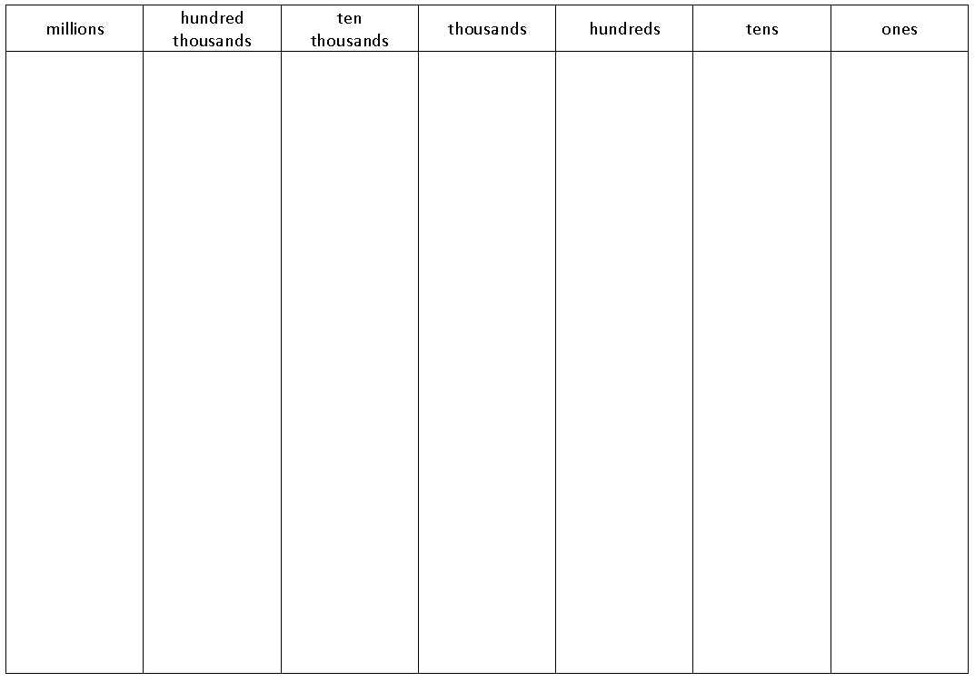
Place Value Chart with Headings
(used for numbers or the chip model)
Place Value Chart Without Headings
(used for place value disk manipulatives or drawings)

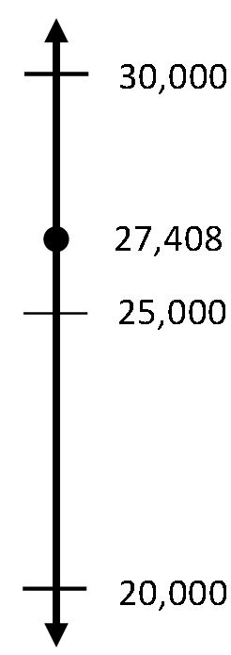
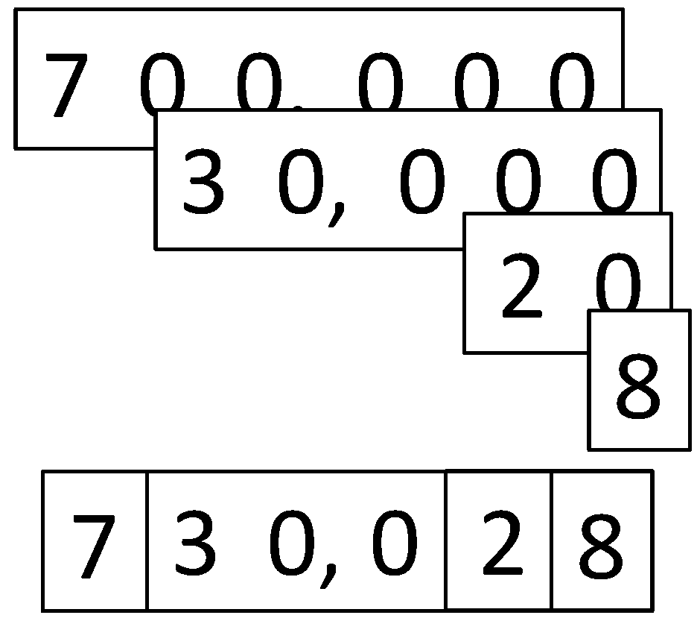
Vertical Number Line
Place Value Cards
Place Value Disks

Suggested Methods of Instructional Delivery
Directions for Administration of Sprints
Sprints are designed to develop fluency. They should be fun, adrenaline-rich activities that intentionally build energy and excitement. A fast pace is essential. During Sprint administration, teachers assume the role of athletic coaches. A rousing routine fuels students’ motivation to do their personal best. Student recognition of increasing success is critical, and so every improvement is celebrated.
One Sprint has two parts with closely related problems on each. Students complete the two parts of the Sprint in quick succession with the goal of improving on the second part, even if only by one more.
With practice, the following routine takes about 9 minutes.
Sprint A
Pass Sprint A out quickly, face down on student desks with instructions to not look at the problems until the signal is given. (Some Sprints include words. If necessary, prior to starting the Sprint, quickly review the words so that reading difficulty does not slow students down.)
T: You will have 60 seconds to do as many problems as you can. I do not expect you to finish all of them. Just do as many as you can, your personal best. (If some students are likely to finish before time is up, assign a number to count by on the back.)
T: Take your mark! Get set! THINK!
Students immediately turn papers over and work furiously to finish as many problems as they can in 60 seconds. Time precisely.
T: Stop! Circle the last problem you did. I will read just the answers. If you got it right, call out “Yes!” If you made a mistake, circle it. Ready?
T: (Energetically, rapid-fire call the first answer.)
S: Yes!
T: (Energetically, rapid-fire call the second answer.)
S: Yes!
Repeat to the end of Sprint A or until no student has a correct answer. If needed, read the count-by answers in the same way you read Sprint answers. Each number counted-by on the back is considered a correct answer.
T: Fantastic! Now, write the number you got correct at the top of your page. This is your personal goal for Sprint B.
T: How many of you got one right? (All hands should go up.)
T: Keep your hand up until I say the number that is one more than the number you got correct. So, if you got 14 correct, when I say 15, your hand goes down. Ready?
T: (Continue quickly.) How many got two correct? Three? Four? Five? (Continue until all hands are down.)
If the class needs more practice with Sprint A, continue with the optional routine presented below.
T: I’ll give you one minute to do more problems on this half of the Sprint. If you finish, stand behind your chair.
As students work, the student who scored highest on Sprint A might pass out Sprint B.
T: Stop! I will read just the answers. If you got it right, call out “Yes!” If you made a mistake, circle it. Ready? (Read the answers to the first half again as students stand.)
Movement
To keep the energy and fun going, always do a stretch or a movement game in between Sprints A and B. For example, the class might do jumping jacks while skip-counting by 5 for about 1 minute. Feeling invigorated, students take their seats for Sprint B, ready to make every effort to complete more problems this time.

Sprint B
Pass Sprint B out quickly, face down on student desks with instructions to not look at the problems until the signal is given. (Repeat the procedure for Sprint A up through the show of hands for how many right.)
T: Stand up if you got more correct on the second Sprint than on the first.
S: (Stand.)
T: Keep standing until I say the number that tells how many more you got right on Sprint B. If you got three more right on Sprint B than you did on Sprint A, when I say three, you sit down. Ready? (Call out numbers starting with one. Students sit as the number by which they improved is called. Celebrate the students who improved most with a cheer.)
T: Well done! Now, take a moment to go back and correct your mistakes. Think about what patterns you noticed in today’s Sprint.
T: How did the patterns help you get better at solving the problems?
T: Rally Robin your thinking with your partner for 1 minute. Go!
Rally Robin is a style of sharing in which partners trade information back and forth, one statement at a time per person, for about 1 minute. This is an especially valuable part of the routine for students who benefit from their friends’ support to identify patterns and try new strategies.
Students may take Sprints home.
RDW or Read, Draw, Write (an Equation and a Statement)
Mathematicians and teachers suggest a simple process applicable to all grades:
1) Read.
2) Draw and Label.
3) Write an equation.
4) Write a word sentence (statement).
The more students participate in reasoning through problems with a systematic approach, the more they internalize those behaviors and thought processes.
- What do I see?
- Can I draw something?
- What conclusions can I make from my drawing?

Modeling with Interactive Questioning | Guided Practice | Independent Practice
The teacher models the whole process with interactive questioning, some choral response, and talk moves such as, “What did Monique say, everyone?” After completing the problem, students might reflect with a partner on the steps they used to solve the problem. “Students, think back on what we did to solve this problem. What did we do first?” Students might then be given the same or similar problem to solve for homework. | Each student has a copy of the question. Though guided by the teacher, they work independently at times and then come together again. Timing is important. Students might hear, “You have 2 minutes to do your drawing.” Or, “Put your pencils down. Time to work together again.” The Debrief might include selecting different student work to share. | The students are given a problem to solve and possibly a designated amount of time to solve it. The teacher circulates, supports, and is thinking about which student work to show to support the mathematical objectives of the lesson. When sharing student work, students are encouraged to think about the work with questions such as, “What do you see Jeremy did?” “What is the same about Jeremy’s work and Sara’s work?” “How did Jeremy show the 3/7 of the students?” “How did Sara show the 3/7 of the students?”

Personal White Boards
Materials Needed for Personal White Boards
1 heavy duty clear sheet protector
1 piece of stiff red tag board 11" × 8 ¼"
1 piece of stiff white tag board 11" × 8 ¼"
1 3" × 3" piece of dark synthetic cloth for an eraser (e.g., felt)
1 low odor blue dry erase marker, fine point
Directions for Creating Personal White Boards
Cut your white and red tag to specifications. Slide into the sheet protector. Store your eraser on the red side. Store markers in a separate container to avoid stretching the sheet protector.
Frequently Asked Questions About Personal White Boards
Why is one side red and one white?
The white side of the board is the “paper.” Students generally write on it, and if working individually, turn the board over to signal to the teacher they have completed their work. The teacher then says, “Show me your boards,” when most of the class is ready.
What are some of the benefits of a personal white board?
- The teacher can respond quickly to a gap in student understandings and skills. “Let’s do some of these on our personal white boards until we have more mastery.”
- Students can erase quickly so that they do not have to suffer the evidence of their mistake.
- They are motivating. Students love both the drill and thrill capability and the chance to do story problems with an engaging medium.
- Checking work gives the teacher instant feedback about student understanding.
What is the benefit of this personal white board over a commercially purchased dry erase board?
- It is much less expensive.
- Templates such as place value charts, number bond mats, hundreds boards, and number lines can be stored between the two pieces of tag board for easy access and reuse.
- Worksheets, story problems, and other problem sets can be done without marking the paper so that students can work on the problems independently at another time.
- Strips with story problems, number lines, and arrays can be inserted and still have a full piece of paper on which to write.
- The red versus white side distinction clarifies your expectations. When working collaboratively, there is no need to use the red. When working independently, the students know how to keep their work private.
- The tag board can be removed so that student work can be projected on an overhead.
Scaffolds
The scaffolds integrated into A Story of Units give alternatives for how students access information as well as express and demonstrate their learning. Strategically placed margin notes are provided within each lesson elaborating on the use of specific scaffolds at applicable times. They address many needs presented by English language learners, students with disabilities, students performing above grade level, and students performing below grade level. Many of the suggestions are organized by Universal Design for Learning (UDL) principles and are applicable to more than one population. To read more about the approach to differentiated instruction in A Story of Units, please refer to “How to Implement A Story of Units.”
Assessment Summary
Type | Administered | Format | Standards Addressed
Mid-Module Assessment Task | After Topic C | Constructed response with rubric | 4.NBT.1  4.NBT.2  4.NBT.3
End-of-Module Assessment Task | After Topic F | Constructed response with rubric | 4.NBT.1  4.NBT.2  4.NBT.3  4.NBT.4  4.OA.3

Grade 4 expectations in the NBT standards domain are limited to whole numbers less than or equal to 1,000,000.
Only addition and subtraction multi-step word problems are addressed in this module. The balance of this cluster is addressed in Modules 3 and 7.
The balance of this cluster is addressed in Modules 3 and 7.
This standard is limited to problems with whole numbers and having whole-number answers; students should know how to perform operations in the conventional order when there are no parentheses to specify a particular order, i.e., the order of operations.
These are terms and symbols students have used or seen previously.
Students with disabilities may require Braille, large print, audio, or special digital files. Please visit the website www.p12.nysed.gov/specialed/aim for specific information on how to obtain student materials that satisfy the National Instructional Materials Accessibility Standard (NIMAS) format.

