Table of Contents
GRADE 3 • MODULE 2
Place Value and Problem Solving with Units of Measure

Module Overview i

Topic A: Time Measurement and Problem Solving 2.A.1

Topic B: Measuring Weight and Liquid Volume in Metric Units 2.B.1

Topic C: Rounding to the Nearest Ten and Hundred 2.C.1

Topic D: Two- and Three-Digit Measurement Addition Using
the Standard Algorithm 2.D.1

Topic E: Two- and Three-Digit Measurement Subtraction Using
the Standard Algorithm 2.E.1

Module Assessments 2.S.1
Grade 3 • Module 2
Place Value and Problem Solving with Units of Measure
OVERVIEW
In this 25-day module, students explore measurement using kilograms, grams, liters, milliliters, and intervals of time in minutes. Students begin by learning to tell and write time to the nearest minute using analog and digital clocks in Topic A (3.MD.1). They understand time as a continuous measurement through exploration with stopwatches, and use the number line, a continuous measurement model, as a tool for counting intervals of minutes within 1 hour (3.MD.1). Students see that an analog clock is a portion of the number line shaped into a circle. They use both the number line and clock to represent addition and subtraction problems involving intervals of minutes within 1 hour (3.MD.1).
Introduced in Topic B, kilograms and grams are measured using digital and spring scales. Students use manipulatives to build a kilogram and then decompose it to explore the relationship between the size and weight of kilograms and grams (3.MD.2). An exploratory lesson relates metric weight and liquid volume measured in liters and milliliters, highlighting the coherence of metric measurement. Students practice measuring liquid volume using the vertical number line and a graduated beaker (3.MD.2). Building on the estimation skills with metric length gained in Grade 2, students in Grade 3 use kilograms, grams, liters, and milliliters to estimate the weights and liquid volumes of familiar objects. Finally, they use their estimates to reason about solutions to one-step addition, subtraction, multiplication, and division word problems involving metric weight and liquid volume given in the same units (3.MD.2).
Now more experienced with measurement and estimation using different units and tools, students further develop their skills by learning to round in Topic C (3.NBT.1). They measure and then use place value understandings and the number line as tools to round two-, three-, and four-digit measurements to the nearest ten or hundred (3.NBT.1, 3.MD.1, 3.MD.2).
Students measure and round to solve problems in Topics D and E (3.NBT.1, 3.MD.1, 3.MD.2). In these topics, they use estimations to test the reasonableness of sums and differences precisely calculated using standard algorithms. From their work with metric measurement, students have a deeper understanding of the composition and decomposition of units. They demonstrate this understanding in every step of the addition and subtraction algorithms with two- and three-digit numbers, as 10 units are changed for 1 larger unit or 1 larger unit is changed for 10 smaller units (3.NBT.2). Both topics end in problem solving involving metric units or intervals of time. Students round to estimate, and then calculate precisely using the standard algorithm to add or subtract two- and three-digit measurements given in the same units (3.NBT.1, 3.NBT.2, 3.MD.1, 3.MD.2).

Focus Grade Level Standards
Use place value understanding and properties of operations to perform multi-digit arithmetic.
3.NBT.1 Use place value understanding to round whole numbers to the nearest 10 or 100.
3.NBT.2 Fluently add and subtract within 1000 using strategies and algorithms based on place value, properties of operations, and/or the relationship between addition and subtraction.
Solve problems involving measurement and estimation of intervals of time, liquid volumes, and masses of objects.
3.MD.1 Tell and write time to the nearest minute and measure time intervals in minutes. Solve word problems involving addition and subtraction of time intervals in minutes, e.g., by representing the problem on a number line diagram.
3.MD.2 Measure and estimate liquid volumes and masses of objects using standard units of grams (g), kilograms (kg), and liters (l). Add, subtract, multiply, or divide to solve one-step word problems involving masses or volumes that are given in the same units, e.g., by using drawings (such as a beaker with a measurement scale) to represent the problem.
Foundational Standards
2.MD.1 Measure the length of an object by selecting and using appropriate tools such as rulers, yardsticks, meter sticks, and measuring tapes.
2.MD.3 Estimate lengths using units of inches, feet, centimeters, and meters.
2.MD.4 Measure to determine how much longer one object is than another, expressing the length difference in terms of a standard length unit.
Focus Standards for Mathematical Practice
MP.2 Reason abstractly or quantitatively. Students decontextualize metric measurements and time intervals in minutes as they solve problems involving addition, subtraction, and multiplication. They round to estimate, and then precisely solve problems, evaluating solutions with reference to units and with respect to real world contexts.
MP.4 Model with mathematics. Students model measurements on the place value chart. They create drawings and diagrams and write equations to model and solve word problems involving metric units and intervals of time in minutes.
MP.6 Attend to precision. Students round to estimate sums and differences, and then use the standard algorithms for addition and subtraction to calculate. They reason about the precision of their solutions by comparing estimations with calculations and by attending to specific units of measure.
MP.7 Look for and make use of structure. Students model measurements on the place value chart. Through modeling, they relate different units of measure and analyze the multiplicative relationship of the base ten system.

Overview of Module Topics and Lesson Objectives
Standards | Topics and Objectives |  | Days
3.NBT.2  3.MD.1 | A | Time Measurement and Problem Solving  Lesson 1: Explore time as a continuous measurement using a stopwatch.  Lesson 2: Relate skip-counting by fives on the clock and telling time to a continuous measurement model, the number line.  Lesson 3: Count by fives and ones on the number line as a strategy to tell time to the nearest minute on the clock.  Lesson 4: Solve word problems involving time intervals within 1 hour by counting backward and forward using the number line and clock.  Lesson 5: Solve word problems involving time intervals within 1 hour by adding and subtracting on the number line. | 5
3.NBT.2  3.MD.2 | B | Measuring Weight and Liquid Volume in Metric Units  Lesson 6: Build and decompose a kilogram to reason about the size and weight of 1 kilogram, 100 grams, 10 grams, and 1 gram.  Lesson 7: Develop estimation strategies by reasoning about the weight in kilograms of a series of familiar objects to establish mental benchmark measures.  Lesson 8: Solve one-step word problems involving metric weights within 100 and estimate to reason about solutions.  Lesson 9: Decompose a liter to reason about the size of 1 liter, 100 milliliters, 10 milliliters, and 1 milliliter.  Lesson 10: Estimate and measure liquid volume in liters and milliliters using the vertical number line.  Lesson 11: Solve mixed word problems involving all four operations with grams, kilograms, liters, and milliliters given in the same units. | 6
 |  | Mid-Module Assessment: Topics A–B (assessment ½ day, return ½ day, remediation or further applications 1 day) | 2

Standards | Topics and Objectives |  | Days
3.NBT.1  3.MD.1  3.MD.2 | C | Rounding to the Nearest Ten and Hundred  Lesson 12: Round two-digit measurements to the nearest ten on the vertical number line.  Lesson 13: Round two- and three-digit numbers to the nearest ten on the vertical number line.  Lesson 14: Round to the nearest hundred on the vertical number line. | 3
3.NBT.2  3.NBT.1  3.MD.1  3.MD.2 | D | Two- and Three-Digit Measurement Addition Using the Standard Algorithm  Lesson 15: Add measurements using the standard algorithm to compose larger units once.  Lesson 16: Add measurements using the standard algorithm to compose larger units twice.  Lesson 17: Estimate sums by rounding and apply to solve measurement word problems. | 3
3.NBT.2  3.NBT.1  3.MD.1  3.MD.2 | E | Two- and Three-Digit Measurement Subtraction Using the Standard Algorithm  Lesson 18: Decompose once to subtract measurements including three-digit minuends with zeros in the tens or ones place.  Lesson 19: Decompose twice to subtract measurements including three-digit minuends with zeros in the tens and ones places.  Lesson 20: Estimate differences by rounding and apply to solve measurement word problems.  Lesson 21: Estimate sums and differences of measurements by rounding, and then solve mixed word problems. | 4
 |  | End-of-Module Assessment: Topics A–E (assessment ½ day, return ½ day, remediation or further applications 1 day) | 2
Total Number of Instructional Days |  |  | 25

Terminology
New or Recently Introduced Terms and Symbols
- About (with reference to rounding and estimation, an answer that is not precise)
- Addend (the numbers that are added together in an addition equation, e.g., in 4 + 5, the numbers 4 and 5 are the addends)
- Capacity (the amount of liquid that a particular container can hold)
- Continuous (with reference to time as a continuous measurement)
- Endpoint (used with rounding on the number line; the numbers that mark the beginning and end of a given interval)
- Gram (g, unit of measure for weight)
- Interval (time passed or a segment on the number line)
- Halfway (with reference to a number line, the midpoint between two numbers, e.g., 5 is halfway between 0 and 10)
- Kilogram (kg, unit of measure for mass)
- Liquid volume (the space a liquid takes up)
- Liter (L, unit of measure for liquid volume)
- Milliliter (mL, unit of measure for liquid volume)
- Plot (locate and label a point on a number line)
- Point (a specific location on the number line)
- Reasonable (with reference to how plausible an answer is, e.g., “Is your answer reasonable?”)
- Round (estimate a number to the nearest 10 or 100 using place value)
- Second (a unit of time)
- Standard algorithm (for addition and subtraction)
- ≈ (symbol used to show that an answer is approximate)
Familiar Terms and Symbols
- Analog clock (a clock that is not digital)
- Centimeter (cm, unit of measurement)
- Compose (change 10 smaller units for 1 of the next larger unit on the place value chart)
- Divide (e.g., 4 ÷ 2 = 2)
- Estimate (approximation of the value of a quantity or number)
- Horizontal (with reference to how an equation is written, e.g., 3 + 4 = 7 is written horizontally)
- Measure (a quantity representing a weight or liquid volume, or the act of finding the size or amount of something)
- Mental math (calculations performed in one’s head, without paper and pencil)
- Meter (m, unit of measurement)
- Minute (a unit of time)
- Multiply (e.g., 2 × 2 = 4)
- Number line (may be vertical or horizontal; vertical number line shown below)
- Rename (regroup units, e.g., when solving with the standard algorithm)
- Simplifying strategy (transitional strategies that move students toward mental math, e.g., make ten to add 7 and 6, (7 + 3) + 3 = 13)
- Unbundle (regroup units, e.g., in the standard algorithm)
- Vertical (with reference to how an equation is written; equations solved using the standard algorithm are typically written vertically)
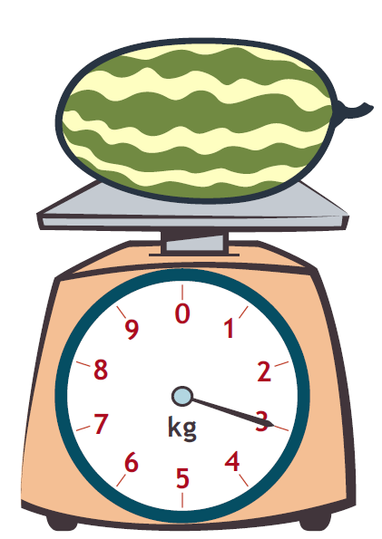
Suggested Tools and Representations
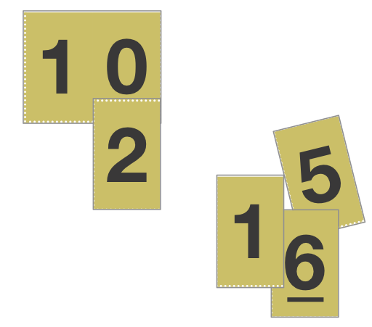
- Beaker (100 mL and optional 1 liter)
- Beans (e.g., pinto beans, used for making benchmark baggies at different weights)
- Bottles (empty, plastic, labels removed, measuring
2 liters; 1 for every group of 3 students)
- Clocks (analog and digital)
Place value cards
- Containers (clear plastic, 1 each: cup, pint, quart, gallon)
Spring scale
- Cups (16, clear plastic, with capacity of about 9 oz)
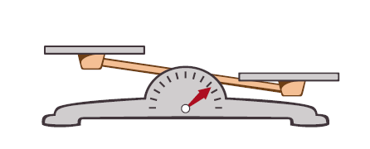
- Cylinder (a slim, cylindrical container whose sides are marked with divisions or units of measure)
- Dropper (for measuring 1 mL)
- Liter-sized container (a container large enough to hold and measure 1 liter)
- Meter strip (e.g., meter stick)
Pan balance
- Pan balance (pictured at right)
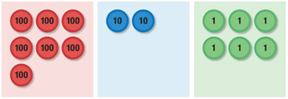
- Pitchers (plastic, 1 for each group of 3 students)
Sample place value chart without headings.
Place value disks are shown in each column.
- Place value cards (pictured at right)
- Place value chart and disks (pictured at right)
- Place value disks (pictured at right)
- Popcorn kernels (30 per student pair)
- Rice (e.g., white rice, used for making benchmark baggies at different weights)
- Ruler (measuring centimeters)
- Scales (digital and spring, measures the mass of an object in grams)
- Sealable plastic bags (gallon-sized and sandwich-sized for making benchmark baggies)
2

1

Vertical number line
0
Ten-frame
- Stopwatch (handheld timepiece that measures time elapsed from when activated to when deactivated,
1 per student pair)
- Tape Diagram (method for modeling)
- Ten-frame (pictured at right)
- Vertical number line (pictured at right)
- Weights (1 set per student pair: 1 g, 10 g, 100 g, 1 kg, or premeasured and labeled bags of rice or beans)
Scaffolds
The scaffolds integrated into A Story of Units give alternatives for how students access information as well as express and demonstrate their learning. Strategically placed margin notes are provided within each lesson elaborating on the use of specific scaffolds at applicable times. They address many needs presented by English language learners, students with disabilities, students performing above grade level, and students performing below grade level. Many of the suggestions are organized by Universal Design for Learning (UDL) principles and are applicable to more than one population. To read more about the approach to differentiated instruction in A Story of Units, please refer to “How to Implement A Story of Units.”
Assessment Summary
Type | Administered | Format | Standards Addressed
Mid-Module Assessment Task | After Topic B | Constructed response with rubric | 3.NBT.2  3.MD.1  3.MD.2
End-of-Module Assessment Task | After Topic E | Constructed response with rubric | 3.NBT.1  3.NBT.2  3.MD.1  3.MD.2  3.OA.7

3.NBT.3 is taught in Module 3.
Originally introduced in Grade 2, but treated as new vocabulary in this module.
Originally introduced in Grade 2, but treated as new vocabulary in this module.
These are terms and symbols students have used or seen previously.
Students with disabilities may require Braille, large print, audio, or special digital files. Please visit the website www.p12.nysed.gov/specialed/aim for specific information on how to obtain student materials that satisfy the National Instructional Materials Accessibility Standard (NIMAS) format.
Although 3.OA.7 is not a focus standard in this module, it does represent the major fluency for Grade 3. Module 2 fluency instruction provides systematic practice for maintenance and growth. The fluency page on the End-of-Module Assessment directly builds on the assessment given at the end of Module 1 and leads into the assessment that will be given at the end of Module 3.

