Name Date

  - In the following diagram triangle $XYZ$ has side-lengths $a$, $b$, and $c$ as shown. The angle $α$ indicated is acute. Show that the area $A$ of the triangle is given by $A=\frac{1}{2}ab\sin{(α)}$.

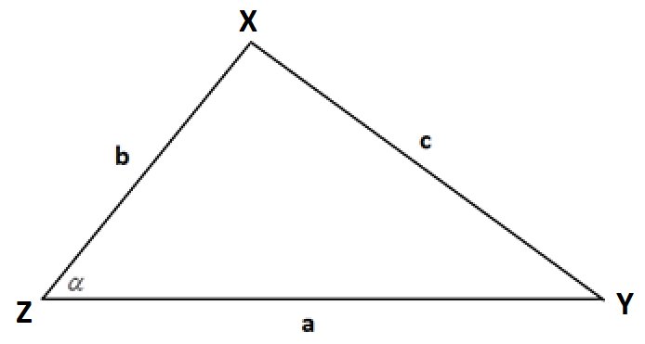

  - In the following diagram triangle $PQR$ has side-lengths $p$, $q$, and $r$ as shown. The angle $β$ indicated is obtuse. Show that the area $A$ of the triangle is given by $A=\frac{1}{2}pq\sin{(β)}$.

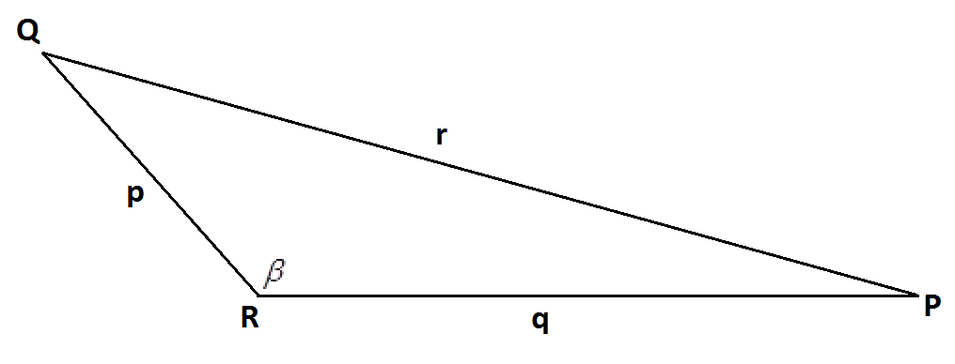

  - To one decimal place, what is the area of the triangle with sides of lengths $10 cm$, $17 cm$, and $21 cm$? Explain how you obtain your answer.

- Triangle $ABC$ with side-lengths $a$, $b$, and $c$ as shown is circumscribed by a circle with diameter $d$.

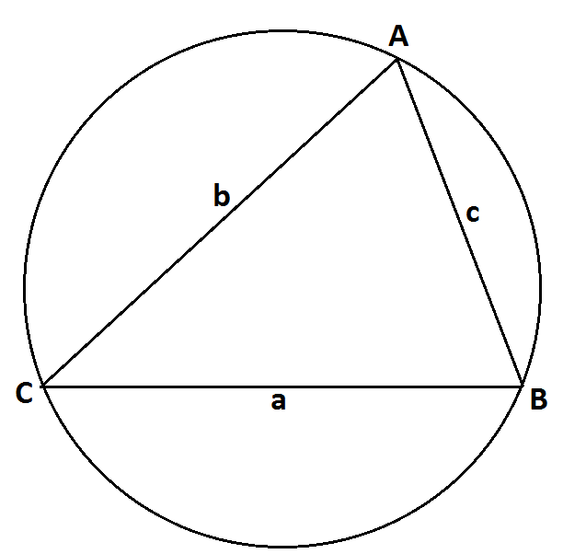

  - Show that $\frac{a}{\sin{(A)}}=d$.

  - The law of sines states that $\frac{a}{\sin{(A)}}=\frac{b}{\sin{(B)}}=\frac{c}{\sin{(C)}}$ for any triangle $ABC$ with side lengths $a$, $b$, and $c$ (with the side of length $a$ opposite vertex $A$, the side of length $b$ opposite vertex $B$, and the side of length $c$ opposite vertex $C$). Explain why the law of sines holds for all triangles.

  - Prove that $c^{2}=a^{2}+b^{2}-2ab\cos{(C)}$ for the triangle shown in the original diagram.

- Beatrice is standing $20$ meters directly east of Ari, and Cece is standing $15$ meters directly north-east of Beatrice.

  - To one decimal place, what is the distance between Ari and Cece?

  - To one decimal place, what is the measure of the smallest angle in the triangle formed by Ari, Beatrice, and Cece?

  - Is it possible to construct an inverse to the sine function if the domain of the sine function is restricted to the set of real values between $\frac{π}{2}$ and $\frac{3π}{2}$? If so, what is the value of $\sin^{-1}\left(\frac{1}{2}\right)$ for this inverse function? Explain how you reach your conclusions.

  - Is it possible to construct an inverse to the cosine function if the domain of the cosine function is restricted to the set of real values between $\frac{π}{2}$ and $\frac{3π}{2}$? If so, what is the value of $\cos^{-1}\left(-\frac{1}{2}\right)$ for this inverse function? Explain how you reach your conclusions.

  - Is it possible to construct an inverse to the tangent function if the domain of the tangent function is restricted to the set of real values between $\frac{π}{2}$ and $\frac{3π}{2}$? If so, what is the value of $\tan^{-1}(-1)$ for this inverse function? Explain how you reach your conclusions.

- The diagram shows part of a rugby union football field. The goal line (marked) passes through two goal posts (marked as black circles) set $5.6$ meters apart.

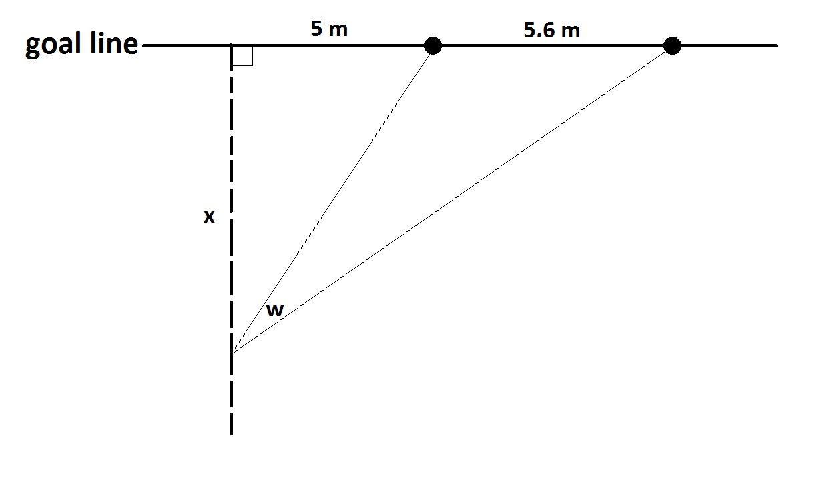
According to the rules of the game, an attempt at a conversion must be taken at a point on a line through the point of touchdown and perpendicular to the goal line. If a touchdown occurred $5$ meters to one side of a goal post on the goal line, for example, the dashed line in the diagram indicates the line on which the conversion must be attempted.
Suppose the conversion is attempted at a distance of $x$ meters from the goal line. Let $w$ be the angle (measured in radians) indicated subtended by the goal posts.
  - Using inverse trigonometric functions, write an expression for $w$ in terms of the distance $x$.

  - Using a graphing calculator or mathematics software, sketch a copy of the graph of the angle measure $w$ as a function of $x$ on the axes below. Indicate on your sketch the value of $x$ that maximizes $w$. What is that maximal angle measure? (Give all your answers to two decimal places.)

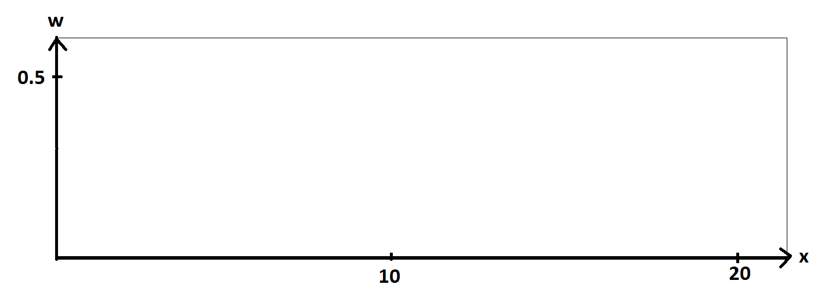

  - In the original diagram, we see that the angle of measure $w$ is one of three angles in an obtuse triangle. To two decimal places, what is the measure of the obtuse angle in that triangle when $w$ has its maximal possible measure?

- While riding her bicycle, Anu looks down for an instant to notice a reflector attached to the front wheel near its rim. As the bicycle moves, the wheel rotates and the position of the reflector relative to the frame of the bicycle changes. Consequently, the angle down from the horizontal that Anu needs to look in order to see the reflector changes with time.

Anu also notices the air-valve on the rim of the front wheel tire and observes that the valve and the reflector mark off about one-sixth of the perimeter of the front wheel.

As Anu rides along a straight path, she knows that there will be a moment in time when the reflector, the valve, and her eye will be in line. She wonders what the angle between the horizontal from her eye and the line from her eye to the reflector passing through the valve is at this special moment.

She estimates that the reflector and the valve are each $1.5$ feet from the center of the front wheel, that her eye is $6$ feet away from that center of that wheel, and that the line between her eye and the wheel center is $45°$ down from the horizontal.

According to these estimates what is the measure, to one decimal place in radians, of the angle Anu seeks?

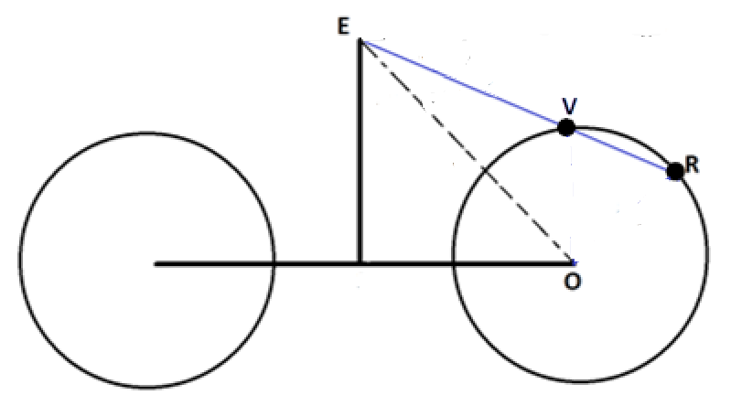
In this diagram, $O$ represents the center of the front wheel, $E$ the location of Anu’s eye, and $R$ and $V$ the positions of the reflector and valve, respectively, at the instant $R$, $V$, and $E$ are collinear.

A Progression Toward Mastery
Assessment  Task Item |  | STEP 1  Missing or incorrect answer and little evidence of reasoning or application of mathematics to solve the problem. | STEP 2  Missing or incorrect answer but evidence of some reasoning or application of mathematics to solve the problem. | STEP 3  A correct answer with some evidence of reasoning or application of mathematics to solve the problem, or an incorrect answer with substantial evidence of solid reasoning or application of mathematics to solve the problem. | STEP 4  A correct answer supported by substantial evidence of solid reasoning or application of mathematics to solve the problem.
1 | a  G-SRT.D.9 | Student shows little or no understanding of the area of a triangle using trigonometry. | Student writes altitude in terms of sine but does not verify the area formula. | Student writes the altitude in terms of sine but makes a mistake when verifying the area formula. | Student writes the altitude in terms of sine and verifies the area formula.
 | b  G-SRT.D.9 | Student shows little or no understanding of the area of a triangle using trigonometry. | Student writes altitude in terms of sine but does not verify the area formula. | Student writes the altitude in terms of sine but makes a mistake when verifying the area formula. | Student writes the altitude in terms of sine and verifies the area formula.
 | c  G-SRT.D.9 | Student shows little or no understanding of the area of a triangle using trigonometry. | Student writes the area formula but does not use it correctly. | Student finds the area with supporting work but does not explain the answer. | Students finds and explains the area correctly.
2 | a  G-SRT.D.10 | Student shows little or no understanding of concept. | Students attempts explanation but makes a major mathematical error. | Student uses Thales’ theorem and identifies a right angle inscribed in a diameter but the explanation is incomplete. | Student uses Thales’ theorem and identifies a right angle inscribed in a diameter leading to a correct explanation.
 | b  G-SRT.D.10 | Student shows little or no understanding of the law of sines. | Student attempts to explain why the law of sines holds but makes a major mathematical mistake. | Student shows knowledge of the law of sines but the explanation is incomplete. | Student completely and correctly explains why the law of sines holds for all triangles.
 | c  G-SRT.D.10 | Student shows little or no understanding of concept. | Student attempts proof but makes a major mathematical error. | Student shows knowledge of proof but makes minor error in proof. | Student correctly proves the statement.
3 | a  G-SRT.D.11 | Student shows little or no understanding of the saw of cosines. | Student uses the law of cosines but makes mathematical mistakes leading to an incorrect answer. | Student uses the law of cosines correctly but does not round properly. | Student uses the law of cosines correctly and rounds answer correctly.
 | b  G-SRT.D.11 | Student shows little or no understanding of the law of sines. | Student knows the shortest angle is $A$ but cannot find $A$. | Student uses the law of sines to find $A$ correctly but makes a mathematical mistake leading to an incorrect answer. | Student uses the law of sines to find $A$ correctly.
4 | a  F-TF.B.6 | Student shows little or no understanding of inverse trigonometric functions. | Student knows that there is an inverse function on the restricted domain but does not explain why or calculate value. | Student either finds the correct value OR explains the restricted domain correctly. | Student correctly explains the restricted domain of the inverse function and calculates the value.
 | b  F-TF.B.6 | Student shows little or no understanding of inverse trigonometric functions. | Student knows that there is not an inverse function on the restricted domain but does not explain why or calculate value. | Student explains that there is not an inverse function on the restricted domain but explanation is incomplete. | Student completely explains that there is not an inverse function on the restricted domain.
 | c  F-TF.B.6 | Student shows little or no understanding of inverse trigonometric functions. | Student knows that there is an inverse function on the restricted domain but does not explain why or calculate value. | Student either finds the correct value OR explains the restricted domain correctly. | Student correctly explains the restricted domain of the inverse function and calculates the value.
5 | a  F-TF.B.7 | Student shows little or no knowledge of inverse trigonometric functions. | Student attempts to write $w$ in terms of $x$ but makes major mathematical mistakes. | Student writes $w$ in terms of $x$ with a minor mathematical mistake. | Student correctly writes $w$ in terms of $x$.
 | b  F-TF.B.7 | Student shows little or no knowledge of trigonometric functions. | Student sketches the graph but does not identify maximal angle measure. | Students sketches the graph and identifies the maximal angle measure but does not round correctly. | Student sketches the graph and identifies the maximal angle measure rounding correctly.
 | c  F-TF.B.7 | Student shows little or no knowledge of trigonometric functions. | Student attempts to find the obtuse angle but makes major mathematical errors. | Student finds the obtuse angle but a minor mathematical error leads to an incorrect answer. | Student correctly finds the measure of the obtuse angle.
6 | G-SRT.D.11 | Student shows little or no knowledge of the law of sines. | Student attempts to use the law of sines but makes mathematical errors leading to an incorrect answer. | Student uses the law of sines and finds the measure of the angle but does not round correctly. | Student uses the law of sines, finds the measure of the angle, and rounds correctly.

Name Date

  - In the following diagram triangle $XYZ$ has side-lengths $a$, $b$, and $c$ as shown. The angle $α$ indicated is acute. Show that the area $A$ of the triangle is given by $A=\frac{1}{2}ab\sin{(α)}$.

Draw an altitude as shown. Call its length $\text{h}$.
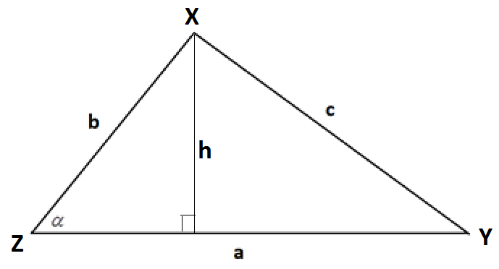
We have $\text{sin}\left(\text{α}\right) \text{= }\frac{\text{h}}{\text{b}}\text{,}$ so $\text{h} \text{=} \text{b}\text{sin}{\text{(}\text{α}\text{)}}$.
The area $\text{A}$ of the triangle is given as “half base times height.” So
$\text{A} \text{=} \frac{\text{1}}{\text{2}} \text{×} \text{a} \text{×} \text{b}\text{sin}\left(\text{α}\right) \text{=} \frac{\text{1}}{\text{2}}\text{ab}\text{sin}{\text{(}\text{α}\text{)}}$.

  - In the following diagram triangle $PQR$ has side-lengths $p$, $q$, and $r$ as shown. The angle $β$ indicated is obtuse. Show that the area $A$ of the triangle is given by $A=\frac{1}{2}pq\sin{(β)}$.

Draw in an altitude as shown. Call its length $\text{h}$.
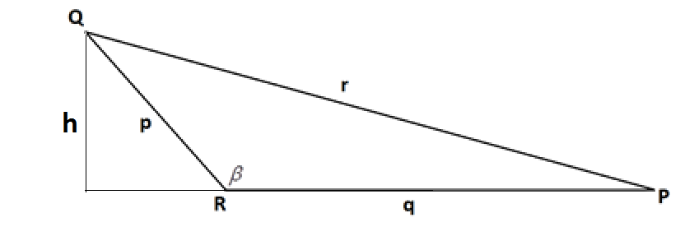
We have $\text{sin}\left(\text{π} \text{- β}\right) \text{=} \frac{\text{h}}{\text{p}}$, so $\text{h} \text{=} \text{p}\text{sin}{\text{(π} \text{-} \text{β)}}$. Since $\text{sin}\left(\text{π} \text{- β}\right) \text{=} \text{sin}{\text{(β)}}$, this can be rewritten $\text{h} \text{=} \text{p}\text{sin}{\text{(β)}}$.
The area $\text{A}$ of the triangle is thus $\frac{\text{1}}{\text{2}} \text{×} \text{q} \text{×} \text{p}\text{sin}\left(\text{β}\right) \text{=} \frac{\text{1}}{\text{2}}\text{pq}\text{sin}{\text{(β)}}$.

  - To one decimal place, what is the area of the triangle with sides of lengths $10 cm$, $17 cm$, and $21 cm$? Explain how you obtain your answer.
Let $θ$ be the measure of the angle between the sides of lengths $\text{10 cm}$ and $\text{17 cm}$. By the law of cosines, we have ${\text{21}}^{\text{2}} \text{=} {\text{10}}^{\text{2}} \text{+} {\text{17}}^{\text{2}}\text{-} \text{2} \text{∙} \text{10} \text{∙} \text{17}\text{cos}{\text{(θ)}}$. This gives $\text{cos}\left(\text{θ}\right) \text{=} \frac{\text{52}}{\text{340}} \text{=} \frac{\text{13}}{\text{85}}$, and so $\text{θ} \text{=} {\text{cos}}^{\text{-1}}\left(\frac{\text{13}}{\text{85}}\right) \text{≈} \text{1.42}$ radians.
The area of the triangle is thus $\frac{\text{1}}{\text{2}} \text{∙} \text{10} \text{∙} \text{17}\text{sin}\left(\text{θ}\right) \text{≈} \text{85}\text{sin}{\text{(1.42)} \text{≈} \text{84.0}}$ square centimeters.

- Triangle $ABC$ with side-lengths $a$, $b$, and $c$ as shown is circumscribed by a circle with diameter $d$.

  - Show that $\frac{a}{\sin{(A)}}=d$.
Consider the point $\text{A’}$ on the circle with $\overline{\text{A'B}}$ a diameter of the circle.
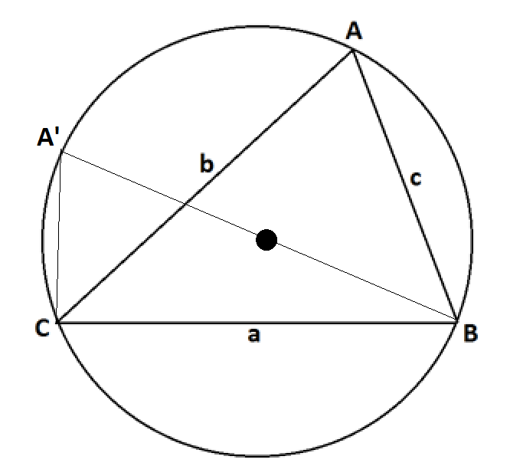
By Thales’ theorem (an inscribed angle that intercepts a semi-circle is a right angle), $\text{∠}\text{A'CB}$ is a right angle. Thus, $\text{sin}\left({\text{A}}^{\text{'}}\right) \text{=} \frac{\text{a}}{\text{d}}$.
But by the inscribed angle theorem (angles intercepting the same arc are congruent), the inscribed angle at $\text{A’}$ has the same measure as the inscribed angle at $\text{A}$. So, $\text{sin}\left({\text{A}}^{\text{'}}\right) \text{=} \text{sin}{\text{(A)}}$, and our equation reads $\text{sin}\left(\text{A}\right) \text{= }\frac{\text{a}}{\text{d}}$. Rearranging gives $\frac{\text{a}}{\text{sin}{\text{(A)}}} \text{=} \text{d}$.

  - The law of sines states that $\frac{a}{\sin{(A)}}=\frac{b}{\sin{(B)}}=\frac{c}{\sin{(C)}}$ for any triangle $ABC$ with side lengths $a$, $b$, and $c$ (with the side of length $a$ opposite vertex $A$, the side of length $b$ opposite vertex $B$, and the side of length $c$ opposite vertex $C$). Explain why the law of sines holds for all triangles.
The relationship between a, sin(A), and d holds for any side of the triangle. So we also have $\frac{\text{b}}{\text{sin}{\text{(B)}}} \text{=} \text{d}$ and $\frac{\text{c}}{\text{sin}{\text{(C)}}} \text{=} \text{d}$. This shows that $\frac{\text{a}}{\text{sin}{\text{(A)}}} \text{=} \frac{\text{b}}{\text{sin}{\text{(B)}}} \text{=} \frac{\text{c}}{\text{sin}{\text{(C)}}}$ for a triangle circumscribed by a circle.

As every triangle can be circumscribed by a circle, the law of sines,
$\frac{\text{a}}{\text{sin}{\text{(A)}}} \text{=} \frac{\text{b}}{\text{sin}{\text{(B)}}} \text{=} \frac{\text{c}}{\text{sin}{\text{(C)}}}$, thus holds for all triangles.

  - Prove that $c^{2}=a^{2}+b^{2}-2ab\cos{(C)}$ for the triangle shown in the original diagram .
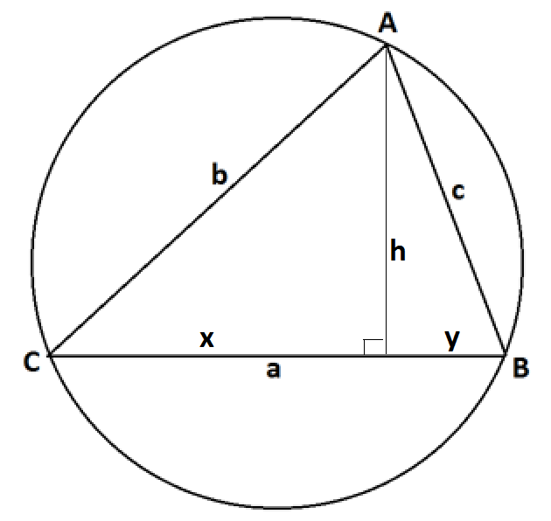
Draw an altitude as shown for the triangle, and identify the three lengths $\text{x}$, $\text{y}$, and $\text{h}$ as shown.
Now $\text{x} \text{=} \text{b}\text{cos}\left(\text{C}\right)\text{, }\text{h} \text{=} \text{b}\text{sin}{\text{(}\text{C}\text{)}}$, and $\text{y} \text{=} \text{a}\text{ -} \text{x} \text{=} \text{a}\text{ -} \text{b}\text{cos}{\text{(}\text{C}\text{)}}$.
Applying the Pythagorean theorem to the right triangle on the right, we have
$${\text{y}}^{\text{2}} \text{+} {\text{h}}^{\text{2}} \text{=} {\text{c}}^{\text{2}} \\ {\text{(a} \text{-} \text{b}\text{cos}{\text{(C))}}}^{\text{2}} \text{+} {\text{(b}\text{sin}{\text{(C))}}}^{\text{2}} \text{=} {\text{c}}^{\text{2}} \\ {\text{a}}^{\text{2}}\text{-} \text{2ab}\text{cos}\left(\text{C}\right) \text{+} {\text{b}}^{\text{2}}{\text{cos}}^{\text{2}}\left(\text{C}\right) \text{+} {\text{b}}^{\text{2}}{\text{sin}}^{\text{2}}\left(\text{C}\right) \text{= }{\text{c}}^{\text{2}}$$
Using ${\text{cos}}^{\text{2}}\left(\text{C}\right) \text{+ }{\text{sin}}^{\text{2}}\left(\text{C}\right) \text{=} \text{1}$ this reads
${\text{a}}^{\text{2}}\text{-} \text{2ab}\text{cos}\left(\text{C}\right) \text{+} {\text{b}}^{\text{2}} \text{=} {\text{c}}^{\text{2}}$
or
${\text{c}}^{\text{2}} \text{=} {\text{a}}^{\text{2}} \text{+} {\text{b}}^{\text{2}}\text{-} \text{2ab}\text{cos}{\text{(C)}}$.

- Beatrice is standing $20$ meters directly east of Ari, and Cece is standing $15$ meters directly north-east of Beatrice.

  - To one decimal place, what is the distance between Ari and Cece?
The following diagram depicts the situation described:
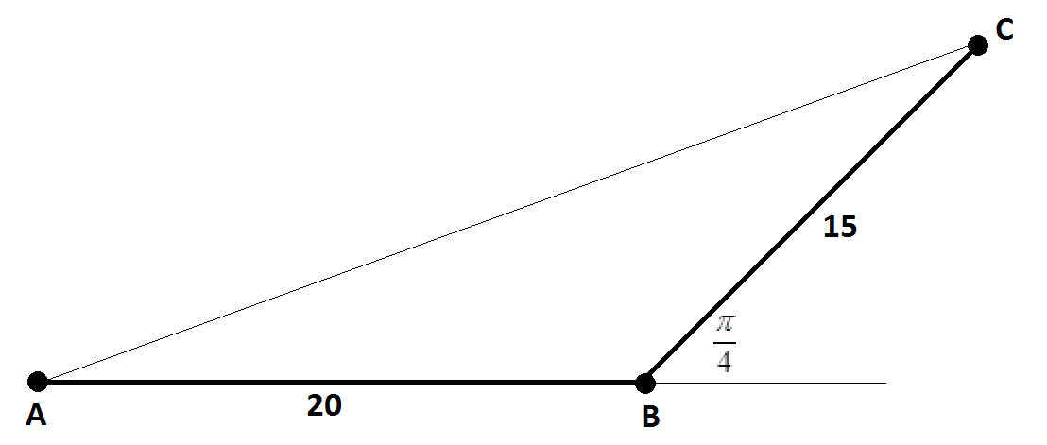
By the law of cosines
$${\left|\text{AC}\right|}^{\text{2}} \text{=} {\text{20}}^{\text{2}} \text{+} {\text{15}}^{\text{2}}\text{-} \text{2} \text{∙} \text{15} \text{∙} \text{20} \text{∙} \text{cos}\left(\frac{\text{3π}}{\text{4}}\right) \\ \text{=} \text{400} \text{+} \text{225} \text{-} \text{600}\left(\text{-}\frac{\text{1}}{\sqrt{\text{2}}}\right) \\ \text{625} \text{+} \text{300}\sqrt{\text{2}}\text{.}$$
Thus, the distance between Ari and Cece is $\sqrt{\text{625} \text{+} \text{300}\sqrt{\text{2} }} \text{≈} \text{32.4}$ meters.

  - To one decimal place, what is the measure of the smallest angle in the triangle formed by Ari, Beatrice, and Cece?
The angle of smallest measure in a triangle lies opposite the shortest side of the triangle. Thus, we seek the measure of the angle at Ari’s position.
By the law of sines
$$\frac{\text{sin}{\text{(A)}}}{\text{15}} \text{=} \frac{\text{sin}\left(\frac{\text{3π}}{\text{4}}\right)}{\left|\text{AC}\right|}$$
giving
$$\text{sin}\left(\text{A}\right) \text{=} \frac{\text{15}}{\sqrt{\text{2}}\left|\text{AC}\right|} \text{≈} \frac{\text{15}}{\sqrt{\text{2}}\text{∙}\text{32.4}} \text{≈} \text{0.33.}$$
Thus,
$\text{A} \text{≈} {\text{sin}}^{\text{-1}}\left(\text{0.33}\right) \text{≈} \text{0.33}$ radian. (This is about $\text{19°}$.)

  - Is it possible to construct an inverse to the sine function if the domain of the sine function is restricted to the set of real values between $\frac{π}{2}$ and $\frac{3π}{2}$? If so, what is the value of $\sin^{-1}\left(\frac{1}{2}\right)$ for this inverse function? Explain how you reach your conclusions.
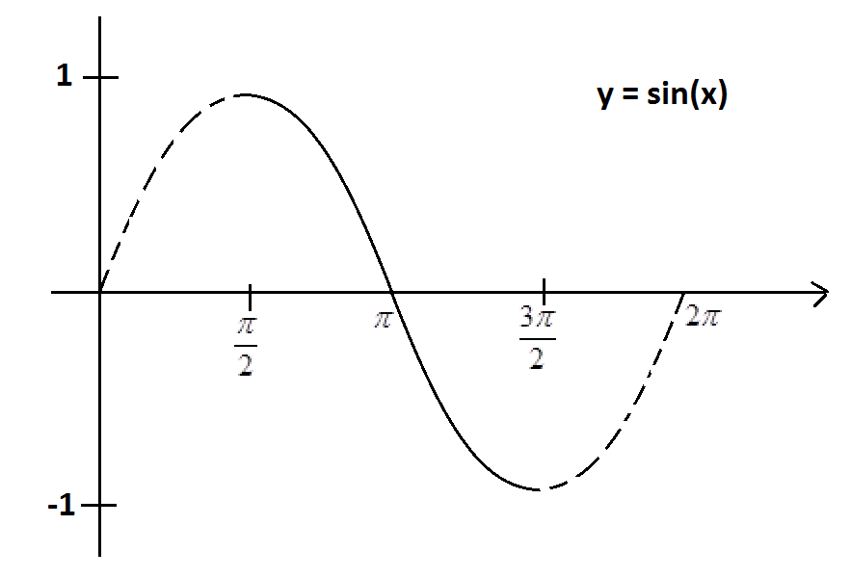
We see, when restricted to inputs between $\frac{\text{π}}{\text{2}}$ and $\frac{\text{3π}}{\text{2}}$, the graph of $\text{y} \text{=} \text{sin}{\text{(x)}}$ is strictly decreasing.
Thus for each value between $\text{-1}$ and $\text{1}$, there is an input value $\text{x}$ within this range for which $\text{sin}{\text{(x)}}$ has this value. That is, there is indeed an inverse function for sine in this restricted domain.
We know that $\text{sin}\left(\frac{\text{π}}{\text{6}}\right) \text{=} \frac{\text{1}}{\text{2}}$. So it follows that $\text{sin}\left(\text{π} \text{+} \frac{\text{π}}{\text{6}}\right) \text{= -}\frac{\text{1}}{\text{2}}$. For our inverse function we have
$${\text{sin}}^{\text{-1}}\left(\text{-}\frac{\text{1}}{\text{2}}\right) \text{=} \text{π} \text{+} \frac{\text{π}}{\text{6}} \text{=} \frac{\text{7π}}{\text{6}}\text{.}$$

  - Is it possible to construct an inverse to the cosine function if the domain of the cosine function is restricted to the set of real values between $\frac{π}{2}$ and $\frac{3π}{2}$? If so, what is the value of $\cos^{-1}\left(-\frac{1}{2}\right)$ for this inverse function? Explain how you reach your conclusions.
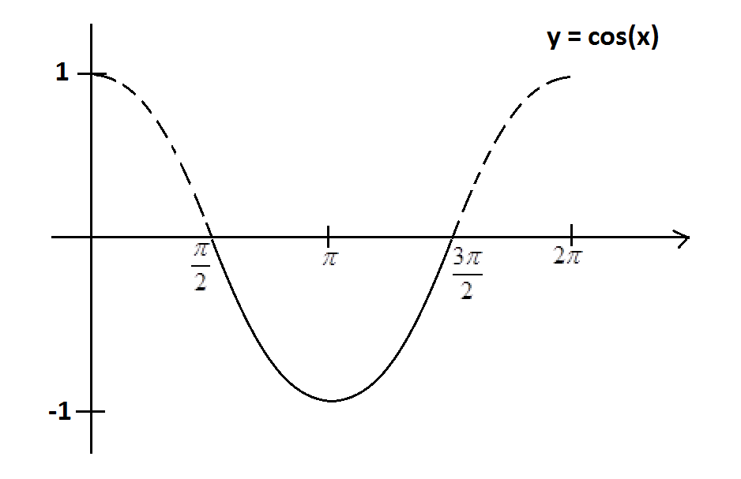
Over restricted domain given the cosine function is not strictly increasing nor strictly decreasing.
There are distinct inputs from the restricted domain that give the same cosine values, and so it is not possible to construct an inverse to cosine for this domain.

  - Is it possible to construct an inverse to the tangent function if the domain of the tangent function is restricted to the set of real values between $\frac{π}{2}$ and $\frac{3π}{2}$? If so, what is the value of $\tan^{-1}(-1)$ for this inverse function? Explain how you reach your conclusions.
The graph of the tangent function is strictly increasing on the restricted domain:
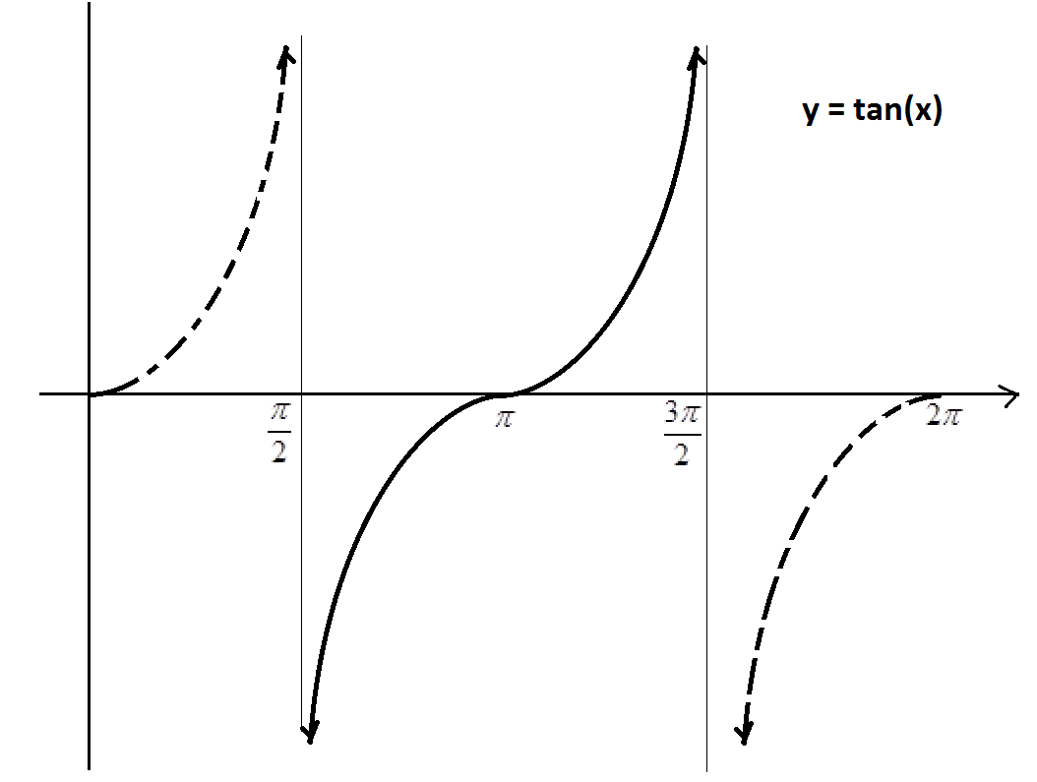

For each real number $\text{y}$, there is indeed a unique real number $\text{x}$ in this restricted domain with $\text{tan}\left(\text{x}\right) \text{=} \text{y}$. We can thus construct an inverse function.
We know that $\text{tan}\left(\frac{\text{π}}{\text{4}}\right) \text{=} \text{1}$, and so we see that $\text{tan}\left(\text{π} \text{+} \frac{\text{π}}{\text{4}}\right) \text{=} \text{-1}$. Thus for our inverse function, ${\text{tan}}^{\text{-1}}\left(\text{-1}\right) \text{=} \frac{\text{5}\text{π}}{\text{4}}$.

- The diagram shows part of a rugby union football field. The goal line (marked) passes through two goal posts (marked as black circles) set $5.6$ meters apart.

According to the rules of the game, an attempt at a conversion must be taken at a point on a line through the point of touchdown and perpendicular to the goal line. If a touchdown occurred $5$ meters to one side of a goal post on the goal line, for example, the dashed line in the diagram indicates the line on which the conversion must be attempted.
Suppose the conversion is attempted at a distance of $x$ meters from the goal line. Let $w$ be the angle (measured in radians) indicated subtended by the goal posts.
  - Using inverse trigonometric functions, write an expression for $w$ in terms of the distance $x$ .
Label the angle $\text{y}$ as shown:
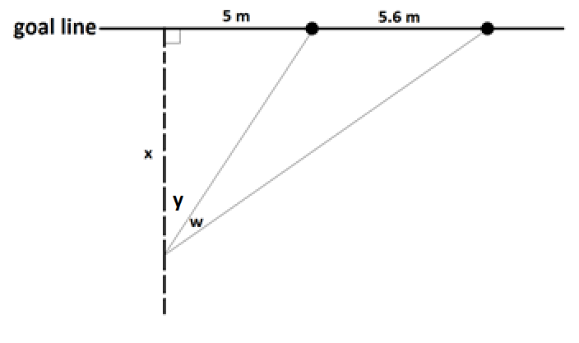
We have $\text{tan}\left(\text{y}\right) \text{=} \frac{\text{5}}{\text{x}}$ and $\text{tan}\left(\text{y} \text{+} \text{w}\right) \text{=} \frac{\text{10.6}}{\text{x}}$ and so
$$\text{w} \text{=} \left(\text{y} \text{+} \text{w}\right)\text{-} \text{y} \text{=} {\text{tan}}^{\text{-1}}\left(\frac{\text{10.6}}{\text{x}}\right)\text{-} {\text{tan}}^{\text{-1}}\left(\frac{\text{5}}{\text{x}}\right).$$

  - Using a graphing calculator or mathematics software, sketch a copy of the graph of the angle measure $w$ as a function of $x$ on the axes below. Indicate on your sketch the value of $x$ that maximizes $w$. What is that maximal angle measure? (Give all your answers to two decimal places.)

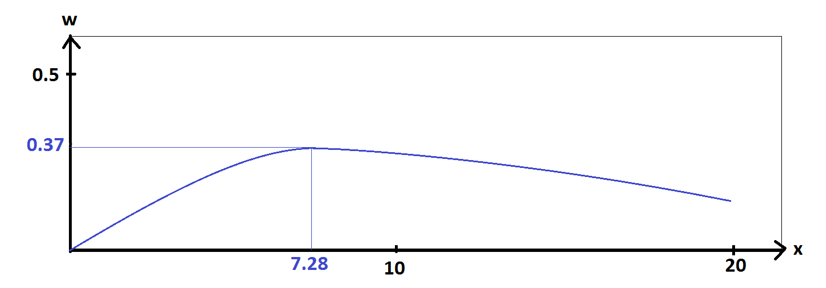
We see

At $\text{x = 7.28}$ meters the angle $w$ has a measure of $\text{0.37}$ radian. (This is about $\text{21°}$.)

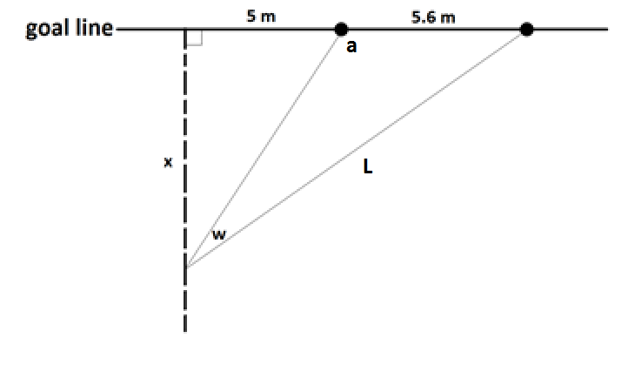
  - In the original diagram, we see that the angle of measure $w$ is one of three angles in an obtuse triangle. To two decimal places, what is the measure of the obtuse angle in that triangle when $w$ has its maximal possible measure?
Label the obtuse angle $\text{a}$ and the length $\text{L}$ as shown.
For $\text{x = 7.28}$ and $\text{w = 0.37}$, we have
$\text{L} \text{=} \sqrt{{\text{10.6}}^{\text{2}} \text{+} {\text{7.28}}^{\text{2}}} \text{≈} \text{12.86}$ meters,
and, by the law of sines,
$\frac{\text{sin}{\text{(a)}}}{\text{L}} \text{=} \frac{\text{sin}{\text{(w)}}}{\text{5.6}}$.

So $\text{sin}\left(\text{a}\right) \text{= }\frac{\text{L}\text{sin}{\text{(w)}}}{\text{5.6}} \text{≈} \frac{\text{12.86} \text{×} \text{sin}{\text{(0.37)}}}{\text{5.6}} \text{≈} \text{0.83}$.
Thus, $\text{a} \text{=} {\text{sin}}^{\text{-1}}\left(\text{0.83}\right) \text{=} \text{0.98 or π -} \text{0.98}$.

Since we are working with an obtuse angle, we must have $\text{a} \text{= π -} \text{0.98} \text{≈} \text{2.16}$ radians. (This is about $\text{124°}$.)

While riding her bicycle, Anu looks down for an instant to notice a reflector
attached to the front wheel near its rim. As the bicycle moves, the wheel rotates and the position of the reflector relative to the frame of the bicycle changes. Consequently, the angle down from the horizontal that Anu needs to look in order to see the reflector changes with time.

Anu also notices the air-valve on the rim of the front wheel tire and observes that the valve and the reflector mark off about one-sixth of the perimeter of the front wheel.

As Anu rides along a straight path, she knows that there will be a moment in time when the reflector, the valve, and her eye will be in line. She wonders what the angle between the horizontal from her eye and the line from her eye to the reflector passing through the valve is at this special moment.

She estimates that the reflector and the valve are each $1.5$ feet from the center of the front wheel, that her eye is $6$ feet away from that center of that wheel, and that the line between her eye and the wheel center is $45°$ down from the horizontal.

According to these estimates what is the measure, to one decimal place in radians, of the angle Anu seeks?
In this diagram, $O$ represents the center of the front wheel, $E$ the location of Anu’s eye, and $R$ and $V$ the positions of the reflector and valve, respectively, at the instant $R$, $V$, and $E$ are collinear.
The following is a schematic diagram of Anu on her bicycle. The point $\text{O}$ is the center of the front wheel, the point $\text{E}$ is the location of Anu’s eye, and the points $\text{R}$ and $\text{V}$ are the locations of the reflector and the valve, respectively, on the rim of the front wheel and the instant those two points and $\text{E}$ are collinear. We have $\text{|EO|} \text{=} \text{6}$ feet and $\left|\text{OR}\right| \text{=} \left|\text{OV}\right| \text{=} \text{1.5}$ feet, and we seek the measure of angle $a$ shown.

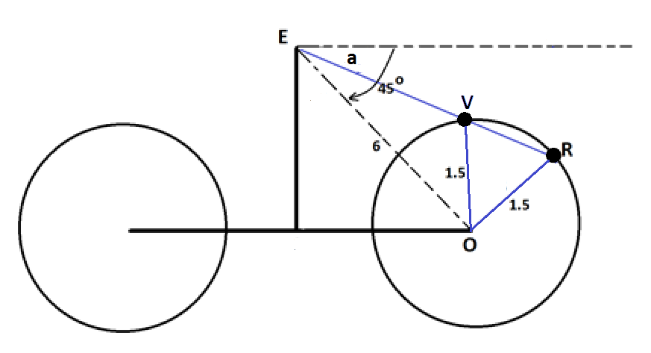

We are told that the length of the arc between $\text{V}$ and $\text{R}$ is one-sixth of the perimeter of the wheel. Thus $\text{m} \text{∠}\text{VOR} \text{=} \frac{\text{1}}{\text{6}} \text{∙} \text{2}\text{π} \text{=} \frac{\text{π}}{\text{3}}$ radian. Consequently,
$\text{m} \text{∠}\text{EVO} \text{=} \frac{\text{2}\text{π}}{\text{3}}$.

Looking at triangle $\text{EVO}$, the law of sines gives $\frac{\text{6}}{\text{sin}\left(\frac{\text{2}\text{π}}{\text{3}}\right)} \text{=} \frac{\text{1.5}}{\text{sin}{\text{(}\text{∠}\text{VEO}\text{)}}}$, and so $\text{sin}\left(\text{∠}\text{VEO}\right) \text{= }\frac{\text{sin}\left(\frac{\text{2}\text{π}}{\text{3}}\right)}{\text{4}} \text{=} \frac{\sqrt{\text{3}}}{\text{8}}$. Thus, $\text{m} \text{∠}\text{VEO} \text{=} {\text{sin}}^{\text{-1}}\left(\frac{\sqrt{\text{3}}}{\text{8}}\right)$ radians. Since $\text{∠}\text{EVO}$ is obtuse, $\text{∠}\text{VEO}$ is acute, and we must work with the value of ${\text{sin}}^{\text{-1}}\left(\frac{\sqrt{\text{3}}}{\text{8}}\right)$ that corresponds to the measure of an acute angle.

It follows that $\text{m} \text{∠}\text{a} \text{=} \frac{\text{π}}{\text{4}}\text{-} {\text{sin}}^{\text{-1}}\left(\frac{\sqrt{\text{3}}}{\text{8}}\right) \text{≈} \text{0.6}$ radians (which is about $\text{34°}$).

