Topic A
Equivalent Fractions
4.NF.1
Focus Standard: | 4.NF.1 | Explain why a fraction a/b is equivalent to a fraction (n x a)/(n x b) by using visual fraction models, with attention to how the number and size of the parts differ even though the two fractions themselves are the same size. Use this principle to recognize and generate equivalent fractions.
Instructional Days: | 2
Coherence -Links from: | G4–M5 | Fraction Equivalence, Ordering, and Operations
-Links to: | G5–M4 | Multiplication and Division of Fractions and Decimal Fractions
 | G6–M3 | Rational Numbers
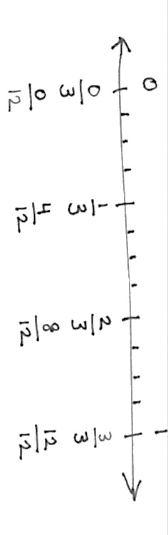
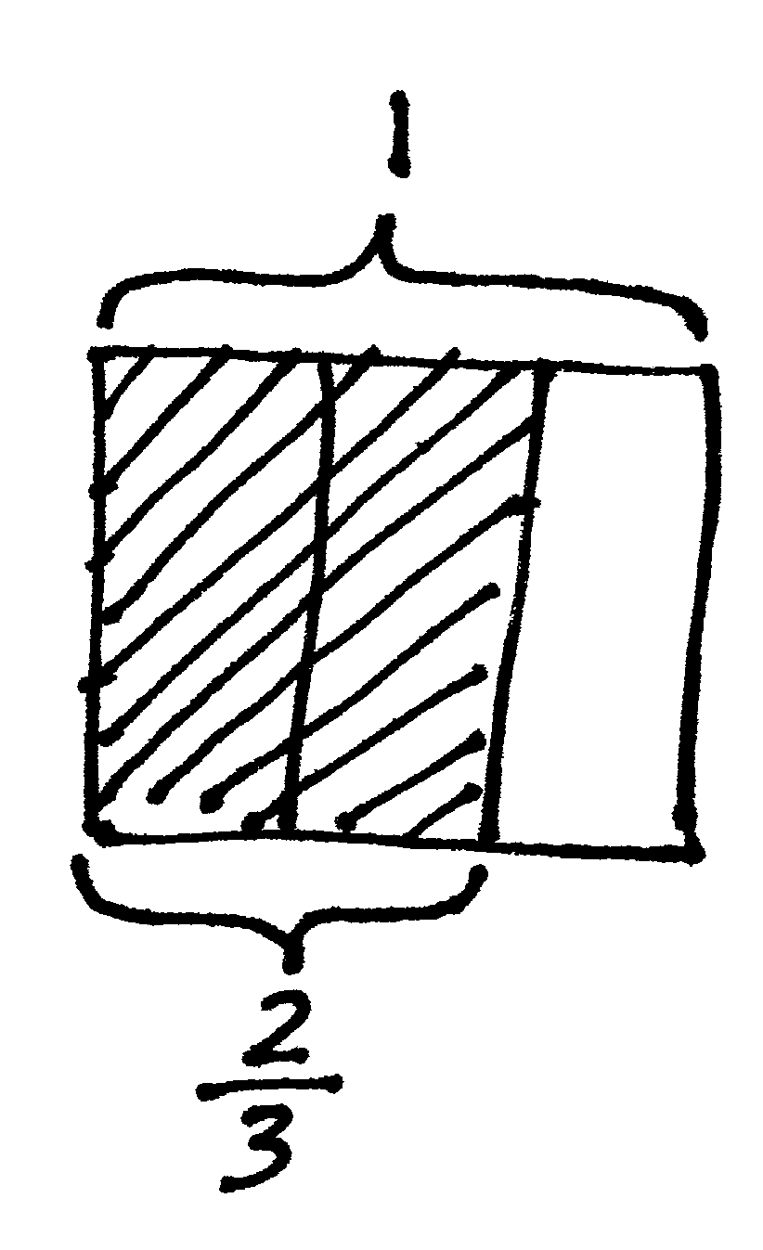
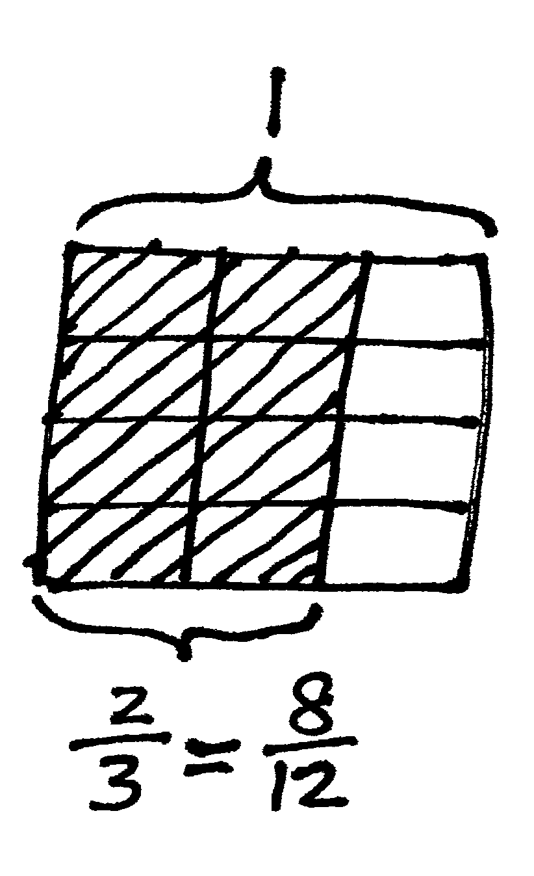
In Topic A, students revisit the foundational Grade 4 standards addressing equivalence. When equivalent, fractions can be represented by the same amount of area of a rectangle, as well as the same point on a number line. Students subdivide areas and divide number line lengths to model this equivalence. On the number line below, there are 3$×$4 parts of equal length. Both the area model and number line show that 2 thirds is equivalent to 8 twelfths.

This equivalence can also be represented symbolically as follows:

$$\frac{2}{3} = \frac{2 × 4}{3 × 4} = \frac{8}{12}$$
Furthermore, equivalence is evidenced when adding fractions with the same denominator. The sum may be decomposed into parts (or recomposed into an equal sum). An example is shown as follows:

$$\frac{2}{3} = \frac{1}{3} + \frac{1}{3}$$

$$\frac{7}{8} = \frac{3}{8} + \frac{3}{8} + \frac{1}{8}$$

$$\frac{6}{2} = \frac{2}{2} + \frac{2}{2} + \frac{2}{2} = 1 + 1 + 1 = 3$$

$$\frac{8}{5} = \frac{5}{5} + \frac{3}{5} = 1\frac{3}{5}$$

$$\frac{7}{3} = \frac{6}{3} + \frac{1}{3} = 2 × \frac{3}{3} + \frac{1}{3} = 2 + \frac{1}{3} = 2\frac{1}{3}$$

In Lesson 1, students analyze how and when units must change, particularly when making an equivalent fraction by decomposing larger units into smaller units. This hones their ability to look for and make use of structure (MP.7). They study the area model to make generalizations, and then apply those generalizations to work with the number line as they see the same process occurring there within the lengths.

A Teaching Sequence Toward Mastery of Equivalent Fractions
Objective 1: Make equivalent fractions with the number line, the area model, and numbers.
(Lesson 1)
Objective 2: Make equivalent fractions with sums of fractions with like denominators.
(Lesson 2)

